
Activity 5.1.3 My Stomach’s Bigger!

Purpose
Now that you have a much better understanding of the digestive systems, which system is found in which animal? The digestive systems of livestock animals differ in structure and function. The large rumen and microbial action in ruminants allow them to digest feeds with tough plant cell walls and convert it to energy. In a chicken, the gizzard allows it to crush and grind hard seeds to increase digestibility. These specialized structures enable animals to convert less digestible feeds to energy. What organs make up each digestive system?

Materials
Per student:
- Modern Livestock and Poultry Production textbook
- Pencil
- Agriscience Notebook

Procedure
During this activity, you will work with a group of four students. Each member of the group is responsible for correctly labeling and explaining the function of the required digestive parts of one animal. Each group member will share his or her information with the group in order that all members understand the types of digestive systems.

- Your teacher will divide you into groups of four.
- Within your group, assign each member one of the four digestive systems being studied.
- Monogastric – Pig | - Monogastric – Horse
- Ruminant – Cow or sheep | - Avian – Chicken or turkey
- Locate the correct Table in Activity 5.1.3 Student Worksheet with the internal anatomy of your animal.
- Label and describe the function of the missing digestive organs in the Table of the worksheet.
- Research and record the capacity of each digestive system.
- When all group members have completed their worksheet, take turns teaching your findings to your group.
- While your group members are sharing their information, record the information in the remaining tables to assist you in completing the diagrams for all four digestive systems.

Conclusion
- What differences exist in the four digestive systems you have studied?

- What substance is consumed by avian species that helps them break down ingested food further?

- Which animal has a digestive system most like yours?
Activity 5.1.3 Student Worksheet

Table 1. Pig Digestive System
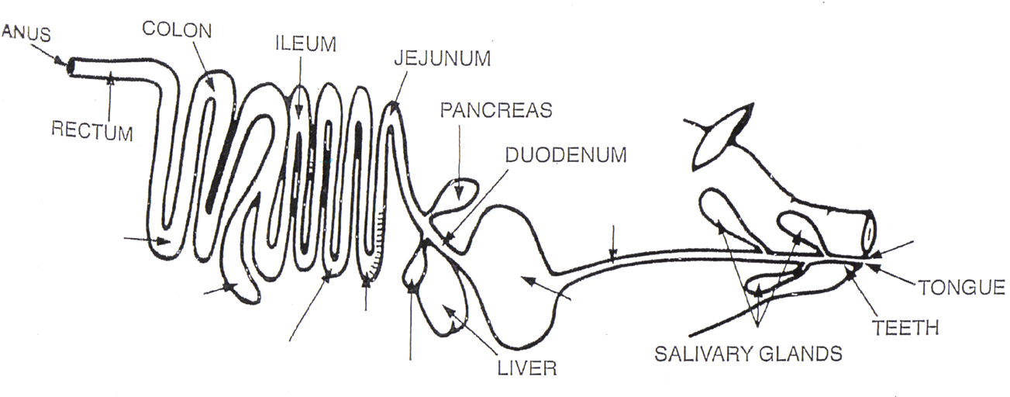

Capacity: | Stomach: | Large Intestine:
Capacity: | Small Intestine: | TOTAL:
Capacity: | Cecum:
Source: Gillespie, J.R., & Flanders, F.B. (2015). Modern livestock and poultry production (9th ed.). Clifton Park, NY: Delmar.

Table 2. Horse Digestive System
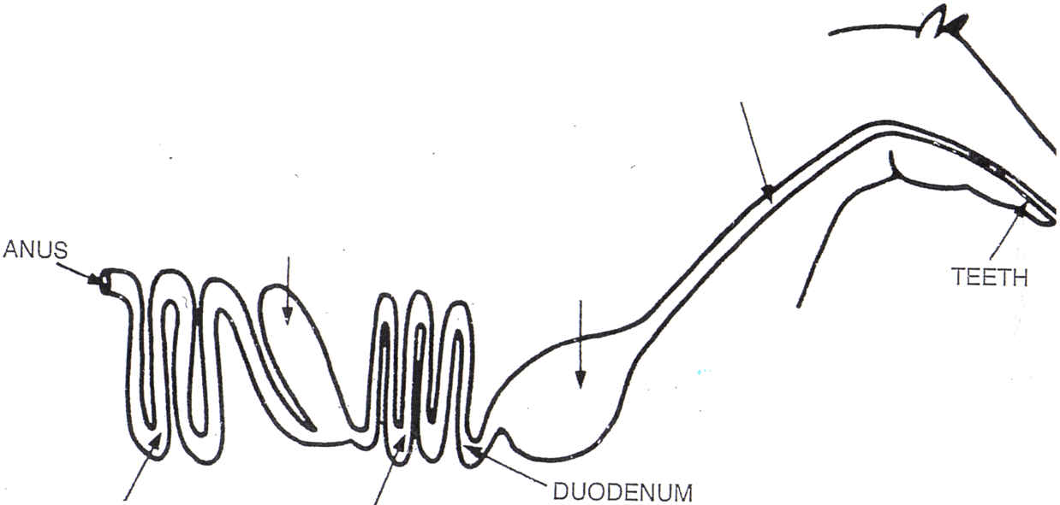

Figure 2. Horse Digestive Tract
Capacity: | Stomach: | Large Intestine:
Capacity: | Small Intestine: | TOTAL:
Capacity: | Cecum:
Source: Gillespie, J.R., & Flanders, F.B. (2015). Modern livestock and poultry production (9th ed.). Clifton Park, NY: Delmar.

Table 3. Cow Digestive System
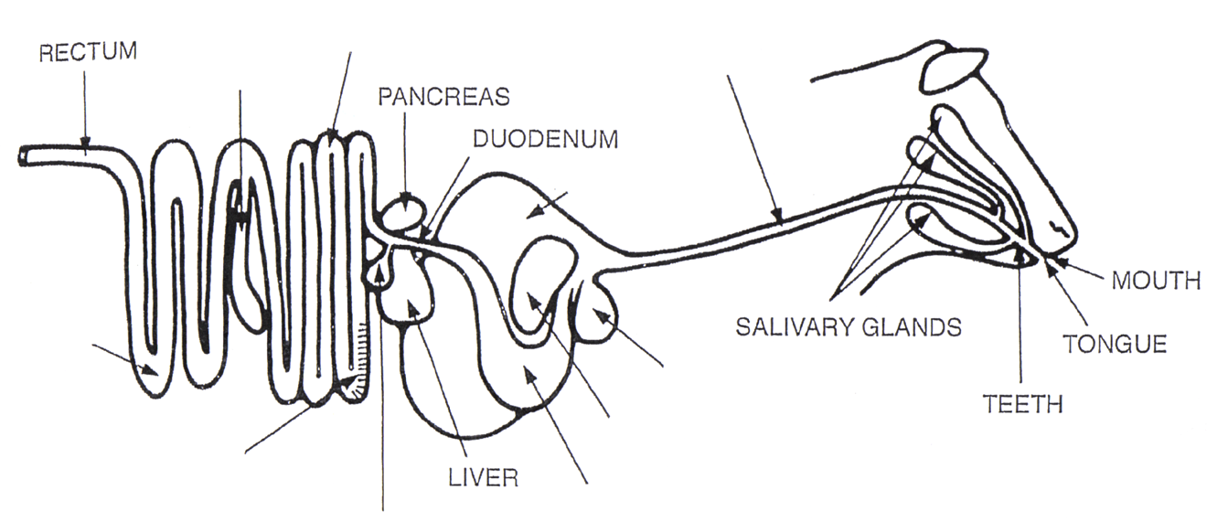

Figure 3. Ruminant Digestive Tract
 | Organ | Cattle | Sheep/Goats | Organ | Cattle | Sheep/Goats
Capacity: | Rumen: |  |  | Small Intestine:
Capacity: | Reticulum: |  |  | Cecum:
Capacity: | Omasum: |  |  | Large Intestine:
Capacity: | Abomasum: |  |  | TOTAL:
Source: Gillespie, J.R., & Flanders, F.B. (2015). Modern livestock and poultry production (9th ed.). Clifton Park, NY: Delmar.

Table 4. Chicken Digestive System
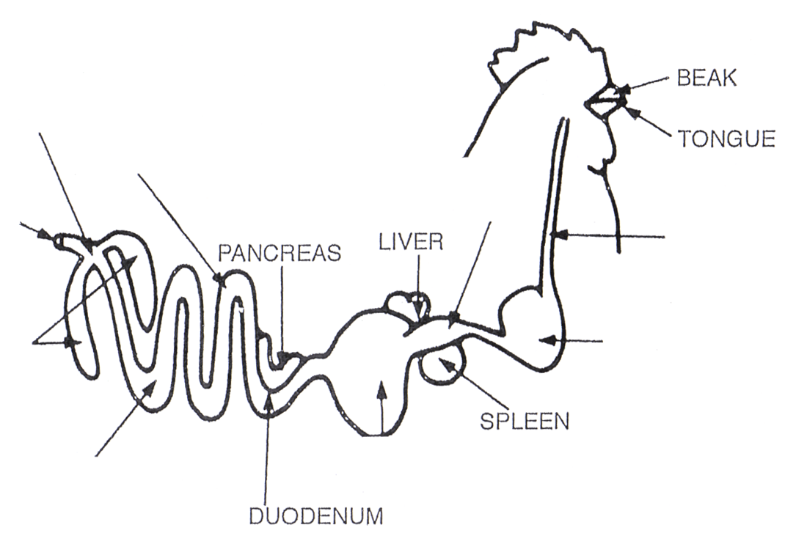
Figure 4. Avian Digestive Tract
Capacity: | Crop: | Large Intestine:
Capacity: | Gizzard: | Ceca:
Capacity: | Small Intestine: | TOTAL:
Source: Gillespie, J.R., & Flanders, F.B. (2015). Modern livestock and poultry production (9th ed.). Clifton Park, NY: Delmar.

