
Project 4.1.1 Cell Analogy Collage

Purpose
What does a nucleus look like or function like? Relating newly discovered information to your previous knowledge, will help you understand and remember new information. An analogy is a comparison between two objects that are similar in some respects, but otherwise different. For example, an analogy of the human kidneys may be made with a pool filter. The kidneys filter out wastes from the human body just as a pool filter removes particles from the swimming pool.

An animal cell has several parts that function in specific ways to assist the cell. Cell parts; such as the nucleus, mitochondria, and Golgi body, work together to perform processes that are necessary for daily living. Since cells are hard to see without the help of a microscope and their functions are even harder to visualize, can you use analogies to help you remember the various aspects and functions of a cell?

Materials
Per student:  - Computer with Internet access and Word® software  - Poster paper  - Glue stick  - Permanent marker  - Project 4.1.1 Organelle Worksheet | - Colored pencils  - Printer  - Scissors  - Pencil  - Agriscience Notebook

Procedure
For this project, you will design and make a collage for an assigned cell part using analogies describing how the cell part functions.

When you have completed your collage, share your interpretation of the cell part as directed by your teacher. Take good notes of all student collages for a complete record of cell parts on your worksheet.

- Your teacher will assign you one of the following cell parts.
- Cell Membrane | - Secretory Vesicle
- Centrosome | - Cytosol (Cytoplasm)
- Cytoskeleton | - Golgi
- Endoplasmic Reticulum | - Mitochondria
- Lysosome | - Nucleus
- Nucleolus | - Ribosomes
- Peroxisome | - Vacuole

- Draw or find a quality picture of your cell part. Make sure the image is large enough to see detail.
- Use the Internet and a textbook to develop your cell collage. Use the following suggestions as a guideline for your collage.
- Write a complete description of the function of your organelle. Use the description as a caption for the illustration you added in Step 2.
- Answer the questions from Project 4.1.1 Organelle Worksheet and paste the worksheet to the poster.
- Draw or find pictures of two everyday items that answer the question – “My cell part looks like…” Use that phrase as the heading for each image.
- Add the name of the everyday item to attach to the collage above the picture and write an analogy with a brief statement that explains the similarities between the everyday item and the cell part it represents.
- Draw or find pictures of three everyday items that answer the question – “My cell part functions similar to (everyday item) because a (everyday item) does…” Use this heading for each image.
- Add the name of the everyday item to be placed above the picture and write a brief statement that explains the similarities between the everyday item and the cell part it represents.
- All analogies should be typed.
- Below is a sample of your poster. Feel free to be unique developing your poster while following suggested guidelines.
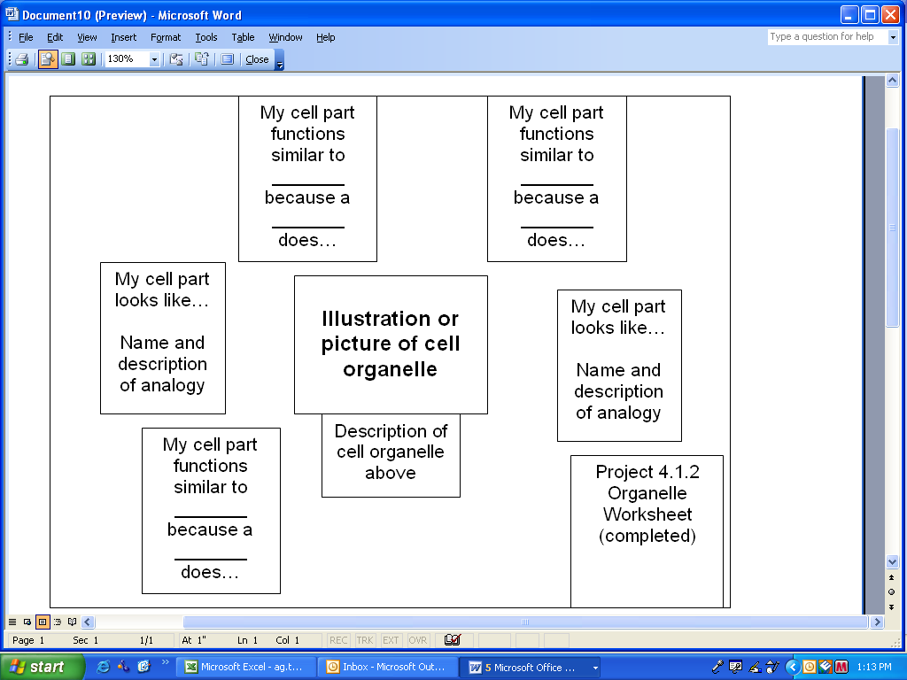
Figure 1. Poster Layout Sample

- Display your completed collage on the classroom wall in the area identified by your teacher.
- When instructed to do so, observe the collages made by your classmates. Complete Project 4.1.1 Student Worksheet as you observe the posters.

Conclusion
- How does the use of analogies help you to remember the function and anatomical features of an animal cell part?

- What is the most creative Cell Analogy poster you observed in class? Why do you think it made an impression on you?

Project 4.1.1 Student Worksheet

Cell Part | “Looks Like” Analogy | “Functions Like” Analogy
Cell Membrane
Centrosome
Cytoskeleton
Cytosol (Cytoplasm)
Endoplasmic Reticulum
Golgi
Lysosome
Mitochondria
Nucleolus
Nucleus
Peroxisome
Ribosomes
Secretory Vesicle
Vacuole

Project 4.1.1 Organelle Worksheet

Directions: Answer the following questions after you have completed developing your poster for Project 4.1.1 Cell Analogy Collage. When completed place this worksheet on your poster.

- Where is your organelle or structure located in the animal cell? Why do you believe it is located there?

- What is the function of your organelle?

- Why is the organelle important for animal cell function?

- Describe what your organelle or structure is made of.

- What would happen to the animal cell if this organelle or structure was missing?

