
Problem Using Data in Selection

Purpose
While visual selection is important in determining many qualities of an animal, tools for genetic prediction are also important in evaluation. As you learned in Lesson 7.2 Predicting Genetic Inheritance, Expected Progeny Differences (EPDs) are often utilized to predict the future performance of animals and their offspring. The combination of visual and genetic traits enables producers to improve the quality of their livestock more efficiently.

Expected Progeny Differences are often a more reliable, less subjective tool for selecting animals than visual selection. Sire summaries compare leading sires within a breed based on their EPDs. Many producers use the visual attributes of an animal combined with their EPDs to select breed pairs that should improve the quality of offspring.

Materials
Per student:
- Computer with Internet access
- Pencil
- Agriscience Notebook

Procedure
Mr. Aberdeen, a local producer, has been raising registered Black Angus cattle for over thirty years. He has noticed that in recent years his calves are smaller and growing slower than his neighbors are. Mr. Aberdeen thinks it is time to improve the quality of his herd through genetic selection.

He has purchased four heifers from a neighboring producer and has asked you to select a bull from popular sires within the industry. The four heifers he bought are numbered 8012, 8014, 8026, and 8038. Using the pictures and performance data, determine why he selected the specific females and based on the information, select a bull he should use to continue improving his livestock.

Table 1. Selected Heifers
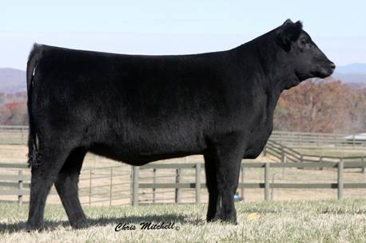 | 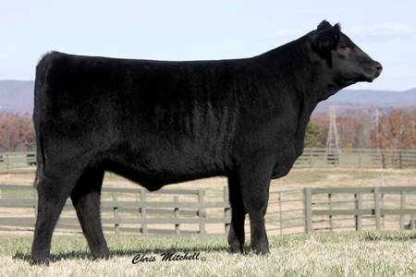
Heifer 8012 | Heifer 8014
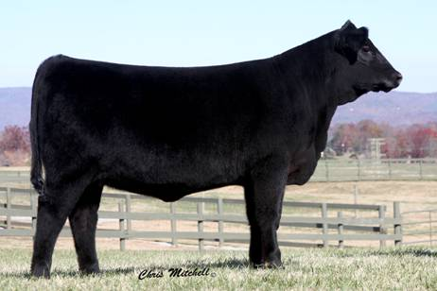 | 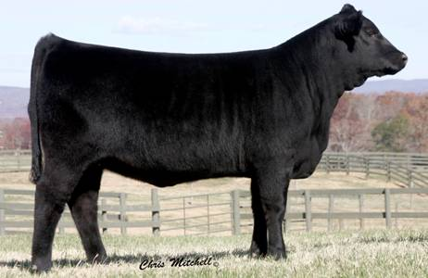
Heifer 8026 | Heifer 8038

Table 2. Performance Data
Heifer Number | BW  EPD | WW  EPD | YW  EPD | Milk  EPD | $W
8001 | -.2 | 30 | 75 | 26 | +$16.23
8002 | 1.3 | 36 | 83 | 15 | +$19.46
8012 | 2.4 | 49 | 84 | 21 | +$26.99
8014 | 1.1 | 44 | 81 | 22 | +$27.22
8025 | 5.0 | 51 | 88 | 14 | +$30.35
8026 | 2.5 | 48 | 79 | 18 | +$24.76
8035 | -1.2 | 36 | 70 | 23 | +$21.44
8038 | 1.9 | 40 | 80 | 20 | +$23.82

Mr. Aberdeen wants to find a herd sire with the same strengths as the heifers to use for artificial insemination. Using the computer, research and select two options for a herd sire for his new heifers. Sources for Angus semen include ABS Global, Genex CRI, and other private producers.

Prepare a report that answers the following two questions.
- What data did Mr. Aberdeen use to select the replacement heifers? Include what you believe to be his production goals in your response.
- What bulls would you recommend using and why?

Conclusion
- Why is understanding the breed average of EPDs important in selection?

- Why are EPDs and artificial insemination advantageous for producers?

