
Activity 9.1.4 Egg Grading Guide

Summary of U.S. Standards for Quality of Individual Shell Eggs
(based on candled appearance of eggs)
Quality Factor | Specification for Each Quality Factor
Quality Factor | AA Quality | A Quality | B Quality
Shell | Clean | Clean | Clean to slightly stained
 | Unbroken | Unbroken | Unbroken
 | Practically normal | Practically normal | Abnormal
Air cell | 1/8 inch or less in depth | 3/16 inch or less in depth | Over 3/16 inch in depth
 | Unlimited movement and free or bubbly | Unlimited movement and free or bubbly | Unlimited movement and free or bubbly
White | Clear | Clear | Weak and watery
 | Firm | Reasonably firm | Small blood and meat spots present
Yolk | Outline is slightly defined | Outline is fairly well defined | Outline is plainly visible
 | Practically free from defects | Practically free from defects | Enlarged and flattened
 |  |  | Clearly visible germ development but no blood
 |  |  | Other serious defects

Interior Quality Grade by Breakout
Grade AA | Grade A | Grade B
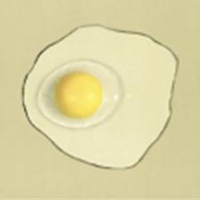 |  | 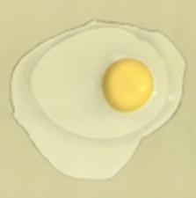
 |  | 
The yolk on a Grade AA egg is tall, round and firm, the thick albumen is thick and stands high, and the thin albumen covers a small area. | The yolk on a Grade A egg is tall and firm, the thick albumen is reasonably thick and stands fairly high, and the think albumen covers a moderate area. | The yolk in a Grade B egg is flattened and enlarged, the thick albumen is watery and can be difficult to distinguish, the thin albumen covers a wide area.

Source: United States Department of Agriculture. (2000). Egg grading manual. Agricultural Marketing Service Agricultural Handbook Number 75. Washington, D.C.: Author. Retrieved from http://www.ams.usda.gov/AMSv1.0/getfile?dDocName=STELDEV3004502

