
Activity 7.1.4 Experiment 7 White Eyed Female

Background
In this experiment, you will start with a homozygous white eyed female and a wild eyed male. Remember that sex-linked traits are carried on the X chromosome.

The wild gene for red eye color is dominant over the mutant, white gene. The symbol used for the wild gene is W and the mutant w. A heterozygous female, X^{W}X^{w}, would have the wild eye color. A male has only one chromosome containing the gene and will either be X^{W}Y or X^{w}Y.

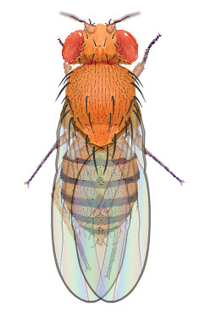 | 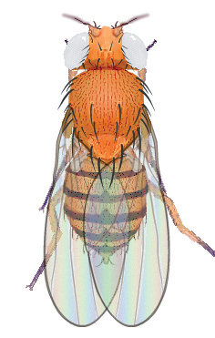 | 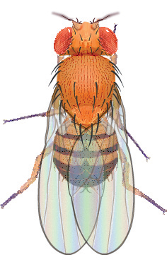 | 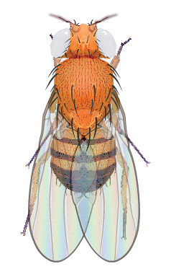
Wild Female | White Eyed Female | Wild Male | White Eyed Male

Procedures
- Open the Drosophila Genetics Lab on your computer as instructed by your teacher.
- Click on the Reset button and then Select button.
- Select Saved Parents and then Exp07.mfp.
- Drag each of the parents over to the Observation Platform and record their phenotype and genotype in question 1 of Predictions.
- Compete questions 2 and 3 of the Predictions to determine the probability of wild eyed flies and white eyed flies in this mating.
- Click the Breed button. Examine and record the phenotype of 100 offspring in Table 1.
- Complete question 1 of the Results Analysis.
- Drag one male and one female into the Hold Jar.
- Empty the Parent/Offspring area.
- Drag the held flies into the Parent jar and select Breed. This is your Hybrid, or F1, cross.
- Examine each parent from the hybrid cross and record their phenotype and genotype in question 4 of Predictions.
- Compete questions 4 – 6 of the Predictions to determine the probability of wild eyed flies and white eyed flies in this mating.
Examine and record the phenotype of 200 offspring in Table 2. Complete questions 2 and 3 of the Results Analysis.

Predictions
- Determine the information below for each of the original parents, one of which is a homozygous white eyed female and the other a wild eyed male.
Parent | Phenotype | Genotype
Female
Male

- Complete the Punnett Square for the parent cross.
Genes from the female | Genes from the male
Genes from the female | ______ | ______
______
______

- What would you expect the ratio of wild eyed flies to white eyed flies to be in the Punnett Square you just completed?
 | wild | : |  | white eyed

- Determine the information below for each of the hybrid parents in your F1 cross.
Parent | Phenotype | Genotype
Female
Male

- Complete the Punnett Square for the hybrid cross.
Genes from the female | Genes from the male
Genes from the female | ______ | ______
______
______

- What would you expect the ratio of wild eyed flies to white eyed flies to be in the Punnett Square you just completed?
 | wild female | : |  | wild male | : |  | white eyed female | : |  | white eyed male

Results Analysis
Table 1. Parent Cross Results
Parent Description
Female Phenotype |  |  | Female Genotype
Male Phenotype |  |  | Male Genotype
Wild Eyed Flies |  |  | White Eyed Flies
Female | Male |  | Female |  | Male
Total = | Total = |  | Total = |  | Total =
Total Wild Eyed Flies = |  |  | Total White Eyed Flies =
Ratio of Wild eyes : White Eyes |  |  |  | :

- How does the ratio of wild : white eyed flies observed in the parent cross experiment compare to the ratio predicted in your Punnett Square?

Table 2. Hybrid Cross Results
Hybrid Description
Female Phenotype |  |  |  |  |  | Female Genotype
Male Phenotype |  |  |  |  |  | Male Genotype
Wild Eyed Flies |  |  |  |  |  | White Eyed Flies
Female |  |  | Male |  |  | Female |  |  | Male
Total = |  |  | Total = |  |  | Total = |  |  | Total =
Total Wild Eyed Flies = |  |  |  |  |  | Total White Eyed Flies =
Ratio of Wild female : Wild male : White eyed female : White eyed male
 |  | : |  |  | : |  |  | :

- How does the ratio of wild female : wild male : white eyed female : white eyed male flies observed in the hybrid cross experiment compare to the ratio predicted in your Punnett Square?

- How many females were white eyed in this experiment? How does this differ from Experiment 6? Why?

