
Activity 7.1.3 Experiment 5 Curled Wing, Black Body

Purpose
In this experiment, you will examine the inheritance of two genes found on different chromosomes in fruit flies. The genes in this experiment are the curled wing and black body genes. Bold wild genes are dominant over the mutant genes.

The examination of two genes is referred to as a dihybrid cross. The genotype of a fruit fly that is homozygous for both wild traits will be represented as CCBB, while the genotype of a fly that is homozygous for both mutant traits is represented as ccbb.

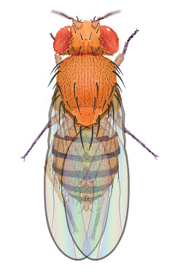 | 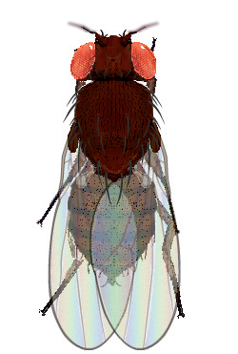 | 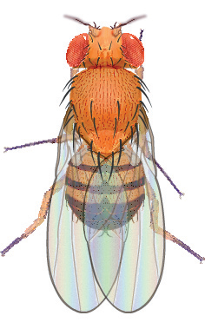 | 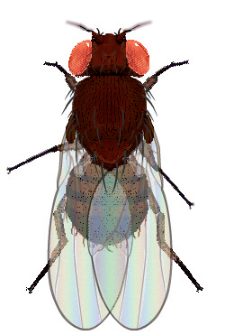
Wild Female | Black Body Female | Wild Male | Black Body Male
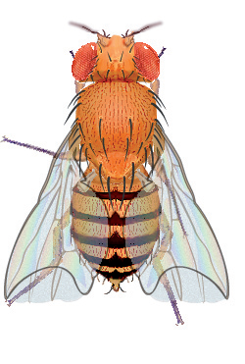 | 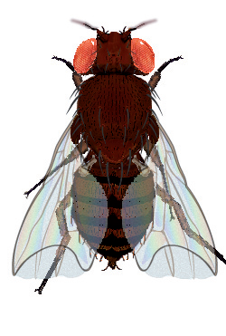 | 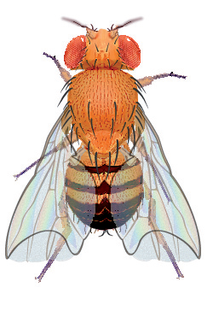 | 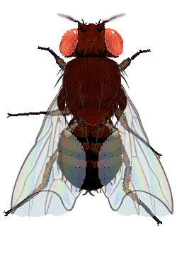
Curled Wing Female | Curled Wing and Black Body Female | Curled Wing Male | Curled Wing and Black Body Male

Procedure
- Open the Drosophila Genetics Lab on your computer as instructed by your teacher.
- Click on the Reset button and then Select button.
- Select Saved Parents and then Exp04_f.mfp or Exp04_m.mfp (f stands for female, while m stands for male).
- Drag each of the parents over to the Observation Platform and record their phenotype and genotype in question 1 of Predictions.
- Compete questions 2 and 3 of the Predictions to determine the probability of wild flies and mutant flies in this mating.
- Click the Breed button. Examine and record the phenotype of 100 offspring in Table 1.
- Complete question 1 of the Results Analysis.
- Drag one male and one female into the Hold Jar.
- Empty the Parent/Offspring area.
- Drag the held flies into the Parent jar and select Breed. This is your Hybrid, or F1, cross.
- Examine each parent from the hybrid cross and record their phenotype and genotype in question 4 of Predictions.
- Compete questions 5 – 7 of the Predictions to determine the probability of wild flies and mutant flies in this mating.
- Examine and record the phenotype of 200 offspring in Table 2. Complete questions 2 and 3 of the Results Analysis.

Predictions
- Determine the information below for each of the original parents, one of which is a homozygous wild individual and the other a homozygous mutant individual.
Parent | Phenotype | Genotype
Female
Male

- Complete the Punnett Square for the parent cross.
Genes from the female | Genes from the male
Genes from the female | ______ | ______ | _______ | ______
______
______
______
______

- What would you expect the ratio of wild flies to mutant flies to be in the Punnett Square you just completed?
 | wild | : |  | mutant

- Determine the information below for each of the hybrid parents, who are both heterozygous, in your F1 cross.
Parent | Phenotype | Genotype
Female
Male

- Complete the Punnett Square for the hybrid cross.
Genes from the female | Genes from the male
Genes from the female | ______ | ______ | _______ | ______
______
______
______
______

- What would you expect the ratio of wild : curled : black : curled and black flies to be in the Punnett Square you just completed?
 | wild | : |  | curled | : |  | black | : |  | curled & black

Results Analysis

Table 1. Parent Cross Results
Parent Description
Female Genotype |  |  |  |  |  | Male Genotype
Female Phenotype |  |  |  |  |  | Male Phenotype
Wild Flies |  |  | Curled Wing Flies |  |  | Black Bodied Flies |  |  | Curled Wing & Black Bodied
Female | Male |  | Female |  | Male | Female | Male |  | Female |  | Male
Total = |  |  | Total = |  |  | Total = |  |  | Total =
Ratio of Wild : Mutant |  |  |  |  |  |  |  | :

- How does the ratio of wild : mutant flies observed in the parent cross experiment compare to the ratio predicted in your Punnett Square?

Table 2. Hybrid Cross Results
Parent Description
Female Genotype |  |  |  |  |  |  |  |  | Male Genotype
Female Phenotype |  |  |  |  |  |  |  |  | Male Phenotype
Wild Flies |  |  |  |  | Curled Wing Flies |  |  |  | Black Bodied Flies |  |  |  | Curled Wing & Black Bodied
Female |  | Male |  |  | Female |  | Male |  | Female |  | Male |  | Female |  |  | Male
Total = |  |  |  |  | Total = |  |  |  | Total = |  |  |  | Total =
Ratio of Wild : Curled : Black : Curled & Black
 |  |  |  | : |  |  |  | : |  |  |  | :

- How does the ratio of flies observed in the hybrid cross experiment compare to the ratio predicted in your Punnett Square?

- Why might there be differences in the observed and predicted phenotypic ratios?

