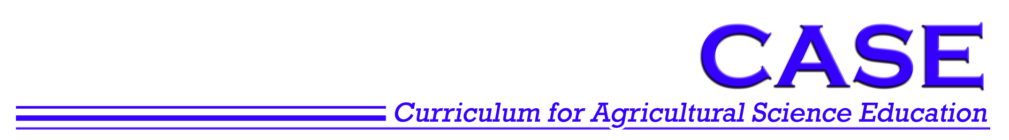
Activity 7.1.3 Experiment 1 Vestigial Wings

Background
In this experiment, you will examine the inheritance of a single gene that governs wing shape in Drosophila melanogaster fruit flies. The gene is found on the second chromosome of the fruit fly and normally results in the fly having wild flat wing shape. However, a mutant allele has been found that causes the wing to become twisted and useless. This wing shape is called vestigial and the recessive allele causing the change in shape is called the vestigial wing allele.

A heterozygous fly possesses an allele for the wild wing shape and an allele for vestigial wing shape. As the wild wing shape is dominant, a heterozygous fly will possess a wild wing phenotype. The symbol used for the wild allele is V and the mutant allele is v.

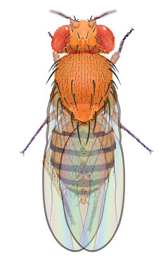 | 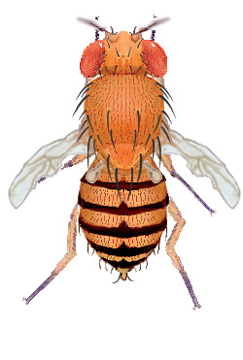 | 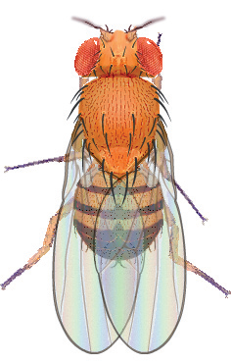 | 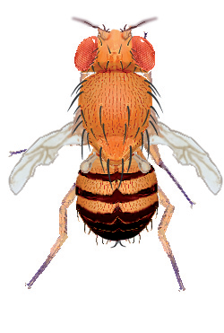
Wild Female | Vestigial Wing Female | Wild Male | Vestigial Wing Male

Procedure
- Open the Drosophila Genetics Lab on your computer as instructed by your teacher.
- Click on the Reset button and then Select button.
- Select Saved Parents and then Exp01_f.mfp or Exp01_m.mfp (f stands for female, while m stands for male).
- Drag each of the parents over to the Observation Platform and record their phenotype and genotype in question 1 of the Predictions.
- Compete questions 2 and 3 of the Predictions to determine the probability of wild wing flies and vestigial wing flies in this mating.
- Click the Breed button. Examine and record the phenotype of 100 offspring in Table 1.
- Drag one male and one female into the Hold Jar.
- Empty the Parent/Offspring area.
- Drag the held flies into the Parent jar and select Breed. This is your Hybrid, or F1, cross.
- Examine each parent from the hybrid cross and record their phenotype and genotype in question 4 of Predictions.
- Compete questions 5 – 7 of the Predictions to determine the probability of wild wing flies and vestigial wing flies in this mating.
- Examine and record the phenotype of 200 offspring in Table 2.

Predictions
- Determine the information below for each of the original parents, one of which is a homozygous wild winged individual and the other a homozygous vestigial winged individual.
Parent | Phenotype | Genotype
Female
Male

- Complete the Punnett Square for the parent cross.
Genes from the female | Genes from the male
Genes from the female | ______ | ______
______
______

- What would you expect the ratio of wild wing flies to vestigial wing flies to be in the Punnett Square you just completed?
 | wild | : |  | vestigial

- Determine the information below for each of the hybrid parents, who are both heterozygous, in your F1 cross.
Parent | Phenotype | Genotype
Female
Male

- Complete the Punnett Square for the hybrid cross.
Genes from the female | Genes from the male
Genes from the female | ______ | ______
______
______

- What would you expect the ratio of wild wing flies to vestigial wing flies to be in the Punnett Square you just completed?
 | wild | : |  | vestigial

- What are the expected ratios of genotypes in this cross? (VV : Vv : vv)
 | : |  | :

Results Analysis
Table 1. Parent Cross Results
Parent Description
Female Genotype |  | Male Genotype
Female Phenotype |  | Male Phenotype
Wild Wing Flies |  | Vestigial Wing Flies
Female | Male | Female | Male
Total = | Total = | Total = | Total =
Total Wild Wing Flies = |  | Total Vestigial Wing Flies =
Ratio of Wild wings: Vestigial Wings |  |  | :

- How does the ratio of wild : vestigial winged flies observed in the parent cross experiment compare to the ratio predicted in your Punnett Square?

Table 2. Hybrid Cross Results
Hybrid Description
Female Genotype |  | Male Genotype
Female Phenotype |  | Male Phenotype
Wild Wing Flies |  |  | Vestigial Wing Flies
Female | Male |  | Female |  | Male
Total = | Total = |  | Total = |  | Total =
Total Wild Wing Flies = |  |  | Total Vestigial Wing Flies =
Ratio of Wild wings: Vestigial Wings |  |  | :

- How does the ratio of wild : vestigial winged flies observed in the hybrid cross experiment compare to the ratio predicted in your Punnett Square?

- Why might there be differences in the observed and predicted phenotypic ratios?

