
Activity 5.5.4 A Balanced Diet

Purpose
While the Pearson Square is useful to develop a ration of two feedstuffs balanced for one nutrient, frequently rations must be balanced for multiple nutrients and often use three or more feedstuffs. There are ration formulation methods that are completed by hand to develop rations that are more complex, but there are also computer programs that do much of the work for you.

Determining when to use the Pearson Square method versus a computer program is influenced by the cost of the service and if it saves an animal producer time and money. Do you need the same information to formulate a ration using a computer based program as you do using the Pearson Square?

Materials
Per student:
- Computer with spreadsheet software
- Activity 5.5.4 A Balanced Diet Spreadsheet
- Calculator
- Pencil
- Agriscience Notebook

Procedure
In this activity, you will use the Pearson Square method of ration formulation to balance a ration. You will check that ration with a computer-based program to determine if it meets the needs of the animal for all nutrient categories. Then you will familiarize yourself with the use of a computer ration-balancing program by developing two additional rations.

Part One – Balancing a Ration by Hand
You have a Columbia ewe that weighs 80kg. Formulate a maintenance ration using oat hay and corn. Be careful to use the correct units of measurement in your calculations.

Step 1 | Nutrient requirements of the ewe
 |  | DM |  | TDN |  | CP |  | Ca |  | Calculate the percent of each nutrient on a dry matter basis.  $$\left(\frac{kg nutrient}{kg DM}\right)100$$
 | kg/day | 1.3 |  | .72 |  | 0.122 |  | 2.7g
% of ration |  | 100

Step 2 | Feed composition
 |  | DM  (%) |  | TDN  (%) |  | CP  (%) |  | Ca  (%) |  | All quantities come from the NRC Feed Composition Tables.
 | Oat hay | 91 |  | 53 |  | 9.3 |  | .24 |  | All quantities come from the NRC Feed Composition Tables.
 | Corn | 88 |  | 87 |  | 10.1 |  | 0.02 |  | All quantities come from the NRC Feed Composition Tables.

Step 3 | Pearson Square - Balance for protein (CP)
 |  |  |  |  |  |  | Use the information from the chart above for the crude protein values. You calculated the % CP in the ration in Step 1.
Oat hay
 |  | %CP
Corn
 |  | %CP | Total Parts

Step 4 | Percentage of feedstuffs in ration
(______ parts oat hay / ______total parts) * 100 |  | = _______% oat hay
(______ parts corn / ______total parts) * 100 |  | = _______% corn

Step 5 | Kilograms of feedstuff per day
NOTE: Convert percentages to decimals before calculating.
______(% oat hay) |  |  | * |  | = |  | (kg) oat hay/day
______(% corn) |  |  | * |  | = |  | (kg) corn/day
 |  |  |  | kg DM |  |  | (kg) Total Ration (DM)/day

Step 6 | Check adequacy of nutrients in the ration. Show answers to 3 decimal places.
 | Protein:
 | Oat hay (kg) |  | * | %CP | = |  | kg CP
 | Corn (kg) |  | * | %CP | = |  | kg CP
 |  |  |  | Total: |  |  | kg of CP/day
 | Calcium:
 | Oat hay (kg) |  | * | %Ca | = |  | kg Ca
 | Corn (kg) |  | * | %Ca | = |  | kg Ca
 |  |  |  | Total: |  |  | kg of Ca/day
 | TDN:
 | Oat hay (kg) |  | * | %TDN | = |  | kg TDN
 | Corn (kg) |  | * | %TDN | = |  | kg TDN
 |  |  |  | Total: |  |  | kg of TDN/day

Step 7 | Compare the needs to the Nutrients in the ration.
 |  | DM | TDN | CP | Ca
1. Nutrient requirements for a 80 kg ewe (kg/day): |  | ____ | ____ | ____ | ____
2. Nutrients in ration (kg/day): |  | ____ | ____ | ____ | ____
Balance (Line 2 – Line 1): |  | ____ | ____ | ____ | ____
Is there an excess, deficiency, or neither? |  | ____ | ____ | ____ | ____

Step 8 | Convert to As-fed
 | Oat hay:
 | Corn:

Part Two – Using a Ration Balancing Program
Often if more than one nutrient is of concern, or if more than two feedstuffs are needed, animal producers will use computer programs to balance a ration. The Pearson Square is still useful as it helps determine the quantity of the two main feedstuffs that will be used to meet a specific requirement.

- Open Activity 5.5.4 – A Balanced Diet Spreadsheet. You should see the following screen.
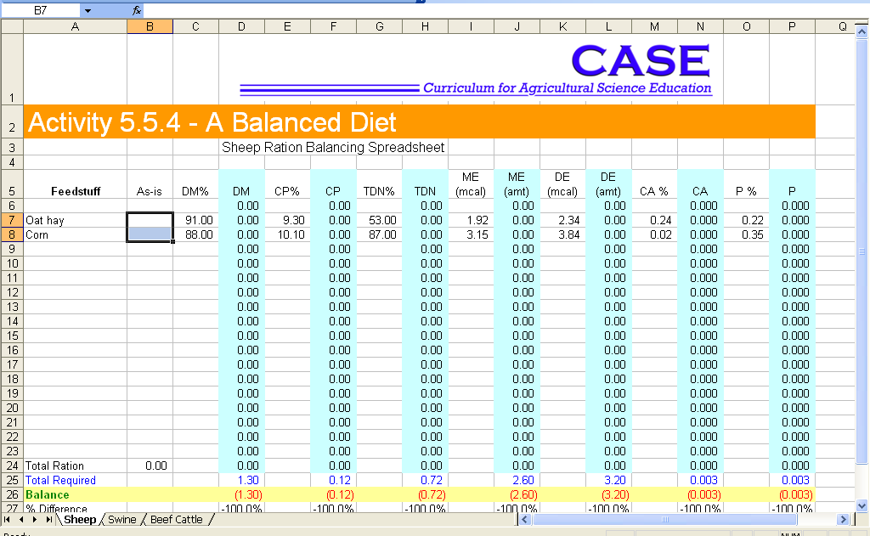

- Observe lines 7 and 8. The feeds you used in Part One have been inserted for you. Notice there are more categories of nutritional needs in the spreadsheet than you solved for by hand. You will need to input the nutrient values from the feed composition tables in Table 48 from the appendix of the Modern Livestock and Poultry Production textbook.
- Observe line 25 on the spreadsheet. This line represents the needs of the Columbia ewe from Part One. This information comes from Table 7 of the appendix found in the textbook.
- Line 26 shows the difference between the nutrients in the feeds provided and the needs of the ewe. In an ideal situation, all columns would equal 0.
- Hint: Green lettering means you are meeting or exceeding the needs of the animal. Red lettering means your ration is deficient in a nutrient.
- You may never get a perfectly balanced ration for all nutrients. The goal is to as close or as “balanced” as possible.

- Input the amount of oat hay and corn you determined the ewe needs in Step 8 in the As-is column.
- Save the file with your initials following the original title. Do not close the program.
- How do your results from using the Pearson Square method compare to the computer results?

- If you had not done the Pearson Square, how would you have determined the quantity of each feed to use?

Part Three – Developing a Ration
You are feeding out several crossbred market hogs that weigh approximately 15kg. You have always fed a corn and soybean meal mix that your pigs grow well on. However, the price of soybeans is outrageous. You have discovered several alternative feedstuffs, but are not sure if you can balance a ration using them.

- On the bottom of the spreadsheet, click on the Swine tab.
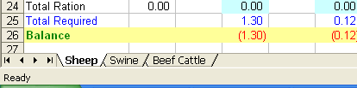

- You should see your current ration with several feed choices not in use.
- Place a 0 in the Amt column for soybeans. Use the remaining feedstuffs to balance a ration for your hogs.
- Parameters:
- Total amount of feed must be within 4% of the requirement.
- Total CP less than 1% over, but not under the requirement.
- Energy may be up to 2% over, but not under the requirement.
- Save the file again.
- Print the swine ration for your teacher.
- What problems did you encounter trying to balance without soybean meal?

- If you have deficiencies, how could you resolve them?

- Balance a ration for a 450kg cow nursing a calf. Find her nutritional needs on Table 4 of the appendix of your textbook and input into the Total Required row on the Beef Cattle worksheet. There are several feeds already in the worksheet, you may use those or add others from the Feed Composition Tables. You must find current market prices for any feeds you use.
- Parameters
- Total amount of feed, CP, and energy must be within 1% of the requirement.
- Energy may be over, but not under the requirement.
- Micronutrients must be within 2% the requirement.
- Save your work and print a copy of your ration to submit to your teacher.
- Which feeds did you choose and why?

- How much does it cost you to feed your cow each day?

Conclusion
- Based on your experiences, what are two advantages to using the computer ration spreadsheet over the Pearson Square?

- List three factors you should consider when selecting feedstuffs for a ration and describe why each is important.

- List the five steps used in balancing a ration.

