
Activity 4.3.1 Show What I Know

Purpose
As you discovered in the dissection activities in Lesson 4.2 Putting the Puzzle Together, there are many systems, parts, and functions within an animal’s body. While you primarily studied anatomy or the parts in that lesson, the physiology of those parts is also essential in your quest to become an animal scientist. Physiology is the study of the function of plant and animal bodies, systems, organs, tissues, and cells.

The respiratory and circulatory systems are closely related in their functions in a body. These systems are essential to animal life. The respiratory system exchanges oxygen from the air with carbon dioxide, the product of respiration, to maintain a balance in the body. The circulatory system uses blood to serve as a carrier of oxygen (O₂) and carbon dioxide (CO₂) from cells to the lungs. How well do you know the respiratory and circulatory systems?

Materials
Per student:
- 2 colored pencils
- Pencil
- Agriscience Notebook

Procedure
This activity reviews the anatomy of the respiratory and circulatory systems and defines the major functions of each part in preparation for a more in depth study of these systems.

Part One – What I Know
- Using one of the colored pencils provided, label the diagrams on Activity 4.3.1 Student Worksheet and describe the function of each to the best of your ability.
- Use the color key to identify how you use each color for future reference in this activity.

Color Key
What I Know
Additions and Corrections

Parts of the Circulatory and Respiratory Systems
Alveoli | Lung
Aorta | Nasal Cavity
Artery | Nose/Mouth
Bronchiole | Pharynx
Bronchus (bronchi) | Right atrium
Capillary | Right ventricle
Larynx | Trachea
Left atrium | Vein
Left ventricle | Vena cava

Part Two – What I Need to Learn
Your teacher will now present Respiratory and Circulatory Anatomy. Take notes of the presentation as your teacher discusses the functions of organs in the respiratory and circulatory systems. Use the slides to check your work and correct mistakes. Make any necessary corrections or additions to your diagrams with the second colored pencil.

Conclusion
- How has dissecting these systems helped in your understanding of their functions?

- What is the main function for which the respiratory and circulatory systems rely on each other?

Activity 4.3.1 Student Worksheet

Table 1. The Respiratory System
Diagrams | Part | Function
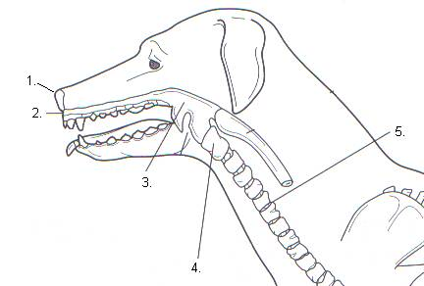
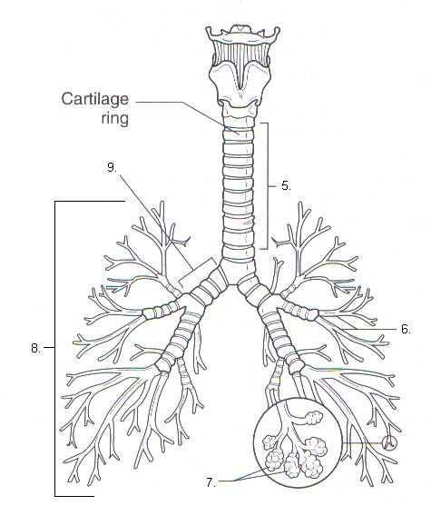

Table 2. The Circulatory System
Diagram | Part | Function
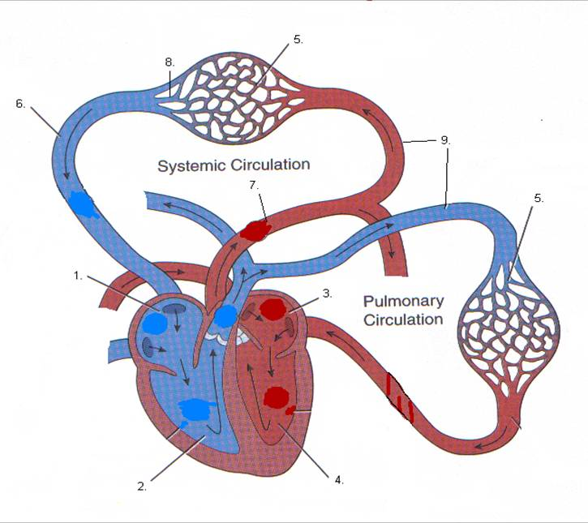

Sources:
Lawhead, J., & Baker, M. (2005). Introduction to veterinary science. Clifton Park, NY: Delmar.
Romich, J.A. (2006). An illustrated guide to veterinary medical terminology (2nd ed.). Clifton Park, NY: Thompson Delmar Learning.

