
Activity 4.1.5 Just Passing Through

Purpose
Have you ever wondered why your fingers shrivel in bath water? Although your fingers have become “prunes”, you have actually experienced osmosis or the diffusion of water through your skin cells.

The uptake of water and dissolved nutrients are cellular processes called diffusion and osmosis. Molecules are selectively allowed to pass through membranes. For molecules to pass through the membrane, they must be small and of differing concentrations. The result is diffusion of substances between the solutions on each side of the membrane until the concentration of substances is equal. When the concentration of water on either side of the cell membrane is unequal, osmosis or the passing of water through the membrane occurs.

Although many molecules pass through the cell membrane, you are going to investigate sugar molecules. One test for the presence of sugars is a glucose test strip. Scientists insert a test strip into a substance then observe the reaction area of the strip for color changes. In the presence of glucose, the reaction area will turn a green color. Sugars can be found in more complex forms called starch. An indicator for the presence of starch is Lugol’s solution, which turns blue/black in color in the presence of starch. Will sugar molecules move across a membrane through osmosis and/or diffusion?

Materials
Per class:  - Lugol’s solution (iodine)  - Corn syrup  - Liquid starch  - Warm water | Per student:  - Pencil  - Agriscience Notebook
Per pair of students:  - Dialysis tubing  - 2 glucose testing strips  - 2 16oz plastic cups  - Ring stand  - Dialysis tubing closure  - Parafilm  - Pipette  - Syringe | - 20cm piece of vinyl tubing  - Plastic tubing clamp  - LabQuest2  - Vernier gas pressure sensor  - Vernier temperature sensor  - Permanent marker  - Stopwatch  - Ring stand clamp

Procedure
You and your partner will monitor the diffusion and osmosis of substances through a semi-permeable membrane. This is similar to the process cells use to transfer material through a cell membrane. Follow the procedures below and record necessary evidence of diffusion and osmosis.

Part One – Setting Up the Experiment
- Construct the ring stand system according to Figure 1. Attach the gas pressure sensor to the ring stand and connect the vinyl tubing. Set this system aside until later.
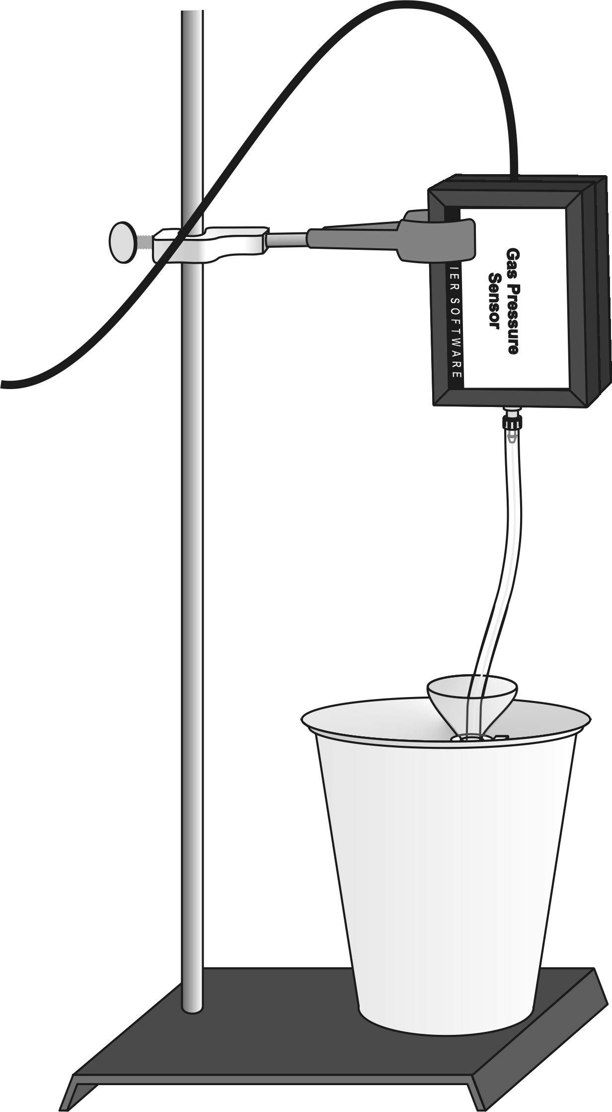
Figure 1. Ring Stand Set Up.

- Fill two plastic cups ¾ of the way full with water that is 37°C.
- To ensure no glucose is present in the water prior to the experiment, use one glucose test strip and test the water in both cups. Record your observations in Table 1 of Activity 4.1.5 Student Worksheet.
- Be careful not to touch the reaction area of the test strip.
- Add 2ml of Lugol’s solution to the water in each cup and mix by carefully swirling the cup. Record your observations in Table 1.
- Test the water in the cups again for the presence of glucose. The same test strip may be used.
- Answer the discussion questions in Table 1 of Activity 4.1.5 Student Worksheet.
- Obtain a piece of dialysis tubing. Rub the end of the tubing between your fingers to find the opening.
- Fold over one end of the dialysis tubing and fasten a dialysis tubing closure over the folded end according to Figure 2.
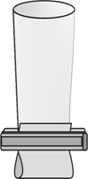
Figure 2. Tubing Closure.

- Use the pipette to add 3ml of glucose solution and 6ml of starch solution into the tubing.
- Be very careful not to spill the solutions down the outside of the tubing. If you do, hold the tubing closed with your fingers and place it under running water in the sink to wash off all solution. Why is this important?
- While holding the top opening closed with your fingers, carefully swirl the tubing and invert it a couple of times to mix the solutions inside the tubing.
- Slide the plastic tubing clamp onto the plastic tubing connected to the gas pressure sensor.
- Insert the free end of the vinyl tubing attached to the sensor into the dialysis tubing being careful not to get the vinyl tubing into the solution.
- Collapse the dialysis tubing around the end of the vinyl tubing and wrap the dialysis tubing tightly around the plastic tubing.
- Slide the clamp over the end of the wrapped dialysis tubing and fasten the clamp very snugly around the tubing (See Figure 3).
- Be sure not to pinch off the vinyl tubing.
- Be sure there is an air gap of approximately 1cm between the vinyl tubing and the solution.
- Leave minimal air space above the liquid.
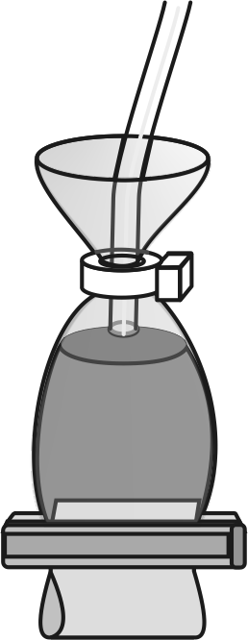
Figure 3. Tubing With Cable Tie.

- Wrap parafilm around the connection to provide extra sealing ability to avoid pressure loss inside the dialysis tubing.

Part Two – Collecting LabQuest2 Data
- Place the filled dialysis tube into one of the cups of 37°C water and Lugol’s solution. Check that the dialysis tubing is completely submerged and without kinks.
- Use a permanent marker and mark the water level of the cup and the solution level inside the tube on the outside of the cup.
- Using the stopwatch, wait five minutes.
- One partner should observe changes occurring in the tubing and the cup during the five minutes. The other partner should connect the sensor to the LabQuest2, and turn on the LabQuest2 device.
- Choose “New” from the “File” menu across the top.
- On the Meter screen, select “Rate”. Change the data collection rate to 0.1 samples/second and the data collection length to 1800 seconds.
- When five minutes have elapsed, start data collection with the LabQuest2.

Part Three – Collecting and Analyzing Qualitative Data
- While LabQuest2 data is being collected, record your observations in Table 1 on Activity 4.1.5 Student Worksheet concerning the liquids inside the dialysis tube and inside the cup. Use your control cup to compare color changes. Note any volume changes.
- Use a glucose test strip and test the cup water for the presence of glucose.
- When LabQuest2 data collection has been completed, tap the “Stop” button. A graph of pressure versus time will be available.

- Read the graph provided by LabQuest2 to record your findings for pressure in Table 2 on Activity 4.1.5 Student Worksheet.

Clean up and put away all equipment and supplies according to your teacher’s directions.

Conclusion
- Describe how the processes of diffusion and osmosis were demonstrated in this lab. List the substances that moved between the cup solution and the dialysis tubing solution. Explain why some substances were able to pass through the membrane while others were not.

- What evidence do you have to support the answer regarding movement of substances through the membrane for Conclusion question number one? Provide specific evidence.

- Did the “cell membrane” demonstrate an isotonic, hypotonic, or hypertonic osmotic response? Describe how you can observe this.

- If substances were free to pass through the membrane, why did the pressure increase inside the dialysis tubing?

Source: Lab-Aids Incorporated. (2000). Osmosis and diffusion kit [Brochure]. Ronkonkoma, NY.
Source: Redding, K., & Masterman, D. (2007). Biology with vernier. Beaverton, OR: Vernier Software & Technology.
Activity 4.1.5 Student Worksheet

Table 1. Qualitative Data
Test | Initial Observation | Post-Trial Observation
Glucose (in tap water) |  | NA – Control purposes only
Starch (in tap water) |  | NA – Control purposes only
Glucose (in water-iodine solution)
Color (inside cup)
Color (inside dialysis tube)
Volume (inside cup) | NA – Made a mark only
Volume (inside dialysis tubing) | NA – Made a mark only
Discussion Questions
- What is the purpose of the second test for glucose in the cups?

- Only one of the cups you prepared will be used in the activity. What is the purpose of the second cup?

Discussion of Your Findings

Table 2. Osmotic Pressure
Beginning Pressure | kPa
Ending Pressure | kPa
Pressure Change | kPa

Why do you suspect there was a change in pressure?

