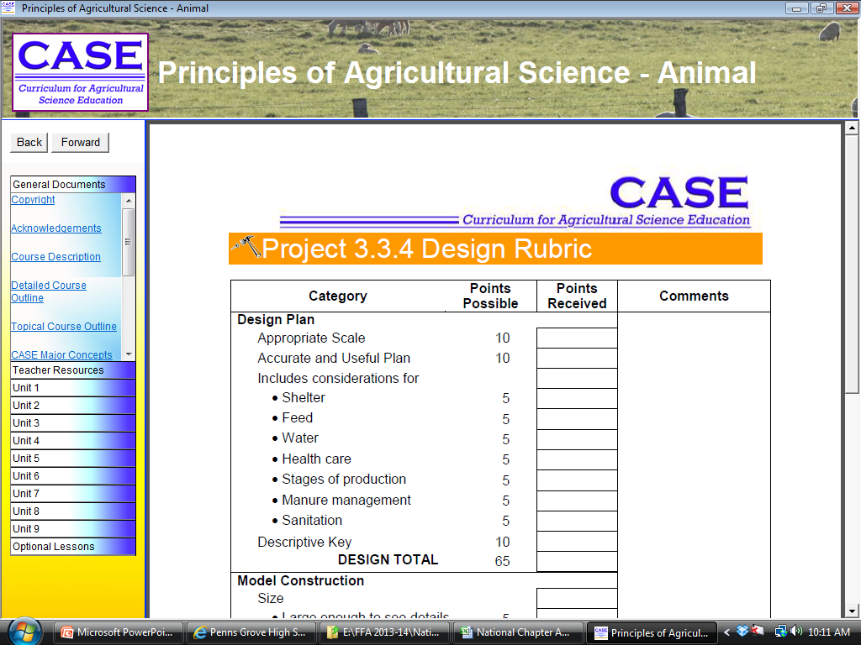
Name: ____________________________
Facility Designed for: _____________________
Name: ____________________________
Facility Designed for: _____________________

