Normal Adult Heart
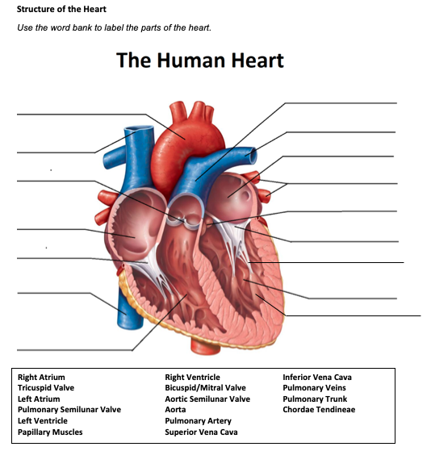
- Label the structures of the heart:

Pulmonary trunk
Aorta
Pulmonary artery
Left atrium
Superior vena
Pulmonary veins
Pulmonary semilunar valve
Aortic semilunar valve
Right atrium
Bicuspid/mitral valve
Tricuspid valve
Chordae tendineae
Left ventricle
Inferior vena cava
Papillary muscles
Right ventricle

- Write the blood flow through the heart:
Inferior/superior vena cava, right atrium, tricuspid valve, right ventricle, pulmonary valve, pulmonary artery, lungs, pulmonary veins, left atrium, mitral valve, left ventricle, aortic valve, aorta, and then to the tissues of the body.

Obstructive Defect Questions
- What does obstructive mean?
The narrowing of the blood vessel exiting the heart.

- Where is the defect with an atrial septal defect? (Between which two structures?)
Right and left atrium

- Where is the defect with a ventricular septal defect? (Between which two structures?)
Right and left ventricle

- In fetal circulation, what is the ductus arteriosus? What is its purpose?
It serves as a shunt between the pulmonary artery and the aorta. It sends oxygen poor blood to the organs in the lower half of the fetal body.

- What does the term coarctation mean?
This is when the aorta is narrower than usual.

- What does the term stenosis mean?
Narrowing of the aortic valve.

- If there is an issue with the aorta or aortic valve being narrow, which ventricle would have to work harder? Where would blood back up?
The left ventricle would have to pump harder to get the blood into the aorta. The blood will flow back up into the left atrium and then to the lungs.

- If there is an issue with the pulmonic valve being narrow, which ventricle would have to work harder? Where would blood back up?
The right ventricle will have to pump harder. The blood will flow back to the right atrium.

Cyanotic Defects
- If blood cannot get to the lungs, what happens?
Hypoxia can occur.

- What does the prefix “Tetra-” mean?
It means 4

- What are the defects associated with Tetralogy of Fallot?
Pulmonary stenosis, right ventricular hypertrophy, overriding aorta, ventricular septal defect

- What does atresia mean?
A body part that is tubular in nature does not have a normal opening or lacks the ability to allow material to pass through it.

- How would you describe tricuspid atresia to a parent of a small child?
Your heart has 2 sides, the right and left side. Tricuspid atresia occurs in the right not allowing blood to travel there.
Mixed Defects
- If a baby has transposition of the great vessels, the aorta is abnormally attached to the right ventricle, and the pulmonary artery is abnormally attached to the left ventricle.

- If the pulmonary veins do not attach to the left atrium, what type of defect would be helpful in allowing blood to get into the left atrium?

Total anomalous pulmonary venous return

- What is the large base of a tree called before it reaches the branches?
Trunk

- What does hypoplastic mean?
Is the underdevelopment/incomplete development of tissue/organ.

Medication Questions
- What is an adult cardiac medication we can give to increase the heart contractility, decrease heart rate, and increase cardiac output?
The medication is digoxin.

- What electrolyte makes the previous medication work more effectively, easily leading to toxicity?
The electrolyte is potassium.

- What does an ACE Inhibitor do? (Hint, there are multiple things!)
ACE inhibitors block vasoconstriction and promotes vasodilation. It also decrease pulmonary and SVR, and blocks aldosterone secretion (decreases fluid retention)

- What electrolyte do you need to check before administering Furosemide?
The electrolyte that needs to be assessed is potassium and sodium.

- What electrolyte do you need to check before administering Aldactone?
The electrolyte that needs to be assessed is potassium.

