Normal Adult Heart
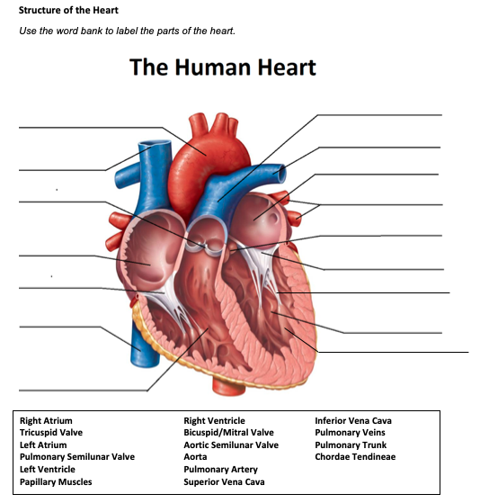
- Label the structures of the heart:

Pulmonary Trunk
Aorta
Pulmonary Artery
Superior VC
L Atrium
Pulmonary veins
Aortic Valve
Aortic semilunar
Mitral
R Atrium
Chordae Tendineae
Tricuspid
L Ventricle
Inferior VC

Papillary Muscle
R ventricle

- Write the blood flow through the heart:
Blood enters the right atrium from the inferior and superior vena cava. Passes through the tricuspid and enters right ventricle. Then is sent though the pulmonic valve to the pulmonary arteries where it enters the lungs to exchange CO2 and O2. Once oxygenated, blood passes into the pulmonary veins and enters the left atrium. Then passes through the mitral valve into the left ventricle. From there it is squeezed through the aortic vale into the aorta and is sent though systemic circulation.
Obstructive Defect Questions
- What does obstructive mean?
Narrowing of a blood vessel exiting the heart

- Where is the defect with an atrial septal defect? (Between which two structures?)
Between the right and left atria

- Where is the defect with a ventricular septal defect? (Between which two structures?)
Right and left ventricles

- In fetal circulation, what is the ductus arteriosus? What is its purpose?
It connects the pulmonary artery and the aorta and helps shunt blood away from the lungs while in utero.

- What does the term coarctation mean?
Localized narrowing of the aorta near the insertion point of the ductus

- What does the term stenosis mean?
Narrowing or stiffening of a valve

- If there is an issue with the aorta or aortic valve being narrow, which ventricle would have to work harder? Where would blood back up?
Left ventricle because of the back up of blood. This could push fluid into the lungs.

- If there is an issue with the pulmonic valve being narrow, which ventricle would have to work harder? Where would blood back up?
Right ventricle because it would be harder to pump blood to the lungs

Cyanotic Defects
- If blood cannot get to the lungs, what happens?
Hypoxia and heart failure

- What does the prefix “Tetra-” mean?
four

- What are the defects associated with Tetralogy of Fallot?
Mild cyanosis that progresses as pulmonary stenosis worsens
Acutely cyanotic at birth
Murmur
Aute episodes of hypoxia and/or cyanosis

- What does atresia mean?
An orifice or passage into the body is closed or absent

- How would you describe tricuspid atresia to a parent of a small child?
In this defect, the tricuspid valve did not form and prevents blood flow through the heart
Mixed Defects
- If a baby has transposition of the great vessels, the aorta is abnormally attached to the __Right_ ventricle, and the pulmonary artery is abnormally attached to the ___Left___ ventricle.

- If the pulmonary veins do not attach to the left atrium, what type of defect would be helpful in allowing blood to get into the left atrium?
TAPVC arises from failure of the left atrium to link with pulmonary venous plexus

- What is the large base of a tree called before it reaches the branches?
Trunk

- What does hypoplastic mean?
Lack of cell growth

Medication Questions
- What is an adult cardiac medication we can give to increase the heart contractility, decrease heart rate, and increase cardiac output?
Dig

- What electrolyte makes the previous medication work more effectively, easily leading to toxicity?
Potassium

- What does an ACE Inhibitor do? (Hint, there are multiple things!)
Promotes vasodilation, decreases systemic vascular resistance, decrease fluid retention

- What electrolyte do you need to check before administering Furosemide?
Potassium

- What electrolyte do you need to check before administering Aldactone?
Potassium

