Normal Adult Heart
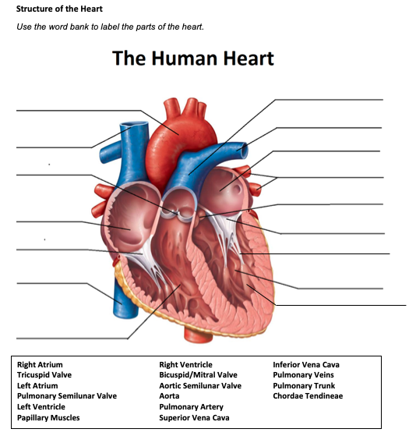
- Label the structures of the heart:

Pulmonary trunk
Pulmonary artery Left atrium
Pulmonary vein

Aortic Valve
Mitral valve
Chordae tendineae
Papillary muscles
Left ventricle

Aorta

Superior vena cava
Pulmonic valve

Right atrium
Tricuspid valve
Inferior vena cava

Right ventricle

- Write the blood flow through the heart:
Blood comes into the right atrium from the body, moves into the right ventricle and is pushed into the pulmonary arteries in the lungs. After picking up oxygen, the blood travels back to the heart through the pulmonary veins into the left atrium, to the left ventricle and out to the body's tissues through the aorta.
Obstructive Defect Questions
- What does obstructive mean?
interrupting, hindering, or opposing the progress or course of some process

- Where is the defect with an atrial septal defect? (Between which two structures?)
An atrial septal defect is a birth defect of the heart in which there is a hole in the wall (septum) that divides the upper chambers (atria) of the heart.

- Where is the defect with a ventricular septal defect? (Between which two structures?)
A ventricular septal defect is a birth defect of the heart in which there is a hole in the septum that separates the two lower ventricles of the heart.

- In fetal circulation, what is the ductus arteriosus? What is its purpose?
the ductus arteriosus serves as a shunt between the pulmonary artery and the aorta

- What does the term coarctation mean?
a birth defect in which a part of the aorta, the tube that carries oxygen-rich blood to the body, is narrower than usual

- What does the term stenosis mean?
a narrowing or constriction of the diameter of a bodily passage or orifice

- If there is an issue with the aorta or aortic valve being narrow, which ventricle would have to work harder? Where would blood back up?
As the aortic valve narrows, the left ventricle has to work harder to pump blood out through the valve. Back up into the left ventricle

- If there is an issue with the pulmonic valve being narrow, which ventricle would have to work harder? Where would blood back up?
Due to the slowed blood flow into the valve, the right ventricle is forced to work harder to pump blood to the lungs successfully. It will back up into the right ventricle

Cyanotic Defects
- If blood cannot get to the lungs, what happens?
Hypoxia is low levels of oxygen in your body tissues. It causes symptoms like confusion, restlessness, difficulty breathing, rapid heart rate, and bluish skin.

- What does the prefix “Tetra-” mean?
Having 4

- What are the defects associated with Tetralogy of Fallot?
Tetralogy of Fallot is a congenital anomaly resulting in pulmonary stenosis, an interventricular defect, biventricular aortal origin, and right ventricular hypertrophy.

- What does atresia mean?
Atresia is a medical term that means that a body part that is tubular in nature does not have a normal opening, or lacks the ability to allow material to pass through it.

- How would you describe tricuspid atresia to a parent of a small child?
Tricuspid atresia is a birth defect of the heart where the valve that controls blood flow from the right upper chamber of the heart to the right lower chamber of the heart doesn't form at all
Mixed Defects
- If a baby has transposition of the great vessels, the aorta is abnormally attached to the _right________ ventricle, and the pulmonary artery is abnormally attached to the __left_________ ventricle.

- If the pulmonary veins do not attach to the left atrium, what type of defect would be helpful in allowing blood to get into the left atrium?
TAPVR

- What is the large base of a tree called before it reaches the branches?
Trunk

- What does hypoplastic mean?
a condition of arrested development in which an organ or part remains below the normal size or in an immature state.

Medication Questions
- What is an adult cardiac medication we can give to increase the heart contractility, decrease heart rate, and increase cardiac output?
Inotropic agents such as milrinone, digoxin, dopamine, and dobutamine

- What electrolyte makes the previous medication work more effectively, easily leading to toxicity?
Electrolyte disturbances such as hypomagnesemia, hypercalcemia, and hypokalemia lead to increased sensitivity

- What does an ACE Inhibitor do? (Hint, there are multiple things!)
Decrease BP
Tx. Of acute MI
Heart failure
Diabetic nephropathy
- What electrolyte do you need to check before administering Furosemide?
potassium, sodium, and magnesium

- What electrolyte do you need to check before administering Aldactone?
serum potassium levels because mild hyperkalemia. If hyperkalemia is present, ALDACTONE should be discontinued immediately.

