Normal Adult Heart
- Label the structures of the heart:
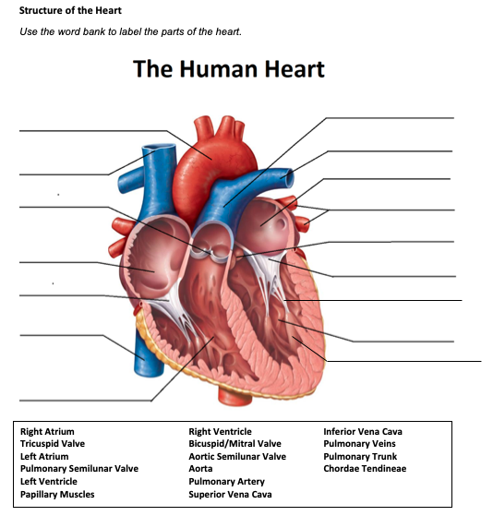

Pulmonary trunk
Aorta
Pulmonary Artery
Left Atrium
Superior Vena Cava
Pulmonary Semilunar Valve
Pulmonary Veins
Aortic valve
Right Atrium
Mitral Valve
Tricuspid Valve
Chordae Tendineae
Left Ventricle
Inferior Vena Cava
Papillary Muscles
Right Ventricle

- Write the blood flow through the heart:
Deoxygenated blood enters the heart through the superior and inferior vena cava which then enters the R atrium, goes through the tricuspid valve into the R ventricle. The right ventricle pumps the blood though the pulmonary valve and through the pulmonary artery to go the lungs for where oxygenation occurs. The oxygenated blood re-enters the heart through the pulmonary veins into the L atrium, goes through the mitral valve into the L ventricle, and finally through the aortic valve and aorta to perfuse the rest of the body with oxygen rich blood.

Obstructive Defect Questions
- What does obstructive mean?
The anatomical narrowing of blood vessels that are exiting the heart.

- Where is the defect with an atrial septal defect? (Between which two structures?)
An atrial septal defect occurs between the atria.

- Where is the defect with a ventricular septal defect? (Between which two structures?)
A ventricular septal defect occurs between the R and L ventricle.

- In fetal circulation, what is the ductus arteriosus? What is its purpose?
The ductus arteriosus is an opening in the fetal heart between the pulmonary artery and the aorta to bypass the lungs and distributes the oxygen received through the placenta from the mom.

- What does the term coarctation mean?
Coarctation is the narrowing of the aorta where the ductus arteriosus inserts.

- What does the term stenosis mean?
Stenosis is known to be narrowing. For example, a pulmonic stenosis is the narrowing of the pulmonary valve or artery that can lead to cyanosis due to the obstruction of blood flow to the lungs.

- If there is an issue with the aorta or aortic valve being narrow, which ventricle would have to work harder? Where would blood back up?
If there is an issue with the aorta or aortic valve, the L ventricle will have to work harder to pump blood to the rest of the body. Blood could potentially be backed up into the lungs.

- If there is an issue with the pulmonic valve being narrow, which ventricle would have to work harder? Where would blood back up?
If there is an issue with the pulmonic valve, the R ventricle will have to work harder to pump blood to the lungs. Blood could potentially back up into the R atrium.

Cyanotic Defects
- If blood cannot get to the lungs, what happens?
If blood cannot get to the lungs, it will result in hypoxia.

- What does the prefix “Tetra-” mean?
Tetra refers to the number 4.

- What are the defects associated with Tetralogy of Fallot?
Combination of four defects in the structure of the heart resulting in mild cyanosis that progresses over the first year of life as pulmonary stenosis worsens, characteristic murmur, and acute episodes of hypoxia and cyanosis.

- What does atresia mean?
Absence or abnormal narrowing of an opening or passage in the body.

- How would you describe tricuspid atresia to a parent of a small child?
Tricuspid atresia is a condition where the NB is born without the tricuspid valve which interferes with blood pumping to the lungs.
Mixed Defects
- If a baby has transposition of the great vessels, the aorta is abnormally attached to the R ventricle, and the pulmonary artery is abnormally attached to the L ventricle.

- If the pulmonary veins do not attach to the left atrium, what type of defect would be helpful in allowing blood to get into the left atrium?
A septal defect would be helpful to allow blood to return to the heart from the arteries.

- What is the large base of a tree called before it reaches the branches?
The large base of a tree before it reaches branches is called the trunk.

- What does hypoplastic mean?
Hypoplastic means under-developed.

Medication Questions
- What is an adult cardiac medication we can give to increase the heart contractility, decrease heart rate, and increase cardiac output?
Digoxin

- What electrolyte makes the previous medication work more effectively, easily leading to toxicity?
Potassium

- What does an ACE Inhibitor do? (Hint, there are multiple things!)
Vasodilation, decrease in preload and afterload, decrease BP, decrease VR.

- What electrolyte do you need to check before administering Furosemide?
Check potassium prior to administration.

- What electrolyte do you need to check before administering Aldactone?
Check potassium levels prior to administration.

