Normal Adult Heart
- Label the structures of the heart:
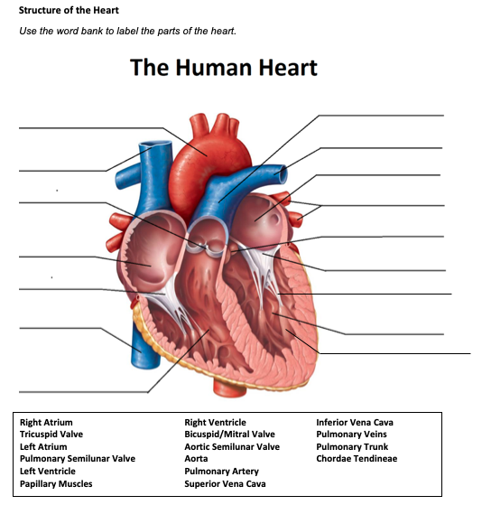

Pulmonary trunk
Aorta
Pulmonary artery
L. Atrium
Superior Vena Cava
L. Pulmonary Veins
Aortic Valve
Aortic semilunar valve
Right Atrium
Mitral Valve
Tricuspid Valve
Chordae Tendineae
Inferior Vena Cava
Left Ventricle
Papillary muscles
R. Ventricle

- Write the blood flow through the heart:
The unoxygenated blood enters the heart through the superior and inferior vena cava, blood enters into the right atrium, and is squeezed through the tricuspid valve, blood then enters into the right ventricle. Then is squeezed into the pulmonic valve and blood is shot up through the pulmonary artery and then enters the lungs for oxygen.
On the left side of the heart blood enters from the lungs through the pulmonary vein and enters into the left atrium, down through the bicuspid valve (Mitral valve) and then blood is squeezed into the left ventricle and up through the aortic valve. Lastly up through the aorta, where it is pumped throughout the body.

Obstructive Defect Questions
- What does obstructive mean?
Anatomic narrowing of blood vessel exiting the heart

- Where is the defect with an atrial septal defect? (Between which two structures?)
Between the atria

- Where is the defect with a ventricular septal defect? (Between which two structures?)
Between Right and Left Ventricle

- In fetal circulation, what is the ductus arteriosus? What is its purpose?
It is found connecting the pulmonary artery and the aorta, it helps shunt mixed (oxygenated blood and deoxygenated blood) away from the lungs, instead, it flows directly into the aorta. Where it will eventually travel to the umbilical arteries and back to the placenta.

- What does the term coarctation mean?
It is a localized narrowing of the aorta near the insertion of the ductus.

- What does the term stenosis mean?
Stenosis means narrowing, which could be the narrowing of the opening of the mitral valve caused by stiffening of the valve leaflets which obstructs blood flow from the left atrium to the left ventricle.

- If there is an issue with the aorta or aortic valve being narrow, which ventricle would have to work harder? Where would blood back up?
The left ventricle must work harder to pump blood out through the valve, blood could back up into the lungs

- If there is an issue with the pulmonic valve being narrow, which ventricle would have to work harder? Where would blood back up?
The right ventricle is forced to work harder to pump blood to the lungs

Cyanotic Defects
- If blood cannot get to the lungs, what happens?
Hypoxia, can cause confusion, breathing difficulties, rapid heart rate

- What does the prefix “Tetra-” mean?
Four

- What are the defects associated with Tetralogy of Fallot?
Mild cyanosis that progresses over the first year of life as pulmonary stenosis worsens
- Acutely cyanotic at birth
- Characteristic murmur
- Acute episodes of cyanosis and hypoxia

- What does atresia mean?
a condition in which an orifice or passage in the body is closed or absent.

- How would you describe tricuspid atresia to a parent of a small child?
Tri cuspid is a congenital heart condition in which one of the valves of the heart did not form preventing blood flow through the heart

Mixed Defects
- If a baby has transposition of the great vessels, the aorta is abnormally attached to the _Right__ ventricle, and the pulmonary artery is abnormally attached to the _Left_ ventricle.

- If the pulmonary veins do not attach to the left atrium, what type of defect would be helpful in allowing blood to get into the left atrium?
TAPVC arises from the failure of the left atrium to link with the pulmonary venous plexus

- What is the large base of a tree called before it reaches the branches?
Trunk

- What does hypoplastic mean?
A lack of cell growth causes under development

Medication Questions
- What is an adult cardiac medication we can give to increase the heart contractility, decrease heart rate, and increase cardiac output?
Digoxin

- What electrolyte makes the previous medication work more effectively, easily leading to toxicity?
Potassium

- What does an ACE Inhibitor do? (Hint, there are multiple things!)
Block vasoconstriction, promote vasodilation, decreases pulmonary and systemic vascular resistance, decrease BP, blocks aldosterone secretion, decreases fluid retention.

- What electrolyte do you need to check before administering Furosemide?
Potassium

- What electrolyte do you need to check before administering Aldactone?
Potassium

