Normal Adult Heart
- Label the structures of the heart:
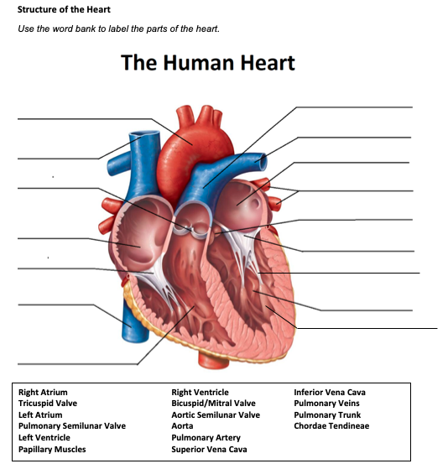

Pulmonary trunk
Aorta
Pulmonary artery
L atrium
Superior vena cava
Pulmonary semilunar valve
Pulmonary veins
Aortic semilunar valve
R atrium
Bicuspid/mitral valve
Tricuspid valve
Chordae tendineae
Inferior vena cava
L ventricle
Papillary muscles
R ventricle

- Write the blood flow through the heart:
Blood enters the heart through the inferior or superior vena cava -> R atrium -> tricuspid valve -> R ventricle -> pulmonary semilunar valve -> pulmonary trunk -> pulmonary artery -> lungs -> pulmonary veins -> L atrium -> biscupid/mitral valve -> L ventricle -> aortic semilunar valve -> aorta -> rest of body

Obstructive Defect Questions
- What does obstructive mean?
Anatomic narrowing of blood vessel exiting the heart

- Where is the defect with an atrial septal defect? (Between which two structures?)
Between the R and L atria

- Where is the defect with a ventricular septal defect? (Between which two structures?)
Between the R and L ventricles

- In fetal circulation, what is the ductus arteriosus? What is its purpose?
The ductus arteriosus is a blood vessel channel connecting the pulmonary artery and the aorta. Its purpose is to bypass the lungs to distribute oxygen due to immature, non-inflating lungs since the placenta does the breathing for the neonate

- What does the term coarctation mean?
The narrowing or constricting of the aorta

- What does the term stenosis mean?
The narrowing or constricting of a blood vessel or valve

- If there is an issue with the aorta or aortic valve being narrow, which ventricle would have to work harder? Where would blood back up?
The L ventricle would have to work harder. Blood would back up behind the aortic valve and eventually into the L atrium

- If there is an issue with the pulmonic valve being narrow, which ventricle would have to work harder? Where would blood back up?
The R ventricle would have to work harder, with blood backing up into the R atrium

Cyanotic Defects
- If blood cannot get to the lungs, what happens?
There will be a lack of oxygen supplied to organs and tissues

- What does the prefix “Tetra-” mean?
Four

- What are the defects associated with Tetralogy of Fallot?
Pulmonary stenosis, ventricular septal defect, hypertrophy of R ventricle, overriding aorta

- What does atresia mean?
absence or abnormal narrowing of an opening or passage in the body

- How would you describe tricuspid atresia to a parent of a small child?
Tricuspid atresia is a congenital heart condition in which one of the valves of the heart didn’t form, preventing the ability of blood to flow through the heart
Mixed Defects
- If a baby has transposition of the great vessels, the aorta is abnormally attached to the R ventricle, and the pulmonary artery is abnormally attached to the L ventricle.

- If the pulmonary veins do not attach to the left atrium, what type of defect would be helpful in allowing blood to get into the left atrium?
TPVAR

- What is the large base of a tree called before it reaches the branches?
Trunk

- What does hypoplastic mean?
A lack of cell growth causing underdevelopment

Medication Questions
- What is an adult cardiac medication we can give to increase the heart contractility, decrease heart rate, and increase cardiac output?
Digoxin

- What electrolyte makes the previous medication work more effectively, easily leading to toxicity?

Low K+ can cause toxicity

- What does an ACE Inhibitor do? (Hint, there are multiple things!)
Decrease BP, fluid retention, preload and afterload, and vascular resistance

- What electrolyte do you need to check before administering Furosemide?
Potassium

- What electrolyte do you need to check before administering Aldactone?
Potassium

