Normal Adult Heart
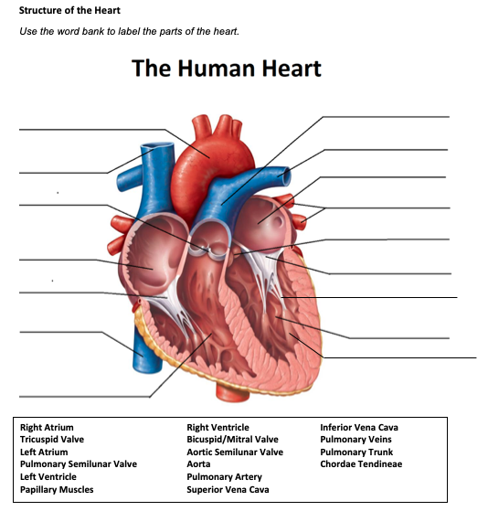
- Label the structures of the heart:

Pulmonary Trunk
aorta
Pulmonary Artery
L. Atrium
Superior Vena Cava
Pulmonary Veins
Pulmonary Semilunar valves
Aortic Semilunar Valve
R. Atrium
Bicuspid/Mitral Valve
Tricuspid Valve
Chordae Tendineae
L. Ventricle
Inferior Vena Cava
Papillary Muscles
R. Ventricle

- Write the blood flow through the heart:
Blood comes into the right atrium from the body, moves into the right ventricle and is pushed into the pulmonary arteries in the lungs. After picking up oxygen, the blood travels back to the heart through the pulmonary veins into the left atrium, to the left ventricle and out to the body's tissues through the aorta.
Obstructive Defect Questions
- What does obstructive mean?
Blockage of a passageway

- Where is the defect with an atrial septal defect? (Between which two structures?)
Between the atria

- Where is the defect with a ventricular septal defect? (Between which two structures?)
separates the two lower chambers of the heart, the ventricles

- In fetal circulation, what is the ductus arteriosus? What is its purpose?
The ductus arteriosus is a fetal vessel that allows the oxygenated blood from the placenta to bypass the lungs in utero, it serves as a shunt between the pulmonary artery and the aorta.

- What does the term coarctation mean?
a birth defect in which a part of the aorta, the tube that carries oxygen-rich blood to the body, is narrower than usual.

- What does the term stenosis mean?
a narrowing or constriction of the diameter of a bodily passage

- If there is an issue with the aorta or aortic valve being narrow, which ventricle would have to work harder? Where would blood back up?
the left ventricle must work harder to pump blood out through the valve, blood might back up into the lungs

- If there is an issue with the pulmonic valve being narrow, which ventricle would have to work harder? Where would blood back up?
the right ventricle is forced to work harder to pump blood to the lungs successfully.

Cyanotic Defects
- If blood cannot get to the lungs, what happens?
It can lead to a lack of oxygen in your body's organs and tissues

- What does the prefix “Tetra-” mean?
Four

- What are the defects associated with Tetralogy of Fallot?
ventricular septal defect, overriding aorta, pulmonary stenosis and right ventricular hypertrophy.

- What does atresia mean?
a condition in which an orifice or passage in the body is (usually abnormally) closed or absent

- How would you describe tricuspid atresia to a parent of a small child?
a birth defect of the heart where the valve that controls blood flow from the right upper chamber of the heart to the right lower chamber of the heart doesn't form at all
Mixed Defects
- If a baby has transposition of the great vessels, the aorta is abnormally attached to the Right ventricle, and the pulmonary artery is abnormally attached to the Left ventricle.

- If the pulmonary veins do not attach to the left atrium, what type of defect would be helpful in allowing blood to get into the left atrium?
TAPVC arises from the failure of the left atrium to link with the pulmonary venous plexus

- What is the large base of a tree called before it reaches the branches?
Trunk

- What does hypoplastic mean?
a condition of arrested development in which an organ or part remains below the normal size or in an immature state

Medication Questions
- What is an adult cardiac medication we can give to increase the heart contractility, decrease heart rate, and increase cardiac output?
Lanoxin (Digoxin)

- What electrolyte makes the previous medication work more effectively, easily leading to toxicity?
Potassium

- What does an ACE Inhibitor do? (Hint, there are multiple things!)
Blocks vasoconstriction, promotes vasodilation, blocks aldosterone secretion, decreases pulmonary and systemic vascular resistance, decreases BP, Reduces afterload
- What electrolyte do you need to check before administering Furosemide?
Potassium

- What electrolyte do you need to check before administering Aldactone?
Potassium

