Normal Adult Heart
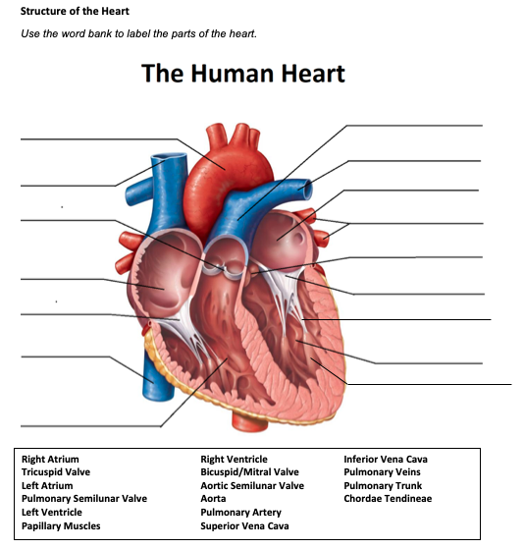
- Label the structures of the heart:

Pulmonary trunk
Left pulmonary artery
Aorta
Left atrium
Superior vena cava
Left pulmonary veins
Pulmonary semilunar valve

Aortic semilunar valve
Right atrium
Mitral valve
Chordae tendineae
Tricuspid valve
Left ventricle
Inferior vena cava
Papillary muscles
Right ventricle

- Write the blood flow through the heart:
Superior vena cava and inferior vena cava right atrium tricuspid valve right ventricle pulmonic valve pulmonary artery lungs blood leaves the lungs pulmonary vein left atrium mitral valve left ventricle aortic valve aorta pushes out blood to the rest of the body

Obstructive Defect Questions
- What does obstructive mean?
Anatomic narrowing of blood vessel exiting the heart

- Where is the defect with an atrial septal defect? (Between which two structures?)
Between the left and right atrium

- Where is the defect with a ventricular septal defect? (Between which two structures?)
Between the left and right ventricle

- In fetal circulation, what is the ductus arteriosus? What is its purpose?
is a normal fetal artery connecting the aorta and the pulmonary artery. Its function allows the blood from the right ventricle to bypass the fetus fluid filled nonfunctioning lungs.

- What does the term coarctation mean?
Aortic narrowing is a congenital heart defect in the baby's aorta

- What does the term stenosis mean?
Is the narrowing or restriction of a blood vessel or valve

- If there is an issue with the aorta or aortic valve being narrow, which ventricle would have to work harder? Where would blood back up?
The left ventricle would have to work harder and the blood would back up into the left atrium going into the lungs

- If there is an issue with the pulmonic valve being narrow, which ventricle would have to work harder? Where would blood back up?
The right ventricle would have to work harder and the blood would back up into the right atrium and stuck in extremities

Cyanotic Defects
- If blood cannot get to the lungs, what happens?
Hypoxemia and respiratory failure can occur if there is not enough blood flow to the lungs or enough oxygen.

- What does the prefix “Tetra-” mean?
Tetra means 4

- What are the defects associated with Tetralogy of Fallot?
Pulmonary stenosis, right ventricle hypertrophy, overriding aorta, ventricular septal defect

- What does atresia mean?
The absence of a valve in the heart

- How would you describe tricuspid atresia to a parent of a small child?
The hearts tricuspid valve does not develop which means blood can't flow or pump properly.

Mixed Defects
- If a baby has transposition of the great vessels, the aorta is abnormally attached to the right ventricle, and the pulmonary artery is abnormally attached to the left ventricle.

- If the pulmonary veins do not attach to the left atrium, what type of defect would be helpful in allowing blood to get into the left atrium?
Atrial septal defect

- What is the large base of a tree called before it reaches the branches?
Trunk

- What does hypoplastic mean?
Is the incomplete development or immature development of an organ or tissue lacking cells and structures

Medication Questions
- What is an adult cardiac medication we can give to increase the heart contractility, decrease heart rate, and increase cardiac output?

Digoxin

- What electrolyte makes the previous medication work more effectively, easily leading to toxicity?
Potassium

- What does an ACE Inhibitor do? (Hint, there are multiple things!)
-blocks the production of angiotensin II, causes coughs, decreases blood pressure, r/f orthostatic hypotension, dilates blood vessels

- What electrolyte do you need to check before administering Furosemide?
Potassium

- What electrolyte do you need to check before administering Aldactone? Potassium

