Normal Adult Heart
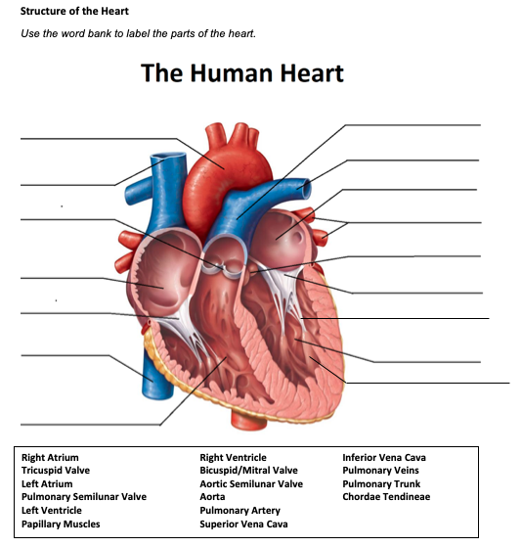
- Label the structures of the heart:

Pulmonary Trunk
Aorta
Left Atrium
Pulmonary Artery
Pulmonary Semilunar valve
Superior Vena Cava
Right Atrium
Tricuspid Valve
Mitral Valve
Chordae Tendineae
Aortic Semilunar Valve
Inferior Vena Cava
Pulmonary Veins
Left Ventricle
Papillary Muscles
Right Ventricle

- Write the blood flow through the heart:
Deoxygenated blood from the upper body comes through the superior vena cava, deoxygenated blood from the lower body comes through the inferior vena cava, the blood goes into the right atrium, the blood passes through the tricuspid valve into the right ventricle, the blood passes through the pulmonic valve and goes through the pulmonary artery to the lungs to be oxygenated. Oxygenated blood then comes back from the lungs via the pulmonary veins, from the veins the blood goes into the left atrium, the blood passes through the mitral valve into the left ventricle, from the left ventricle the blood goes through the aortic valve, up the aorta and out to the body to oxygenate the tissues, once deoxygenated the blood comes back to the heart and the process starts over again.
Obstructive Defect Questions
- What does obstructive mean?
Anatomic narrowing of blood vessel exiting the heart.

- Where is the defect with an atrial septal defect? (Between which two structures?)
Between the left and right atrium.

- Where is the defect with a ventricular septal defect? (Between which two structures?)
Between the left and right ventricle.

- In fetal circulation, what is the ductus arteriosus? What is its purpose?
A blood vessel that connects the first portion of the pulmonary artery to the end of the descending aorta, the purpose is to bypass the lungs that are not usable until birth, the placenta supplies the oxygen because the lungs are filled with amniotic fluid and can not oxygenate the body.

- What does the term coarctation mean?
Narrowing of the aorta.

- What does the term stenosis mean?
Narrowing of a blood vessel or valve.

- If there is an issue with the aorta or aortic valve being narrow, which ventricle would have to work harder? Where would blood back up?
The left ventricle would work harder, and the blood would back up into the left atrium going to the lungs.

- If there is an issue with the pulmonic valve being narrow, which ventricle would have to work harder? Where would blood back up?
The right ventricle would work harder, and the blood would back up into the right atrium and staying stuck in the body/extremities.

Cyanotic Defects
- If blood cannot get to the lungs, what happens?
Hypoxemia or respiratory failure.

- What does the prefix “Tetra-” mean?
Four

- What are the defects associated with Tetralogy of Fallot?
Pulmonary stenosis, right ventricular hypertrophy, overriding aorta, ventricular septal defect.

- What does atresia mean?
The absence of a valve in the heart, such as tricuspid atresia there is no tricuspid valve.

- How would you describe tricuspid atresia to a parent of a small child?
The hearts tricuspid valve, that allows the blood to go to the lungs, is not there, so this means not all blood will be oxygenated.
Mixed Defects
- If a baby has transposition of the great vessels, the aorta is abnormally attached to the right ventricle, and the pulmonary artery is abnormally attached to the left ventricle.

- If the pulmonary veins do not attach to the left atrium, what type of defect would be helpful in allowing blood to get into the left atrium?
Atrial septal defect

- What is the large base of a tree called before it reaches the branches?
Trunk

- What does hypoplastic mean?
Underdeveloped or incomplete development of tissues or organs.

Medication Questions
- What is an adult cardiac medication we can give to increase the heart contractility, decrease heart rate, and increase cardiac output?
Digoxin

- What electrolyte makes the previous medication work more effectively, easily leading to toxicity?
Potassium

- What does an ACE Inhibitor do? (Hint, there are multiple things!)
The cause coughing, blocks production of angiotensin II, decreases blood pressure, risk for orthostatic hypotension, dilates blood vessels, increases potassium.

- What electrolyte do you need to check before administering Furosemide?
Potassium

- What electrolyte do you need to check before administering Aldactone?
Potassium

