Respiratory Class Preparation Part 1 Day 1
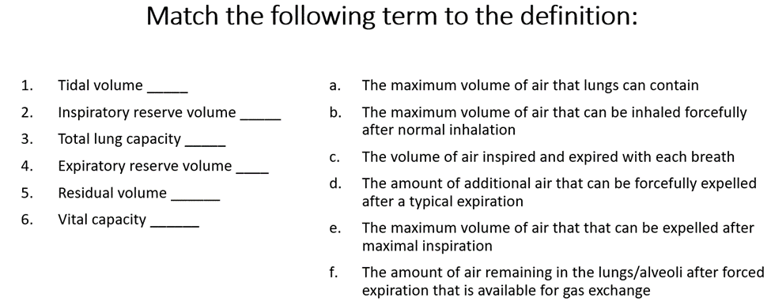
1. C
2. B
3. A
4. D
5. F
6. E
Review Chapter 27 in your Lewis book and then match the descriptions below to the correct location above for labeling respiratory anatomy.
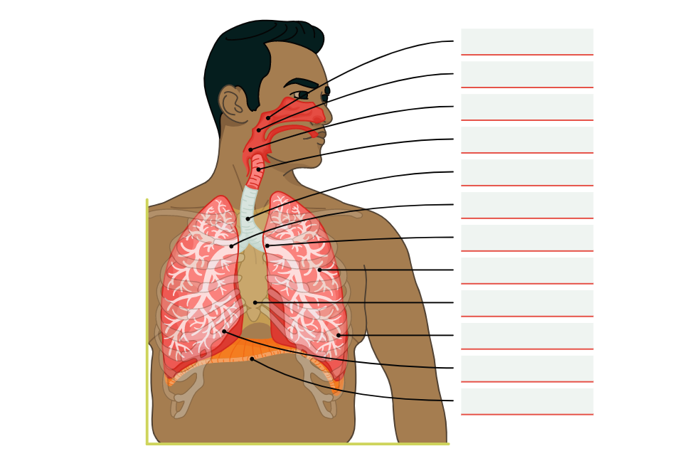
In descending order:
1. Nasopharynx
2. Oropharynx
3. Laryngopharynx
4. Larynx
5. Trachea
6. Right bronchus
7. Left bronchus
8. Bronchioles
9. Mediastinum
10. Left Lung
11. Right Lung
12. Diaphragm

