Respiratory Class Preparation Part 1 Day 1
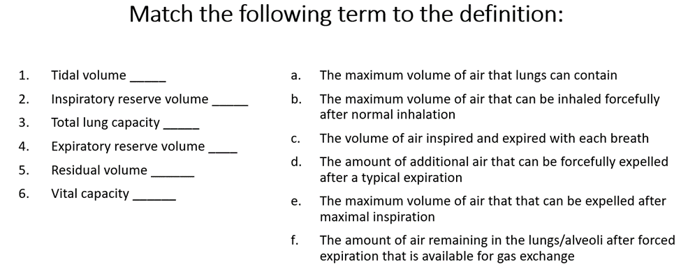
E
F
D
A
B
C
Review Chapter 27 in your Lewis book and then match the descriptions below to the correct location above for labeling respiratory anatomy.
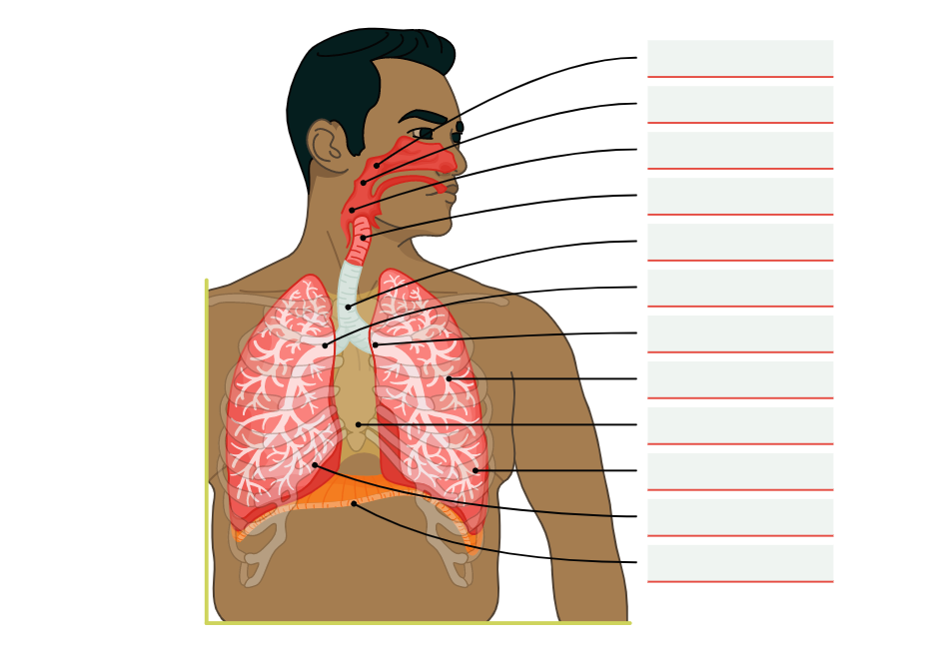
Diaphragm
Right Lung
Left Lung
Right Bronchus
Larynx
Laryngopharynx
Oropharynx
Mediastinum
Bronchioles
Left Bronchus
Trachea
Nasopharynx

