Respiratory Class Preparation Part 1 Day 1
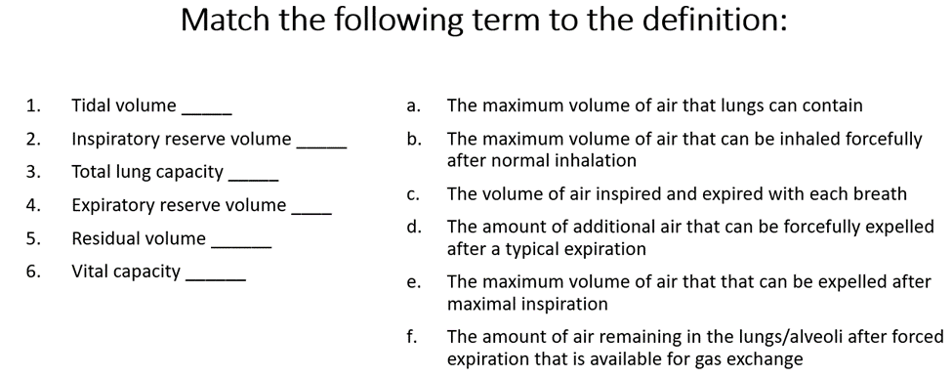
Review Chapter 27 in your Lewis book and then match the descriptions below to the correct location above for labeling respiratory anatomy.
