Respiratory Class Preparation Part 1 Day 1
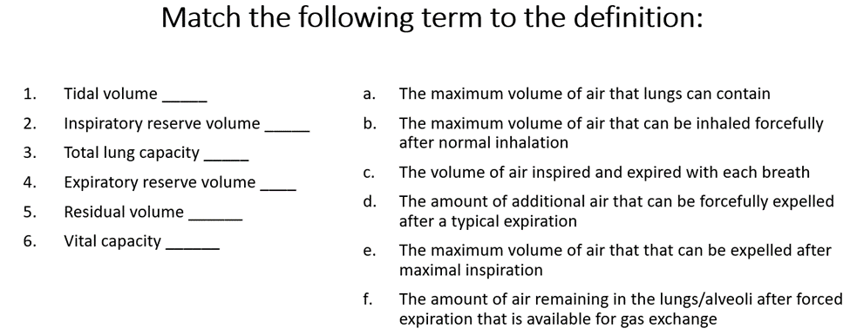
- C
- B
- A
- D
- F
- E

Review Chapter 27 in your Lewis book and then match the descriptions below to the correct location above for labeling respiratory anatomy.
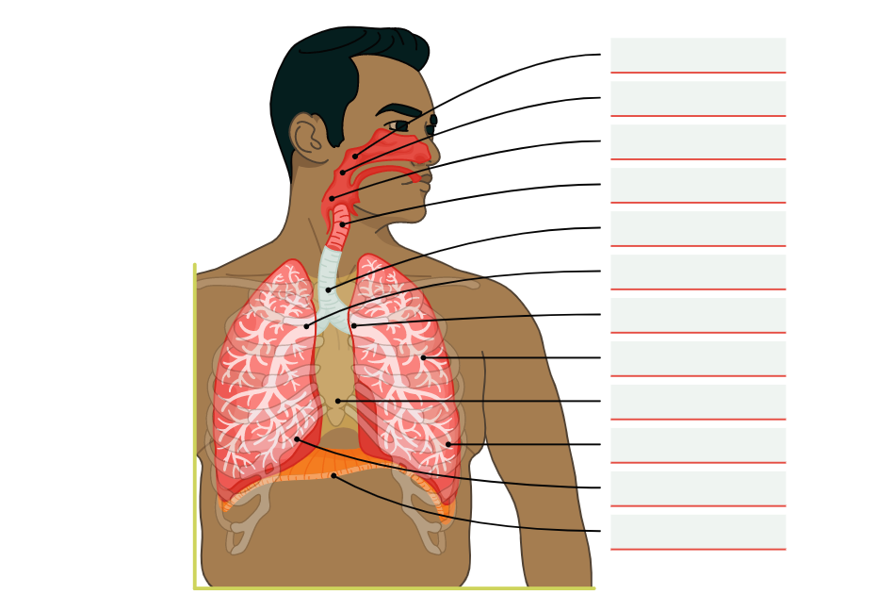

1Nasopharynx, 2- Oropharynx, 3-Laryngopharyx, 4- Larynx, 5- Trachea, 6- Right bronchus, 7- Left bronchus, 8-left lung, 9- mediastinum, 10- bronchioles, Right lung, 11- Diaphragm

