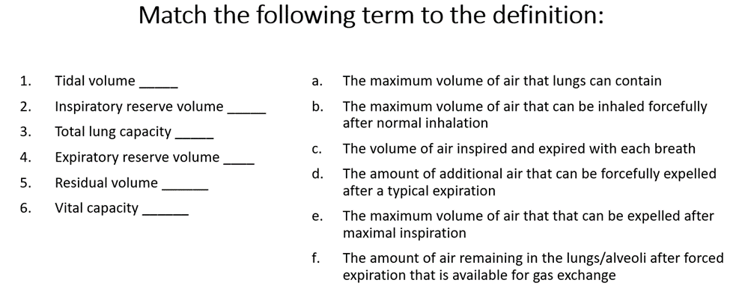
Respiratory Class Preparation Part 1 Day 1
1 C
2 B
3 A
4 D
5 F
6 E

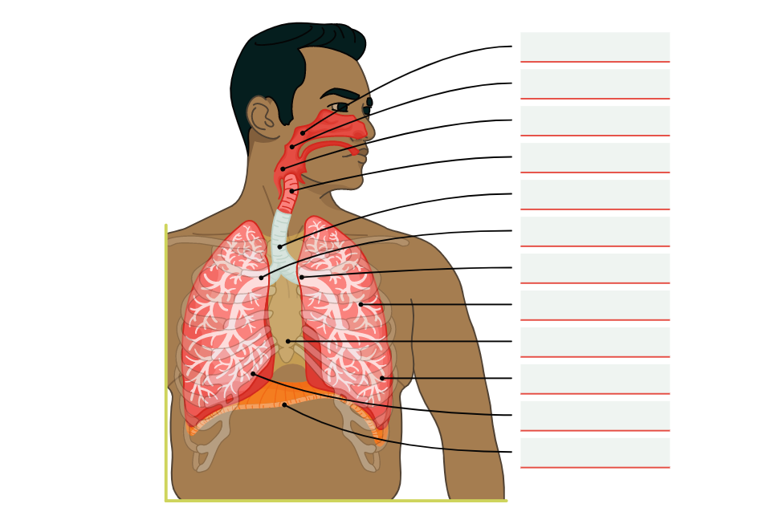
1 Nasopharynx
2 Oropharynx
3 Laryngopharynx
4 Larynx
5 Trachea
6 Right Bronchus
7 Left Bronchus
8 Bronchioles
9 Mediastinum
10 Left Lung
11 Right Lung
12 Diaphragm

