Respiratory Class Preparation Part 1 Day 1
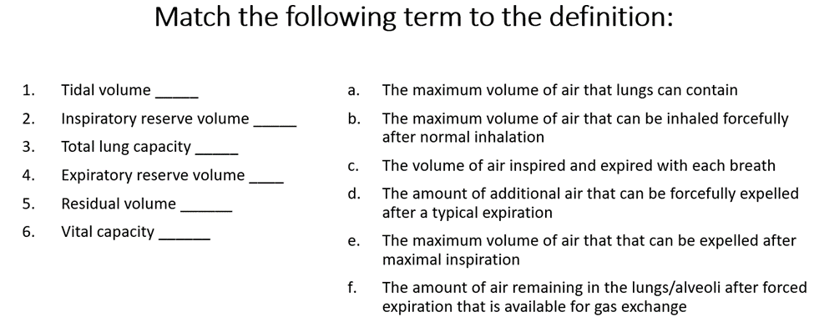
Answers:
- C
- B
- A
- D
- F
- E
Review Chapter 27 in your Lewis book and then match the descriptions below to the correct location above for labeling respiratory anatomy.
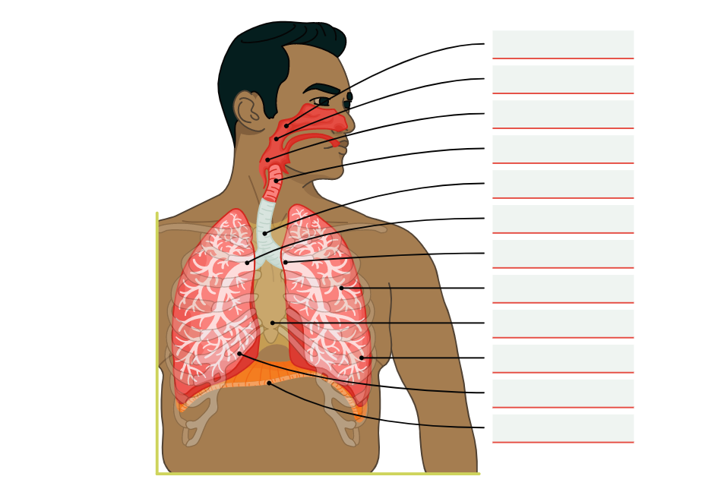
Answers in order:
- Nasopharynx
- Oropharynx
- Laryngopharynx
- Larynx
- Trachea
- Right bronchus
- Left bronchus
- Bronchioles
- Mediastinum
- Left lung
- Right lung
- Diaphragm

