Respiratory Class Preparation Part 1 Day 1
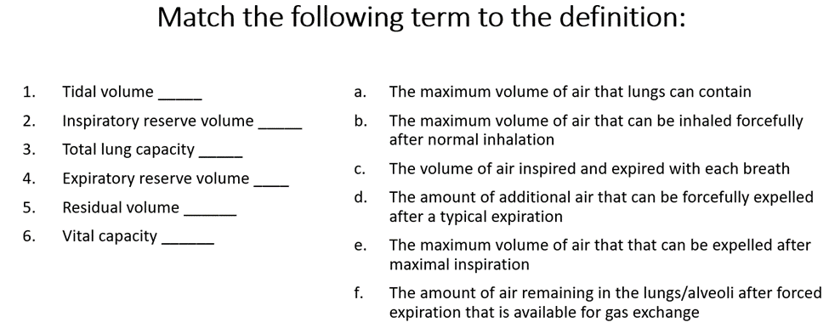
A
B
E
dD
F
C
C
D
Review Chapter 27 in your Lewis book and then match the descriptions below to the correct location above for labeling respiratory anatomy.
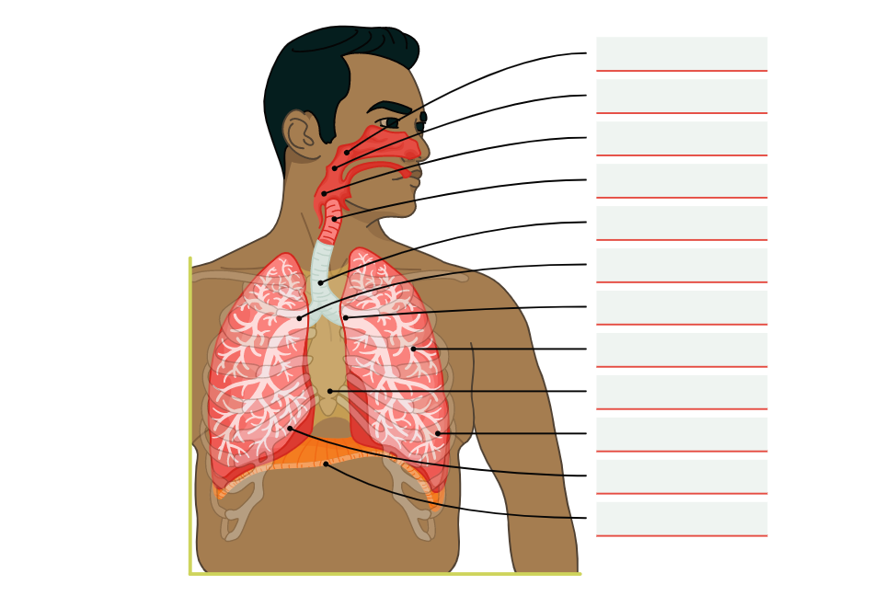
Laryngopharynx
Oropharynx
Nasopharynx
Trachea
Bronchioles
Right lung
Left lung
Mediastinum
Left bronchus
Right bronchus
Diaphragm
Larynx

