Respiratory Class Preparation Part 1 Day 1
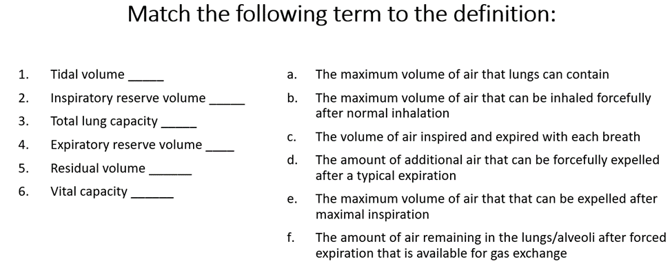
Review Chapter 27 in your Lewis book and then match the descriptions below to the correct location above for labeling respiratory anatomy. 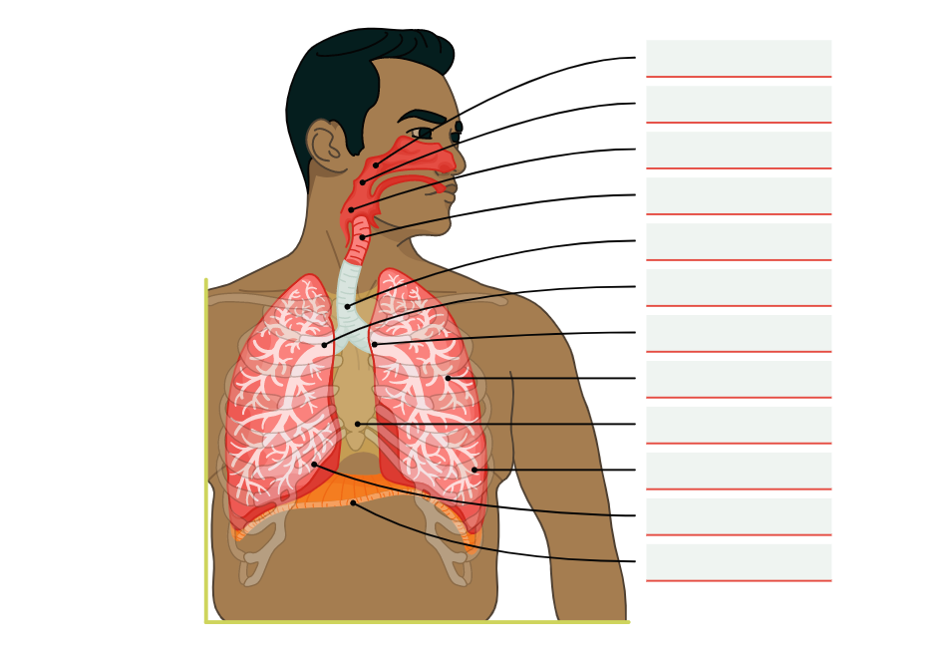
- Nasopharynx
- Oropharynx
- Laryngopharynx
- Larynx
- Trachea
- Right Bronchus
- Left Bronchus
- Bronchioles
- Mediastinum
- Left Lung
- Right Lung
- Diaphragm

