Directions for Respiratory Unit, TTE 11/2/23 Active Learning Templates
Pharmacology Made Easy:
Access your ATI account
Access “My ATI” folder
Access “Learn” tab
Select “Pharmacology Made Easy 4.0”
Access module “The Respiratory System”
“Drug Therapy for Lower Airflow Disorders”
Review the content for Drug Therapy for Lower Airflow Disorders:
- Beta adrenergic agonists, short and long acting
- Inhaled anticholinergics, short and long acting
- Methylxanthines
- Glucocorticoids
*Skip mast cell stabilizers
- Leukotriene modifiers
Under “Drug Therapy for Upper Respiratory Disorders, select mucolytics (6)
Complete Active Learning Templates for each of these 6 categories. Take your time and do them well, but do not write every word down. Use bullet points, key concepts, etc. We will be using these in class.
To access Active Learning Templates:
From “My ATI” home page,
Change “Study Materials” to “Active Learning Templates”
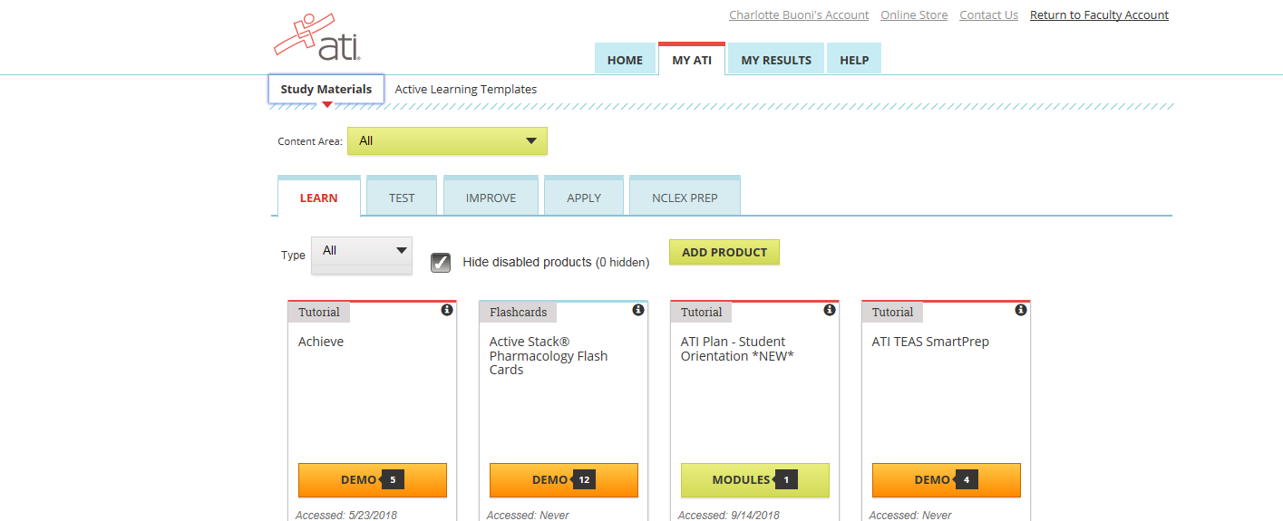

Print out the templates for Medication. You’ll need one for each medication assigned.

