Before typing anything in your document, format the spacing for your APA paper by doing the following.
First, click the spacing format icon located on the toolbar of the “Home” tab of the Word document:
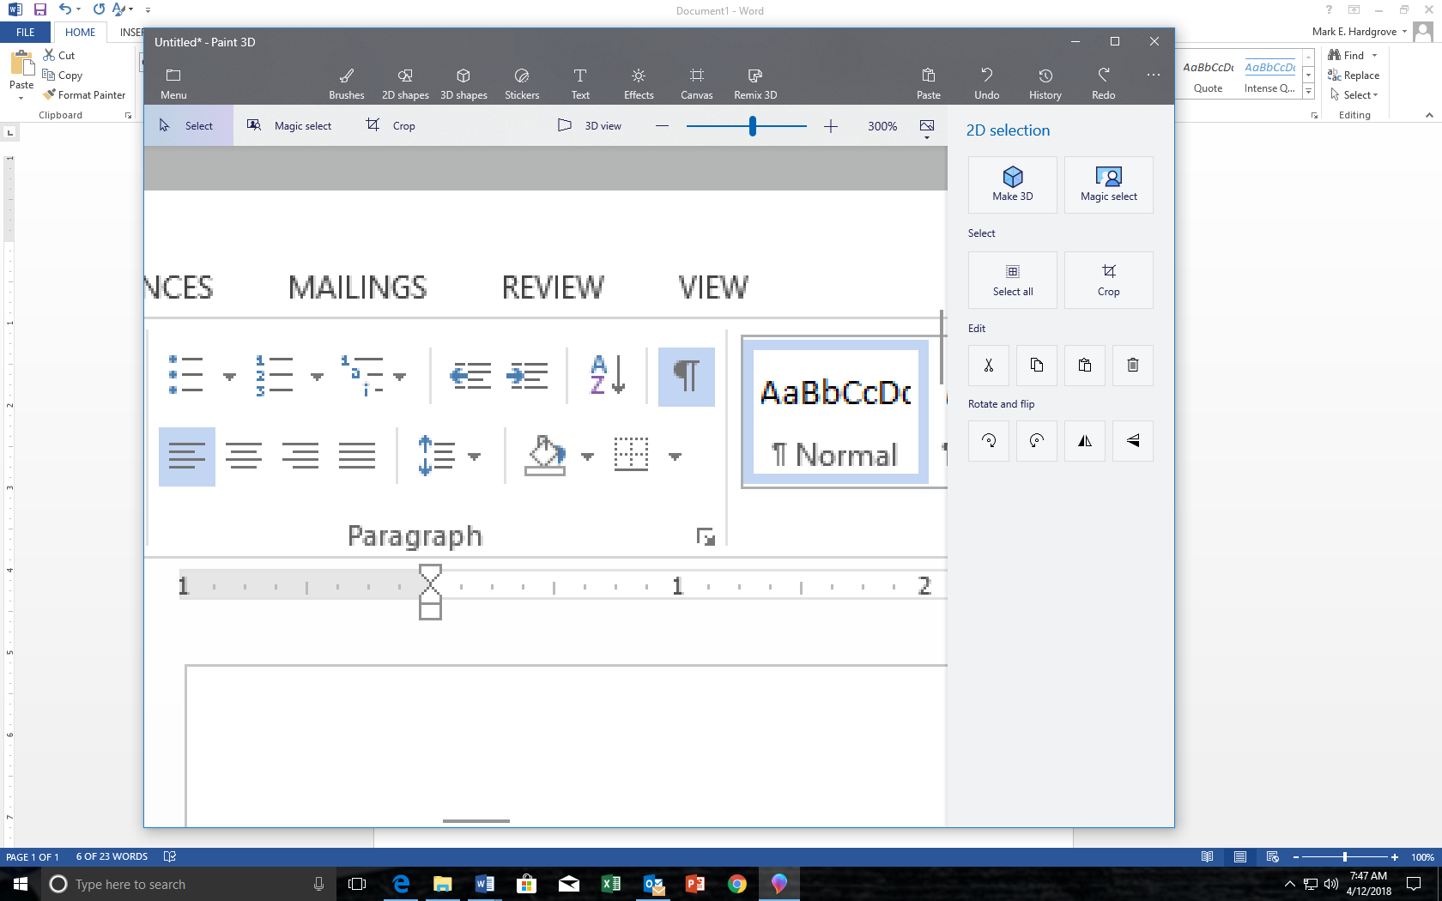
When you open the icon you will probably see the default setting: “Remove Space After Paragraph”
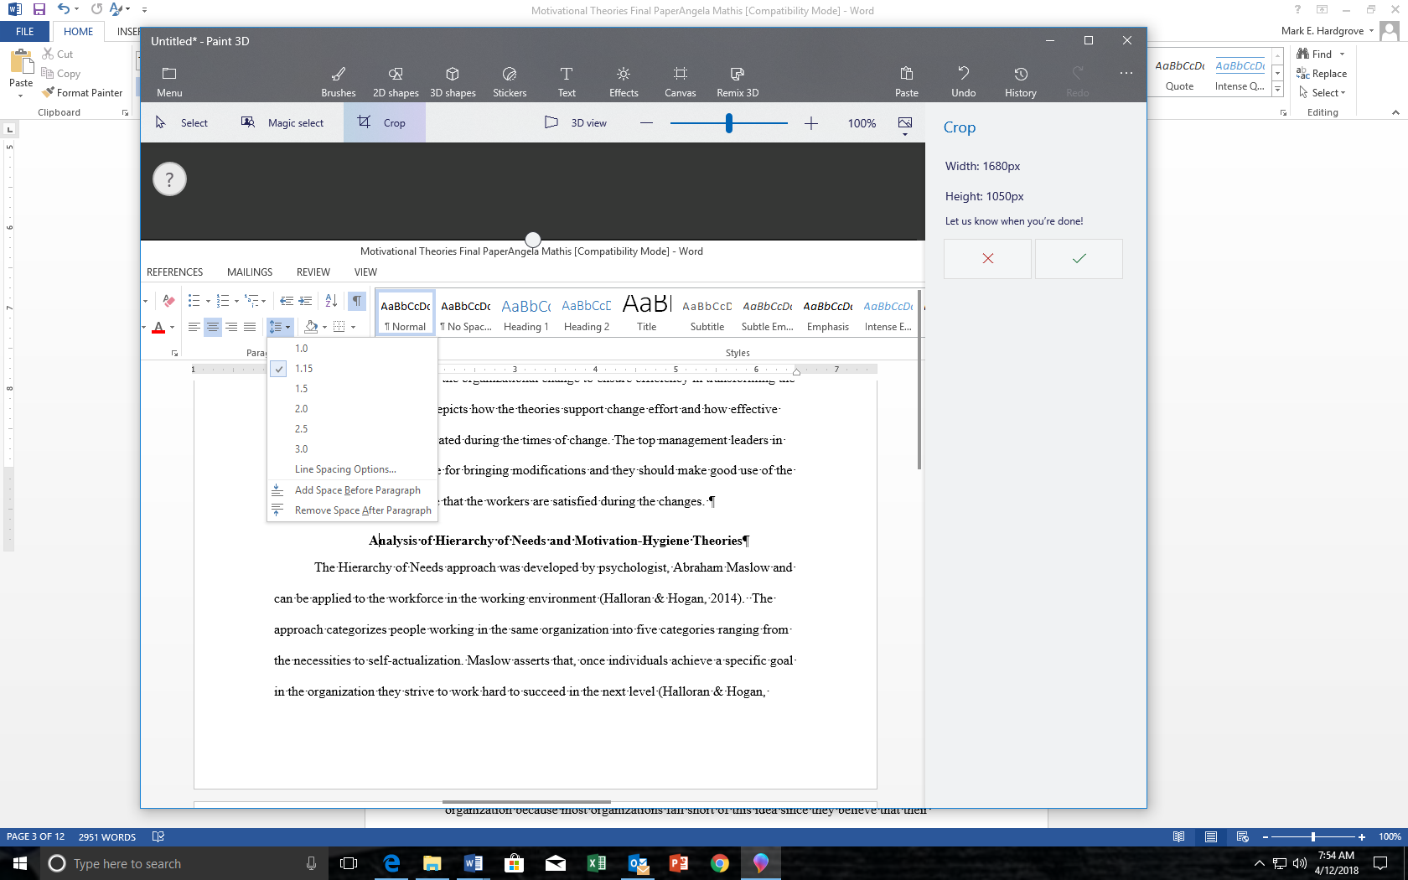
Second, step is to click “Remove Space After Paragraph” [also, if your default has “Remove Space Before Paragraph,” click that as well]. Then, click the 2.0 for line spacing so that before you type your first word on your document, your settings are as follows:
