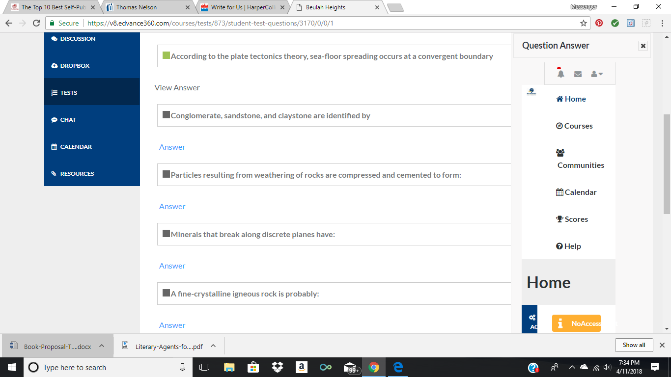

- False
- Grain size
- Sedimentary rocks
- Fractures
- Extrusive in origin

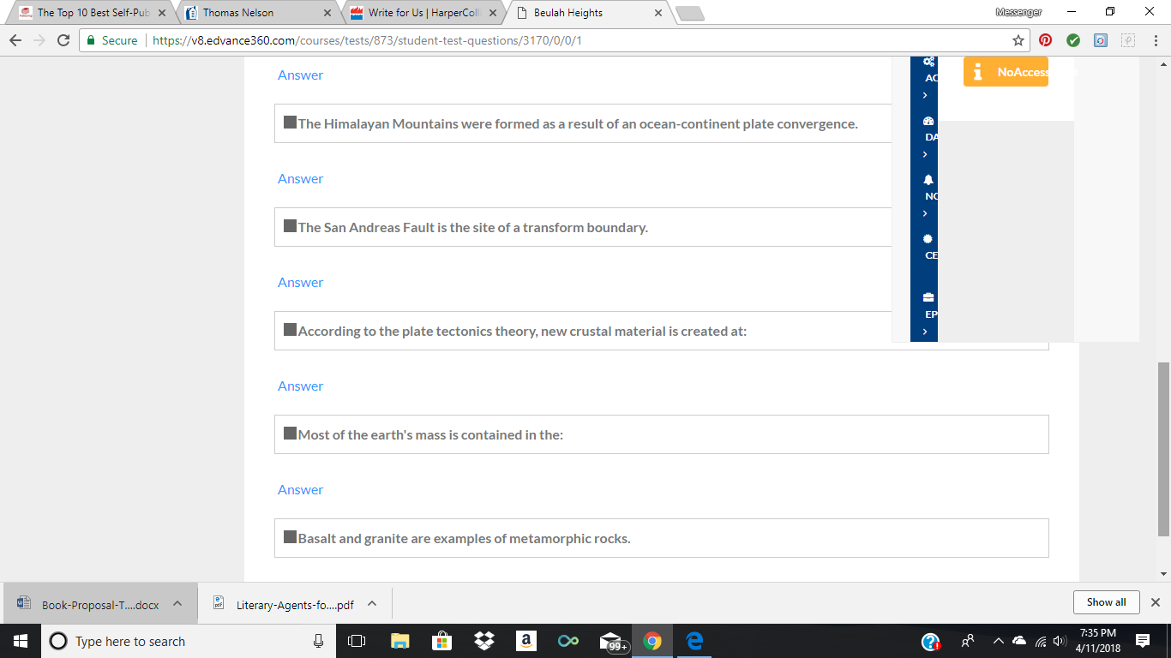

- false continent-continent
- True
- Divergent Plate Boundary
- Mantle
- False Igneous

