How to Write a Biography

How to Write an Interesting Biography
- Share
- Flipboard
- Email

PRINT

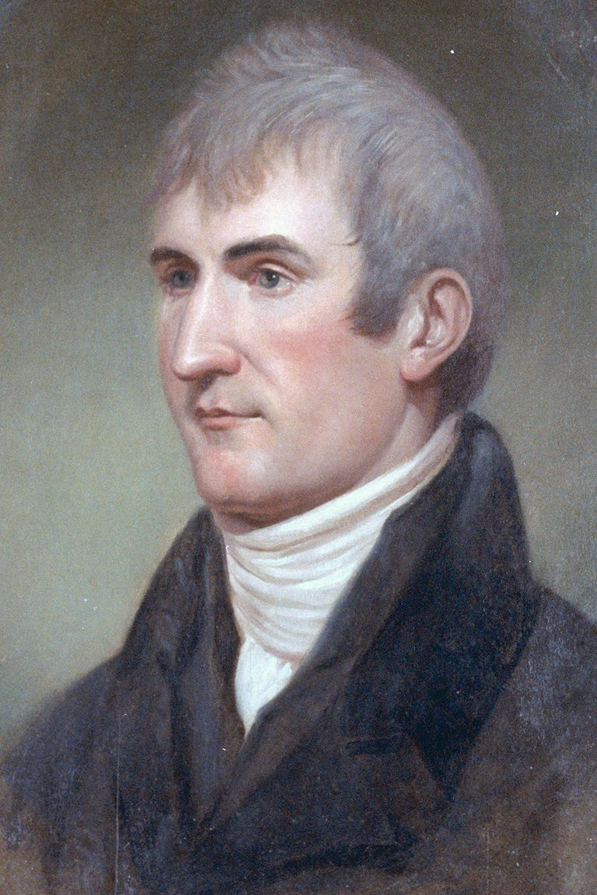
American explorer Meriwether Lewis would make a fantastic biography subject. Fotosearch / Getty Images


For Students & Parents
- Homework Help
  - Tools & Tips
  - Learning Styles & Skills
  - Study Methods
  - Time Management
  - Writing Essays
  - Writing Research Papers
  - Book Summaries
- Private Schools
- Test Prep
- College Admissions
- College Life
- Graduate School
- Business School
- Law School
VIEW MORE
by Grace Fleming
Updated March 17, 2017
A biography is a written account of the series of events that make up a person's life. Some of those events are going to be pretty boring, so you'll need to try to make your account as interesting as possible!
Every student will write a biography at some point, but the level of detail and sophistication will differ. A fourth grade biography will be much different from a middle school-level biography or a high school or college-level biography.
However, each biography will include the basic details. The first information you should gather in your research will include biographical details and facts. You must use a trustworthy resource to ensure that your information is accurate.
Using research note cards, collect the following data, carefully recording the source for each piece of information:
Basic details include:
- Date and place of birth and death
- Family information
- Lifetime accomplishments
- Major events of life
- Effects/impact on society, historical significance
While this information is necessary to your project, these dry facts, on their own, don't really make a very good biography. Once you've found these basics, you'll want to dig a little deeper.
You choose a certain person because you think he or she is interesting, so you certainly don't want to burden your paper with an inventory of boring facts. Your goal is to impress your reader!
You'll want to start off with great first sentence.
It's a good idea to begin with a really interesting statement, a little known fact, or really intriguing event.
You should avoid starting out with a standard but boring line like:
"Meriwether Lewis was born in Virginia in 1774."
Instead, try starting with something like this:
"Late one afternoon in October, 1809, Meriwether Lewis arrived at a small log cabin nestled deep in the Tennessee Mountains. By sunrise on the following day, he was dead, having suffered gunshot wounds to the head and chest.
You'll have to make sure your beginning is motivating, but it should also be relevant. The next sentence or two should lead in to your thesis statement, or main message of your biography.
"It was a tragic end to a life that had so deeply affected the course of history in the United States. Meriwether Lewis, a driven and often tormented soul, led an expedition of discovery that expanded a young nation's economic potential, increased its scientific understanding, and enhanced its worldwide reputation."
Now that you've created an impressive beginning, you'll want to continue the flow. Find more intriguing details about the man and his work, and weave them into the composition.
Examples of interesting details:
- Some people believed that Lewis and Clark would encounter elephants in the western wilderness, having misunderstood the wooly mammoth bones discovered in the United States.
- The expedition resulted in the discovery and description of 122 new animal species and subspecies.
- Lewis was a hypochondriac.
- His death is still an unsolved mystery, although it was ruled a suicide.
You can find interesting facts by consulting diverse sources.
Fill the body of your biography with material that gives insight to your subject's personality. For instance, in a biography about Meriwether Lewis, you would ask what traits or events motivated him to embark on such a monumental exercise.
Questions to consider in your biography:
- Was there something in your subject's childhood that shaped his/her personality?
- Was there a personality trait that drove him/her to succeed or impeded his progress?
- What adjectives would you use to describe him/her?
- What were some turning points in this life?
- What was his/her impact on history?
Be sure to use transitional phrases and words to link your paragraphs and make your composition paragraphs flow.
It is normal for good writers to re-arrange their sentences to create a better paper.
The final paragraph will summarize your main points and re-assert your main claim about your subject. It should point out your main points, re-name the person you're writing about, but it should not repeat specific examples.
As always, proofread your paper and check for errors. Create a bibliography and title page according to your teacher's instructions. Consult a style guide for proper documentation.

