How to Write a Biography

How to Write an Interesting Biography

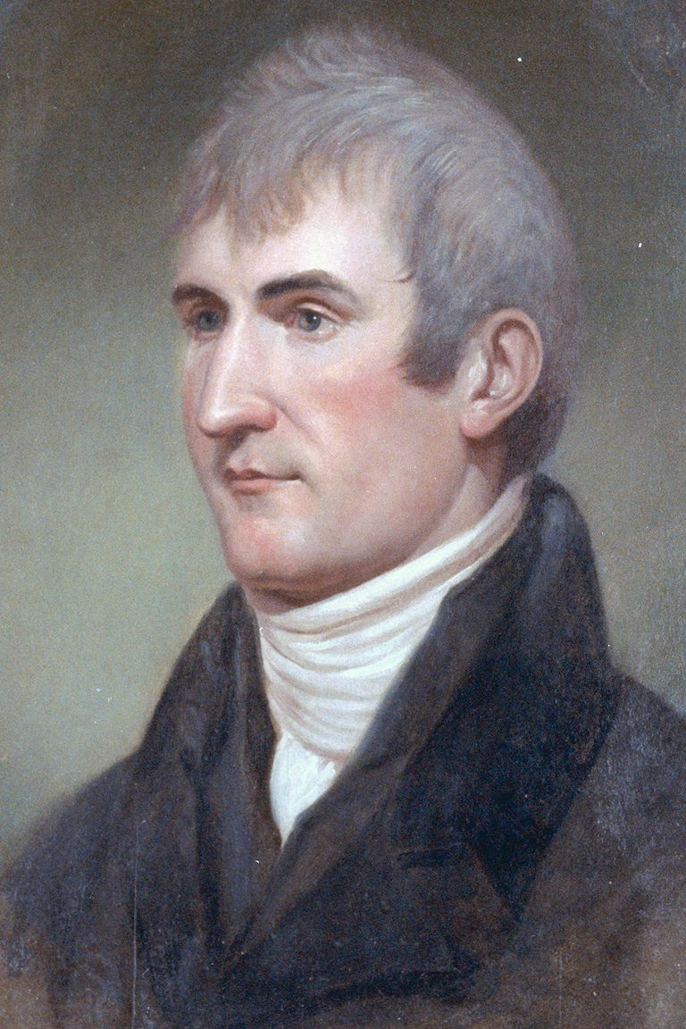
American explorer Meriwether Lewis would make a fantastic biography subject. Fotosearch / Getty Images


For Students & Parents
- Homework Help
  - Tools & Tips
  - Learning Styles & Skills
  - Study Methods
  - Time Management
  - Writing Essays
  - Writing Research Papers
  - Book Summaries
- Private Schools
- Test Prep
- College Admissions
- College Life
- Graduate School
- Business School
- Law School
View More
by Grace Fleming
Updated March 17, 2017
A biography is a written account of the series of events that make up a person's life. Some of those events are going to be pretty boring, so you'll need to try to make your account as interesting as possible!
Every student will write a biography at some point, but the level of detail and sophistication will differ. A fourth grade biography will be much different from a middle school-level biography or a high school or college-level biography.
However, each biography will include the basic details. The first information you should gather in your research will include biographical details and facts. You must use a trustworthy resource to ensure that your information is accurate.
Using research note cards, collect the following data, carefully recording the source for each piece of information:
Basic details include:
- Date and place of birth and death
- Family information
- Lifetime accomplishments
- Major events of life
- Effects/impact on society, historical significance
While this information is necessary to your project, these dry facts, on their own, don't really make a very good biography. Once you've found these basics, you'll want to dig a little deeper.
You choose a certain person because you think he or she is interesting, so you certainly don't want to burden your paper with an inventory of boring facts. Your goal is to impress your reader!

