When logging into Google Chrome, this is what I see
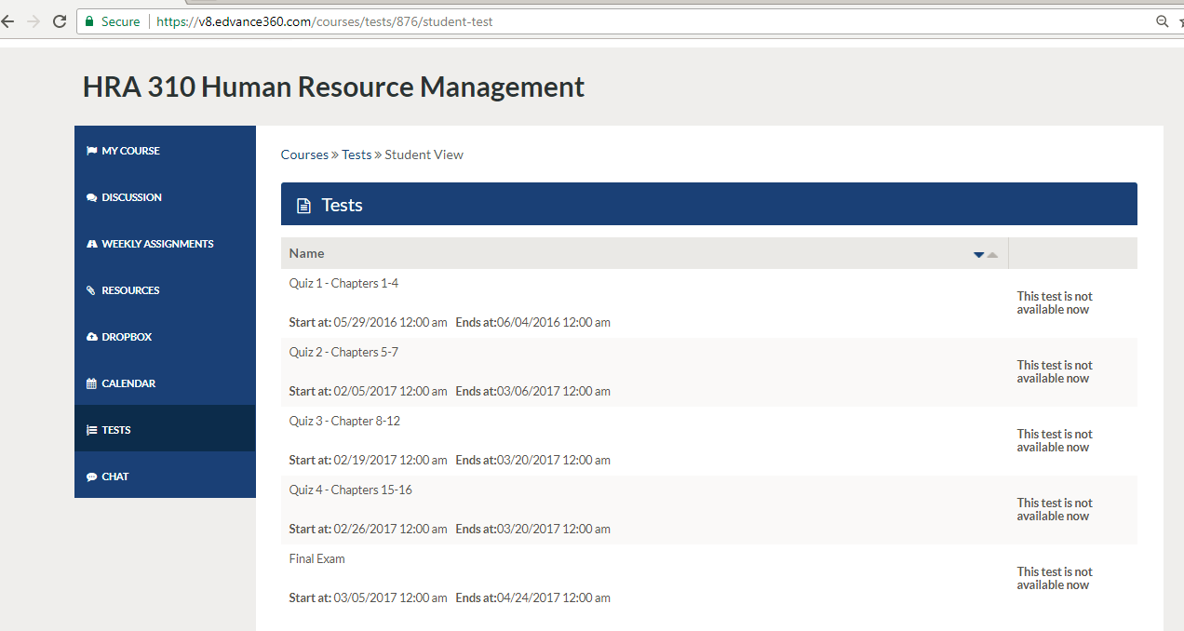
When logging into Internet Explorer, this is what I see
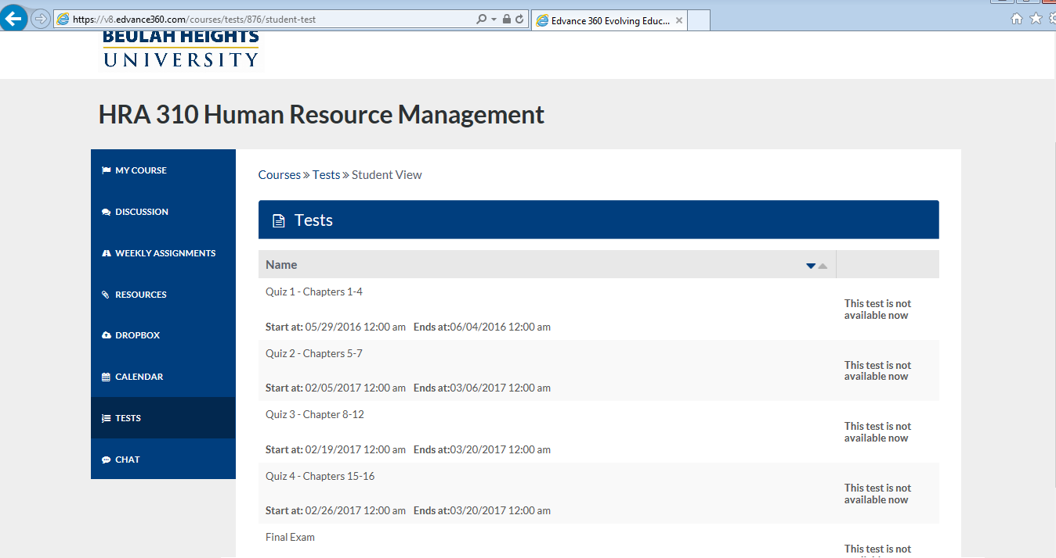
When I log into Firefox, this is what I see
