When trying to access via Google Chrome web browser
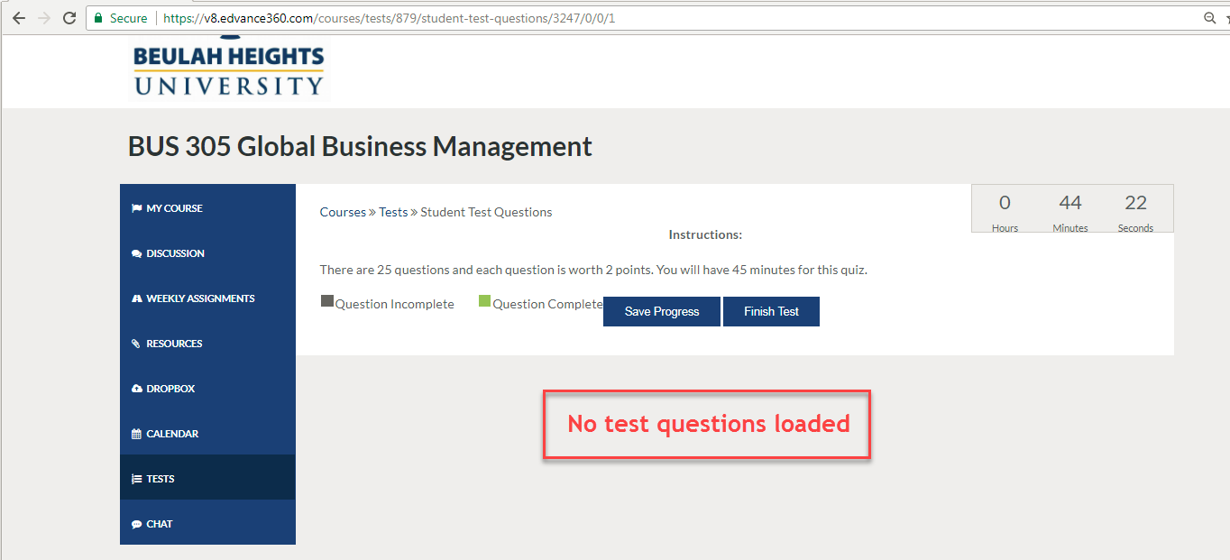

When trying to access via Firefox web browser
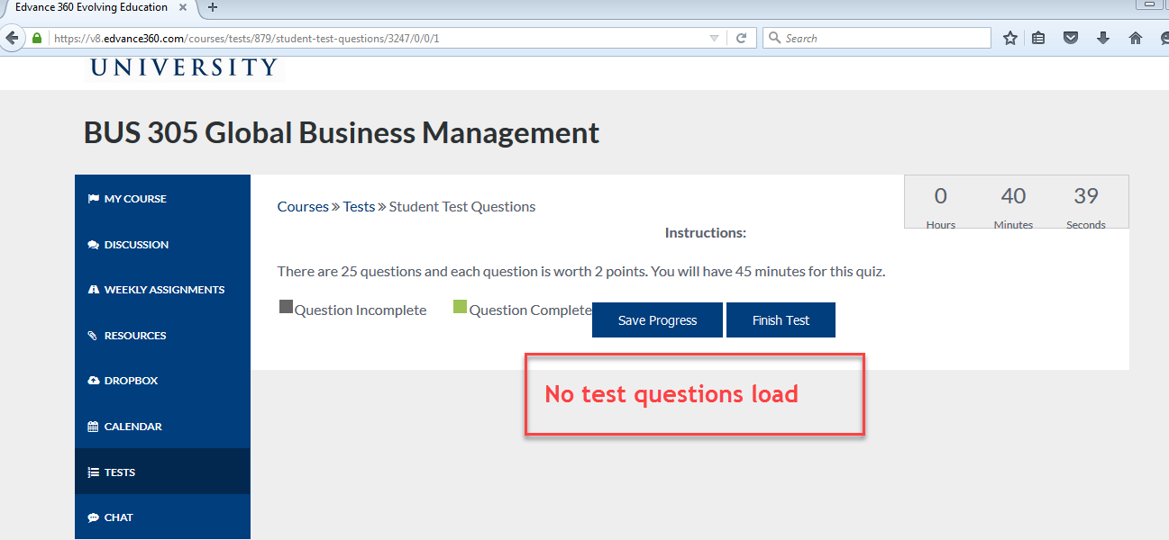

When trying to access via Internet Explorer web browser
