BA 235 – Business Statistics
Graphical Techniques Worksheet

NAME: __________________________________________________________

- The classification of student major (accounting, economics, management, marketing, other) is an example of a(n)
a. | Qualitative variable.
b. | Quantitative variable.
c. | Continuous random variable.
d. | None of these choices.

- For what type of data are frequencies the only calculations that can be done?
a. | Quantitative data
b. | Qualitative data
c. | Ordinational data
d. | None of these choices.

- Which of the following represents a graphical presentation of quantitative data?
a. | A bar chart.
b. | A histogram.
c. | A pie chart.
d. | All of these choices are true.

- Which of the following statements about shapes of histograms is true?
a. | A histogram is said to be symmetric if, when we draw a vertical line down the center of the histogram, the two sides are identical in shape and size.
b. | A negatively skewed histogram is one with a long tail extending to the left.
c. | A positively skewed histogram is one with a long tail extending to the right.
d. | All of these choices are true.

- Observations that are measured at successive points in time is what type of data?
a. | Time-series data
b. | Cross-sectional data
c. | Successive data
d. | None of these choices.

- The relationship between two quantitative variables is graphically displayed by a
a. | Scatter diagram
b. | Histogram
c. | Bar chart
d. | Pie chart

- How do you determine whether two quantitative variables have a positive linear relationship?
a. | Most of the points fall close to a straight line with positive slope.
b. | As the X variable increases, the Y variable increases in a linear way.
c. | The scatter diagram shows a linear pattern that is going uphill.
d. | All of these choices are true.

- Which of the following describes the shape of the histogram below?

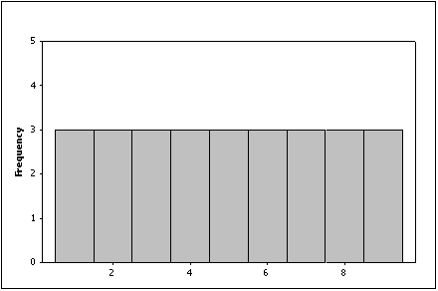

a. | Positively skewed
b. | Negatively skewed
c. | Symmetric
d. | None of these choices

- Which of the following describes the histogram below?

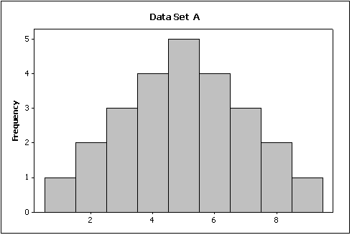

a. | The shape of the histogram symmetrical.
b. | The shape of histogram is bell-shaped.
c. | The histogram is unimodal.
d. | All of the above

- What type of graph depicts the data below?

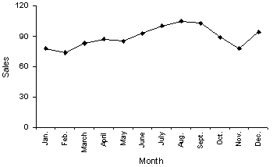

a. | A line chart
b. | A histogram
c. | A dot plot
d. | A bar chart

Directions: Answer the following questions.
Car Buyers

- Forty car buyers were asked to indicate which car dealer offered the best overall service. The four choices were Cute Motors (C), Modern Chrysler (M), Tiny Auto (T), and Uncomfortable Chevrolet (U). The following data were obtained:

T | C | C | C | U | C | M | T | C | U
U | M | C | M | T | C | M | M | C | M
T | C | C | T | U | M | M | C | C | T
T | U | C | U | T | M | M | C | U | T

- Construct a frequency bar chart of this data.
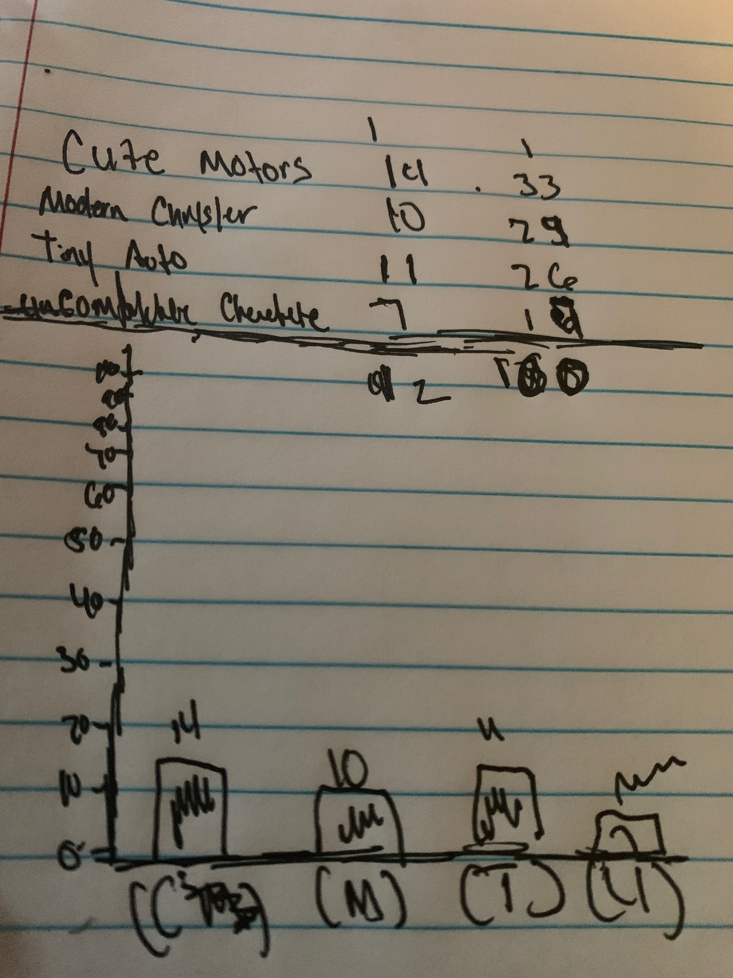

b) Which car dealer came in last place in terms of overall service?

Uncomfortable Chevy

c) Construct a pie chart of this data.

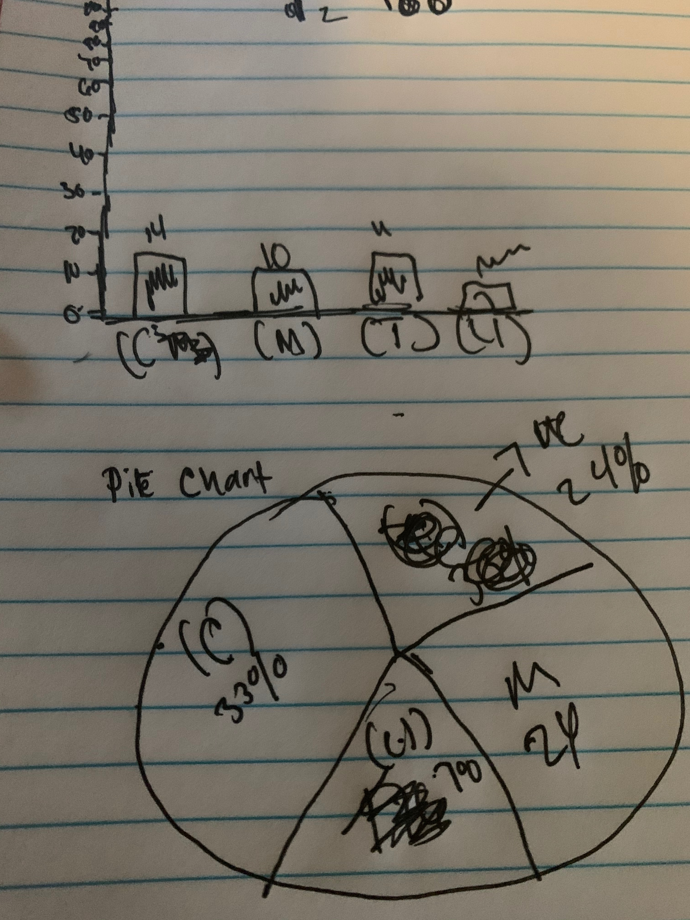

Greetings , My name is Kevin Reese senior marketing major. I believe one idea or practice Benedict College should implement to better the campus for students is community out reach. There are multiple local business surrounding the campus that students shop at daily these organizations also have community out reach budgets that are being spent elsewhere maybe because of lack of communication. A second idea to improve the campus would be to build a stronger connection with the school board leaders. As well all know Benedict College is a private institution governed a board of powerful and wealthy people. Also as a christian school tied to the Baptist organization if I'm not mistaken, these people have the means to improve the college but maybe they don't believe in the mission of the college. Which leads me to the third idea of reinvention, we also know that Benedict College has a newly found president in Dr.Artist. However most of the staff or faculty have been in there position for many years it seems to be a discount between the true mission of the college. As a liberal arts intuition the school should strive to be leading HBCU in innovation.

