BIO 110 General Biology Lab
PRE LAB 5: ROLL CALL OF THE ANIMALS

Name: ________________________________________ Date__________________________

PRELAB 5 (Total points:100)
INTRODUCTION: There is a great diversity within the animal kingdom. We recognize these animals because of certain differences in the characteristics that each possesses. The naming of organisms is a technical process. The scientific identification of organisms involves two different activities. One, taxonomy, is the naming of organisms; the other, phylogeny, involves showing how organisms are related evolutionarily.
The modern system of classification began in 1758, by a Swedish doctor named Carolus Linnaeus. He developed the two word naming system, the binomial system of nomenclature. The first part of an organism’s scientific name is the genus to which the organism belongs. The second part is the specific epithet. For example the leapord frog is scientifically identified as Rana pipiens.
In addition to assigning a specific name to each organism, Linnaeus recognized a need for placing organisms into groups. The taxonomic subdivisions from the most inclusive to the least inclusive are Kingdom, Phylum, Class, Order, Family, Genus, Species.
Although animals come in a variety of sizes and shapes, their bodies do conform to a few basic body plans. Asymmetry is a condition in which there is no pattern to the individual parts. Asymmetrical body forms are rare and occur only in certain species of sponges. Radial symmetry occurs when a body is constructed around a central axis. Any division of the body along this axis results in two similar halves. Examples are starfish and jellyfish. Bilateral symmetry exists when an animal is constructed with equivalent parts on both sides of a plane running from head to tail region. Most animals have bilateral symmetry.
A dichotomous key is a tool used to help determine the taxonomic category to which a specific organism belongs. It consists of a series of pairs of statements that require you to place the organism into one of the two categories. Each choice will lead you to another pair of statements until you have identified the animal’s category. For each of the specimen to be identified begin at step 1 of the key until you have identified the specimen.
Match the descriptions on the left with the terms on the right. Please put the letter of the term in the blank space (8 x 5 =40)

__________ 1. The two word naming system A. Asymmetry

___________ 2. Rana pipiens B. Dichotomous key

___________ 3. Body is constructed around a central axis C. Binomial system of
nomenclature
___________ 4. Tool used to help determine the taxonomic category D. Carolus Linnaeus

___________ 5. Shows how organisms are related evolutionarily E. Radial symmetry

___________ 6. Condition in which there is no pattern to the individual F. Leapord frog parts
____________ 7. The process of naming of organisms G. Phylogeny

____________ 8. Developed the two-word naming system H. Taxonomy
9. The taxonomic subdivisions from the most inclusive to the least inclusive are: (33pts)
__________________, __________________, ___________________, ___________________, ______________________, ___________________, ____________________________.

11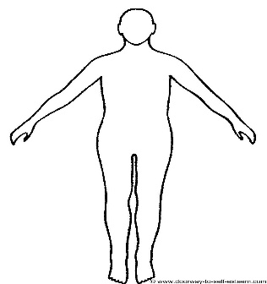 | 12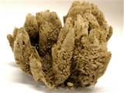 | 13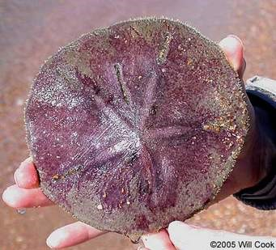
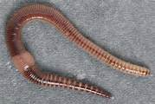 14 | 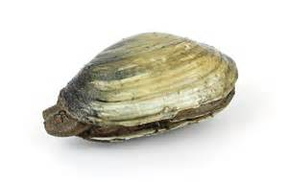15 | 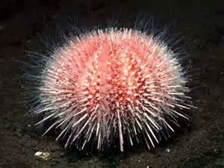 16
17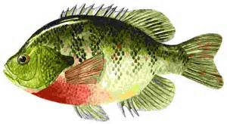 | 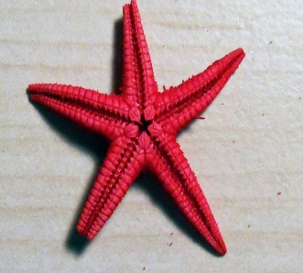  18 | 19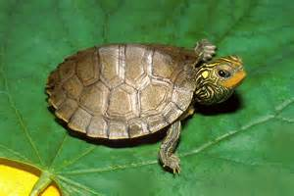
10. Study the pictures given above. Highlight the correct body plan of each specimen.
A. Specimen 11 : a) Asymmetry b) Radial Symmetry c) Bilateral Symmetry (3pts)
B. Specimen 12 : a) Asymmetry b) Radial Symmetry c) Bilateral Symmetry (3pts)
C. Specimen 13 : a) Asymmetry b) Radial Symmetry c) Bilateral Symmetry (3pts)
D. Specimen 14 : a) Asymmetry b) Radial Symmetry c) Bilateral Symmetry (3pts)
E. Specimen 15 : a) Asymmetry b) Radial Symmetry c) Bilateral Symmetry (3pts)
F. Specimen 16 : a) Asymmetry b) Radial Symmetry c) Bilateral Symmetry (3pts)
G. Specimen 17 : a) Asymmetry b) Radial Symmetry c) Bilateral Symmetry (3pts)
H. Specimen 18: a) Asymmetry b) Radial Symmetry c) Bilateral Symmetry (3pts)
I. .Specimen 19: a) Asymmetry b) Radial Symmetry c) Bilateral Symmetry (3pts)

LAB 5: ROLL CALL OF THE ANIMALS
Lab Report (Total points:100)
1. Here is a list of organisms: a) Ant, b) bony fish, c) Starfish, d) Pine, e) Turkey, f) Sponge, g) Eagle, h) Snake, i) Lion, j) Dog, k) Ivy, l) Earthworm, m) Clam, n) Grasshopper

Choose an organism from the above list that best fits the description given in the chart and fill in the chart. (14x 4 =56)

Description | Organism | Description | Organism
Animal |  | Radial symmetry
Plant |  | No shape
Bones absent (animal) |  | 3 pairs of jointed legs
Bones present |  | With feathers
Body in a shell |  | With hair or fur
Segmented body |  | Scales present; sheds skin
Feed young ones with own milk |  | Bilateral symmetry
LAB PROCEDURE:
Use the dichotomous key to identify the taxonomic category to which each specimen belongs. As you go down the dichotomous key, circle the # and letter under Dichotomous key description in this sheet of paper that best describes your specimen.
In the box Record and underline the phylum or class to which this specimen belongs.
SPECIMEN # 11 (from the above picture chart)
Dichotomous key description (7 pts)
1a 1b; 2a 2b; 3a 3b; 4a 4b; 5a 5b; 6a 6b; 7a 7b; 8a 8b; 9a 9b;
10a 10b; 11a 11b; 12a 12b; 13a 13b; 14a 14b; 15a 15b; 16a 16b.

RECORD: (7 pts)

SPECIMEN # 13 (from the above picture chart)
Dichotomous key description (8 pts)
1a 1b; 2a 2b; 3a 3b; 4a 4b; 5a 5b; 6a 6b; 7a 7b; 8a 8b; 9a 9b; 10a 10b; 11a 11b; 12a 12b; 13a 13b; 14a 14b; 15a 15b; 16a 16b;

RECORD: (7 pts)

Specimen 17 (from the above picture chart)
Dichotomous key description (8pts)
1a 1b; 2a 2b; 3a 3b; 4a 4b; 5a 5b ; 6a 6b; 7a 7b; 8a 8b; 9a 9b;10a 10b;
11a 11b; 12a 12b; 13a 13b; 14a 14b; 15a 15b; 16a 16b

RECORD ANSWER: (7 pts)

