Kei Wildgoose
Personal Health and Wellness Plan Paper
Health Education
Course ID: HE 230
Fall 2020
Bad Eating Habits
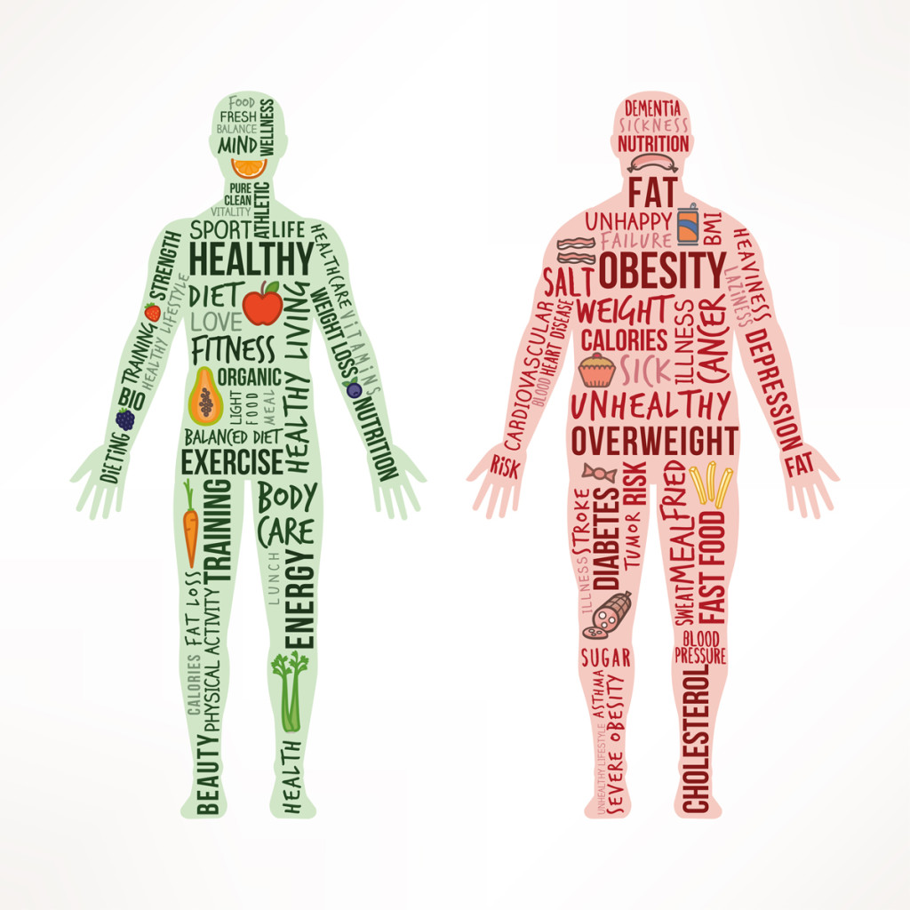

In the broadest sense, health behavior refers to the actions of individuals, groups, and organizations, as well as the determinants, correlates, and consequences, of these actions — which include social change, policy development and implementation, improved coping skills, and enhanced quality of life. A long way from being unavoidable, chronic illnesses are related with undesirable and hazardous health practices. What is more, those practices are frequently molded by the situations in which we live, work, learn and play. That implies there are an assortment of creative and demonstrated approaches to make it simpler for individuals to receive sound practices. One health behavior that I consider an increasing problem for me which can lead to chronic illnesses is an unhealthy diet.
An unhealthy diet can lead to health issues such as malnutrition, poor digestion, inflammation, unwanted weight gain and obesity. It can also increase your risk of chronic diseases, such as diabetes and heart disease, and impact your mental health. These are all risks I want to avoid at all costs.
There are many factors that can contribute to an unhealthy diet. My lack of restraint while eating led me to this unwanted health behavior. While I am not obese, I still feel that my eating habits are quite unhealthy. Furthermore, my failure to recognize the importance of the food pyramid as well as the amounts per serving has led to this sustained health behavior. My failure to do the following led me to unhealthy eating:
Avoid artificial sweeteners.
Eat mindfully.
Do not eat fast.
Avoid late night snacking.
Never skip breakfast.
Surround yourself with healthy foods.
Two long-term health problems that can develop as a result of a sustained unhealthy diet are hypertension and Alzheimer’s disease. A diet that is too high in sodium and too low in potassium puts you at risk for hyper. Eating too much sodium—an element in table salt—increases blood pressure. Sugar creates a dangerous cycle of insulin resistance. Poor insulin control is a risk factor for Alzheimer’s disease. When you eat food, carbohydrates, starches and sugar in your food are broken down into another type of sugar called glucose.
My first strategy for improving my unhealthy diet is by drinking more water. People should drink at least eight glasses of water each day, I probably drink around half that amount. There are a few rather simple ways that I can do this. One is by drinking a glass of water before every meal. I eat three meals a day and drink a glass of water after each, this new strategy will add an extra glass per meal. My second strategy for improving my unhealthy diet is by paying attention to portion sizes. The meat I eat, or protein source, should take up about one-quarter of my plate, and any starchy foods like potatoes, rice or pasta, should only take up another quarter. The other half of my plate can be filled with nutritious low-calorie fruits and vegetables like tomatoes, broccoli, cauliflower, asparagus, peas, green beans, or a garden salad. To meet such improvements, I will strive to become a better chef. For any positive progress I intend to reward myself with a box of pizza twice a week. My various support systems include my older brother who is better in the kitchen than I am. I also have my mother who is more than a talented chef. My final goal ultimately is quite simply to be as healthy as possible and illness free for life.

References:
https://www.encyclopedia.com/medicine/psychology/psychology-and-psychiatry/health-behavior
www.shapefit.com/diet/7-ways-avoid-unhealthy-eating-habits.html
www.ahchealthenews.com/2017/10/24/27-medical-problems-caused-poor-diet/
www.cdc.gov/bloodpressure/behavior.htm
https://www.verywellfit.com/change-your-diet-with-these-five-tips
https://www.thedailymeal.com/20-ways-improve-your-eating-habits
www.cdc.gov

