General Biology Lab (BIO 110L)
LAB 4: The Microscope and Survey of Cells Total points:100
Lab Report
Name: _____________________________________

Date: ___________________________
Microscope
- (A) Study the diagram of the microscope.
(B) Match the terms listed below with the microscope parts labeled in the given figure (7 x 3 =21pts)
Lamp Stage Ocular Lenses Objective Lenses
Coarse Adjustment Knob Fine Adjustment Knob Revolving Nosepiece

ANSWER BOX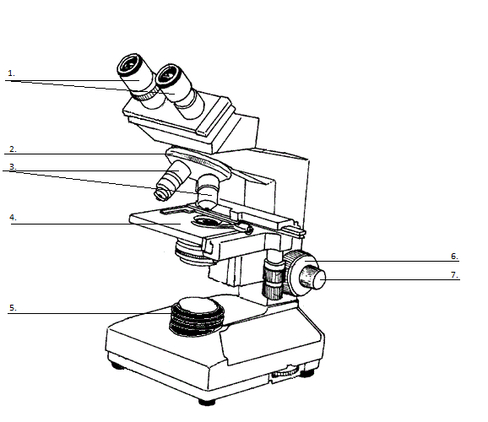

- Ocular Lenses 2. Revolving Nosepiece

- Objective Lenses 4. Stage

5. Lamp 6. Coarse Adjustment Knob

7. Fine Adjustment Knob

Microscopic Images
If you cut out the letter “e” and place it on a slide this is what it looks like to the UNAIDED eye:
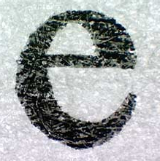

When you view it under a microscope on LOW power magnification, it looks like this:
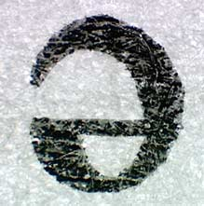

2. What do you notice about the images? (5pts)
- the microscope must be broken.
- the slide was made incorrectly.
- the microscope inverted the image.

When switched to HIGH power magnification on the microscope the “e” looks like this:
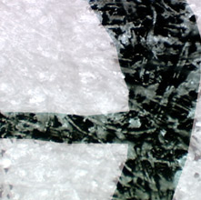
3. Compare the LOW power and HIGH power images. As magnification increased, what can you say about the
image? (5 pts)
a. you see more of it b. you see less of it c. it looks the same

4. When using a microscope, your movements are backwards due to mirrors and lenses inside the microscope.
Keeping this in mind, if you were looking through a microscope at an image and you moved the slide to
the RIGHT, which way will your image appear to move? (6 pts)

a. to the right b. to the left c. upward d. downward

5. The ocular lens (eye piece) of a microscope in our class magnify an image 10X. The HIGH power
objective lens magnifies by 40X. If the equation to calculate TOTAL MAGNIFICATION is:
OCULAR X OBJECTIVE = TOTAL MAGNIFICATION

What would be the total magnification of this microscope on HIGH power? 400X (6 pts)

6. The following diagram illustrates the field of view as if you are using low power magnification. Circle the part of
the slide (numbers) you would see if you switched from low power to high power magnification. (6 pts)
1
9 4
10
3 2
6

7. If you were using low power and wanted to look at the number 3 on high power, what should you do before you switch to high power? (6 pts)
A. Bring 3 to the center B. Focus on the number 10 without moving the slide C. Prepare a new slide with the numbers switched around.
Kingdom Plantae and Kingdom Animalia
Plant cells (unlike animal cells) are surrounded by a thick, rigid cell wall.
Cheek cells are flat, irregularly shaped cells with a large nucleus visible near the center using a microscope.
8. Below are drawings of two cells Cell A and Cell B. Label the following structures: cell wall, cytoplasm, vacuole, nucleus, cell membrane and chloroplast
9. Give a TITLE to each drawing.

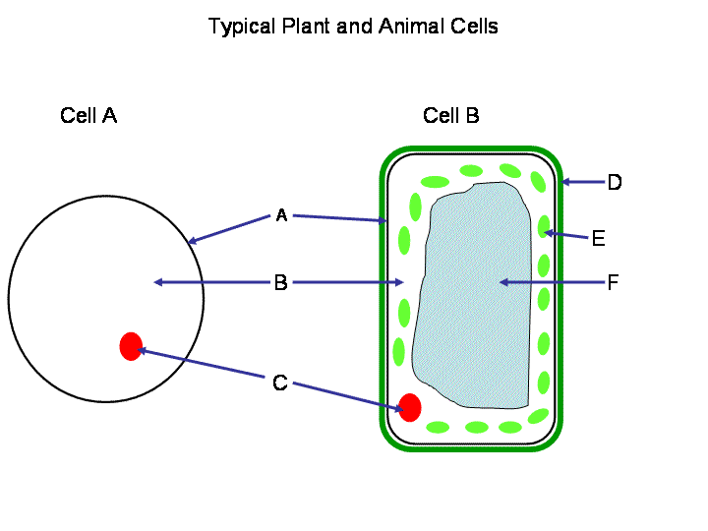

Title : Cell A: Animal (3 pts) Title : Cell B: Plant (3 pts)

Answer Box
A. Cell Membrane B. Cytoplasm

C. Nucleus D. Cell Wall

E. Chloroplast F. Vacuole
Cell parts
6x 4= 24prs

10. State TWO structural differences between plant and animal cells. (5 pts)
A. ONLY plant cells have cell membrane and nucleus B. ONLY plant cells have cell wall and chloroplast. C. ONLY animal cells have cell wall and nucleus. 11. What is the purpose of using the Lugol’s Iodine as a stain? (5pts)
A. Lugol’s iodine make the cells look smaller. B. Lugol’s iodine make the cells look bigger.
C. Lugol’s iodine make the cells more visible
12. What is one function of the cell wall? (5pts)
A. To protect the cells from the environment. B. To capture sunlight from the environment . C. To make plants look green.

