Name: Mia J Pringle 9/14/2020

Hydrogel Procedure:

Introduction
This experiment is to see if hydrogel can be used to lower water conservation and groundwater contamination. While doing this lab it can help us get to know more about the scientific method, learn more about independent and dependent variables. Hydrogel can be used in many ways such as in diapers and help plants keep its moisture. When hydrogel is used it can be very helpful in our environment. That is why doing this lab we can test to see if hydrogel is good for the environment.

Materials
- Flask
- Water
- Potting soil
- 2 Plastic Bottle
- Scissors
- Disposable Diaper
- Spoon
- Graduated Cylinder
- Plastic Wrap

Method

A new diaper was placed on the plastic wrap and then we began to cut out the inside lining of the diaper. The inside lining was rubbed together over the plastic wrap until all the powdery polymer came out. Any left-over cotton that fell on the plastic was removed and the powder was weighed. From the results of the weight we were able to find the concentration of solute and solvent. The powder was placed into a 250 ml beaker and mixed with 60 ml of water. After about 30 seconds the liquid became a solid gel. Two clear plastic bottles that had holes in the caps had potting soil in them. A tablespoon of hydrogel was mixed throughout one bottle of soil from top to bottom while the other soil labeled as the controlled soil. Both soil soakers were placed over a flask and 60 mL of water poured into each one.
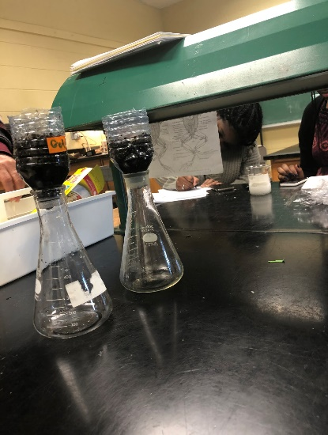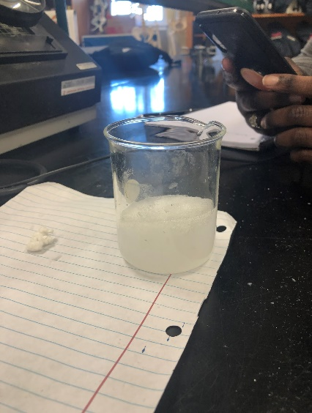

Results

 | Variables | Color | Smell
Experimental | Hydrogel | No Color | No Smell
Control | Soil | No Color | No Smell

15ml x (the weight of your polymer in gram) / 118ml
15 ml x 2.860/ 118ml = 0.36 g
2.860g = weight of polymer

 | Wt./Vol | Smell | Color
Powder | 2.860 | No Smell | No Color
Solvent | 118 | No Smell | No Color

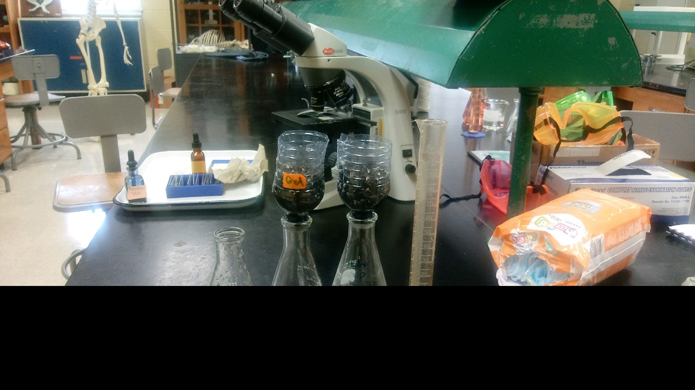
Question
- 1.create and record your data in a table below. (Include experimental group, control group, variables, color, and smell.) (20)

 | Variables | Color | Smell
Experimental | Hydrogel | No color | No smell
Control | Soil | No color | No smell

- What is the concentration of the solution which you added the polymer? Calculations. (10)
0 36 g= 0.118mL
- What were the independent variable(s) and dependent variable(s)? (20)
Independent = water 60mL
Dependent = powder
- Does your hypothesis support or disprove the data? Why or why not? (10)
Yes, the hypothesis supports the data. From the experiment 30mL of water was held from the controlled and 15mL of water from soil.
- Did the addition of the absorbent hydrogel impact the movement of water through the soil? Explain. (10)
Yes, it did because when the water was poured in it started dripping slower than the controlled one.
- Can you think of any design flaws with this experiment (uncontrolled variables)? If so, what were they? (10)
- We could have weighted the soil
- What new questions do you have after doing this experiment? (10)
- What would have happened with more hydrogel in the experiment soil?
- Is hydrogel safe for babies?

Discussion
To make the hydrogel we used powdery polymer taken from a diaper and mixed it with water. The goal in this experiment was to test the water retention using hydrogel. The end results were the soil with hydrogel mixed retained more water. So, my hypothesis was right and supported the data. Is hydrogel safe for humans to use on babies?

Conclusion
The hypothesis was proven by the results and data from the experiment. The absorbent hydrogel impacted the movement of water, it decreased the dripping of water
Experiment 2
September 14, 2020
Acid Base Lab

Introduction

This lab will let us find the pH of items in our homes. The pH scale is used to measure acids, bases, and natural objects around us. When more hydronium ions are in a solution it will be called acid. When there is more hydroxide the solution is a base. A pH scale ranges from 0-14 acids are from 0-6, 7 is neutral, and 8-14 are base. When using the pH scale the farther away from 7 the stronger the acid and base. The hypothesis in this lab is if we test the pH of common household items, then we can determine if the material is an acid, base or natural.

Materials
- Tums
- Coke
- Vinegar
- Tap Water
- Construction Paper
- pH Paper
- Ziploc Bags
- Blackberries
- Test Tubes

Methods
Blackberries were inside the Ziploc bag, then all the berries were mashed until it became jam-like. A little amount of water was added to the berry jam to thin it out. The five strips of white construction papers were placed into the jam so the paper could be soaked with the juice. Using our fingers gently removing any excess juice and pulp, the strips were placed on the paper towel to dry out. The pH of Tums, vinegar, tap water, aspirin, and Pepsi was first predicted and recorded. Using the pH paper all of them were tested and data inserted into the table. One at a time the solutions were tested to avoid mixing them. The berry paper was dipped into each solution and the data was recorded as well.

Results

Material | Predicted pH | pH of litmus paper | Color of Berry pH paper | Acid or Base
Tap Water | 7 | 6 | ~ | Neutral
Tums | 6 | 8 | 8 | Base
Vinegar | 8 | 2 | 4 | Acid
Coke | 3 | 2 | 4 | Acid
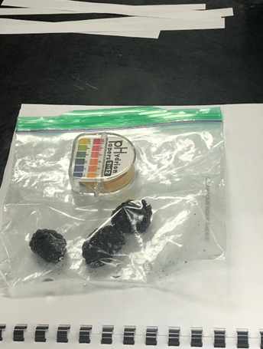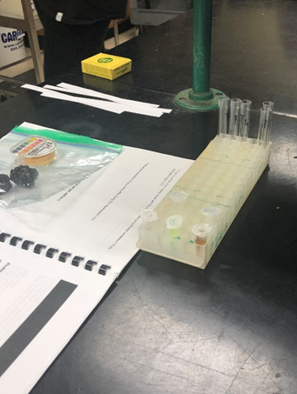

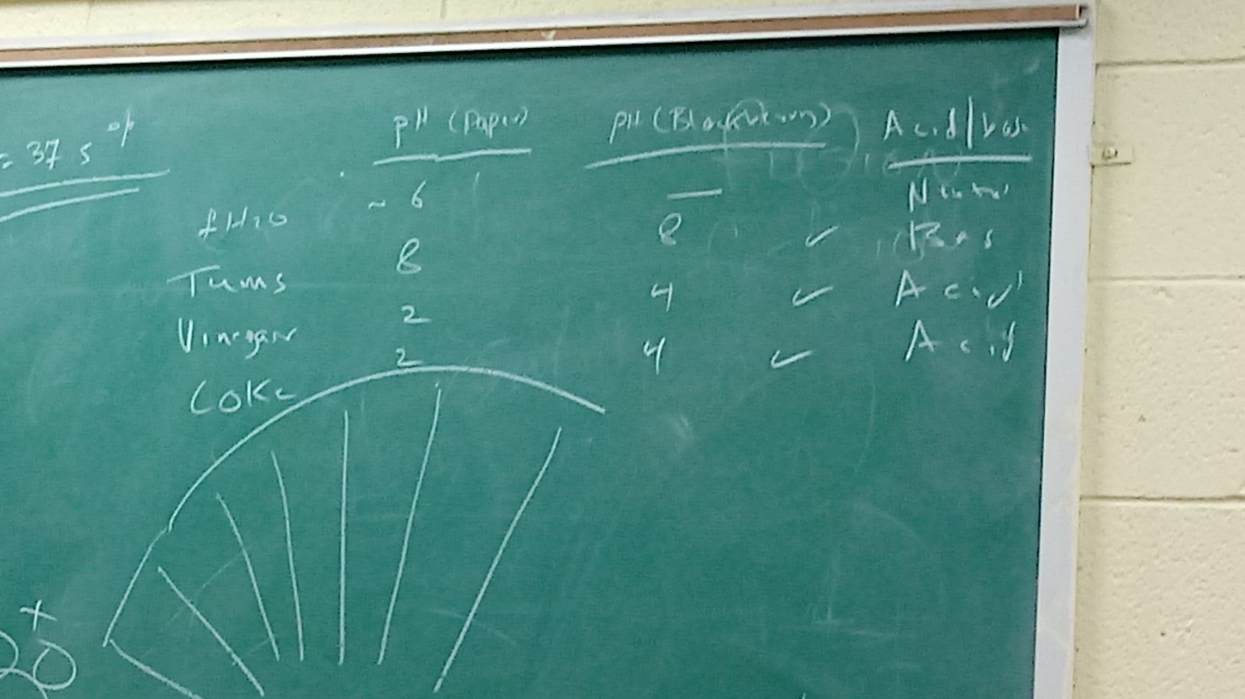

Questions

- The independent variable in the experiment is the litmus paper and dependent variable is the pH number. The control group is the berry paper. (9)
- When is a basic solution, the anthocyanin has an extra hydroxyl which then becomes a(n) acid in a(n) basic solution? (10)
- What was the Ph of Coke? 2 Coke has many acids in it including phosphoric acid and carbonic acid. When carbonic acid (H2CO3) ionizes in water, what are the two products? (10) bicarbonate ion (HCO3-) and a hydrogen ion

For the human body to operate, blood pH must be kept at a stable range. Buffer system help to keep the pH levels within this range. A buffer can absorb either hydrogens ions (h+) or hydroxide ions (OH-). Kidneys produce hydrogen carbonate (HCO3+) that acts as a buffer. Answer the question below.

- What organelle in the cell creates CO2? (5) Mitochondrion
- What was the pH of tums? 8 How does tums help with acid indigestion/heartburn? Why do you think the human stomach pH range is 2.0 – 3.-0? Tums antacid neutralizing, absorbing agents taken to relieve indigestion/heartburn. Stomach acid secreted into stomach response to expansion of stomach wall
- Water can help neutralize the pH of strong acids or bases. If you were to take an aspirin, what other food ingredient could you take to neutralize the pH? (6) milk is a great neutralize if you take aspirin. Also, plenty of proteins and buffer to neutralize.

- Hydrangea plants have flowers that turn blue when in acidic soil and pink when in basic soil. Fertilizers have a compound called ammonium (NH3-). After adding fertilizer to soil, a bacterium converts ammonium to nitrate. During this process 3H6+ are released into the soil. What do fertilizer do to the pH of soil? It increases the pH and the use of ammonium in fertilizers to maintain ph.

- If your hydrangea flowers were pink in color, what could you add to make the flowers blue? To make the flowers blue you would need to add soil acid or add the ammonium to the soil.

Discussion
During this lab you will learn about the pH scale and how to measure ph. Some people do not pay close attention to how important the pH is. Did you know that our stomach must be at the right pH to work correctly? When taking aspirins for a headache if they are to strong you can drink a glass of milk to help with the ph. Having heartburn is bad so you can take a tum which has a ph. of 8. The neutralizing parts calms the acid and removes the neutral protons.

conclusion
The berry pH is not comparable to the original ph. When berries are planted, they probably have acid fertilizer in the soil. In this lab the berries might be miss some of its necessary proteins or ions. In the theory is correct but not in the experiment.

