Lab 1
8/24/2020
Nieeshia Mitchell
Scientific method
Introduction:
Identifying the steps, preparing a hypothesis to test. Then utilizing the information provided and draw a conclusion to support the hypothesis. Predicting whether the hydrogel will effect the water flow through the soil.
Method:
- 1 graduated cylinder
- 2 water bottles cut in half
- 3 measuring beakers
- Soil
- 1 diaper
Result: 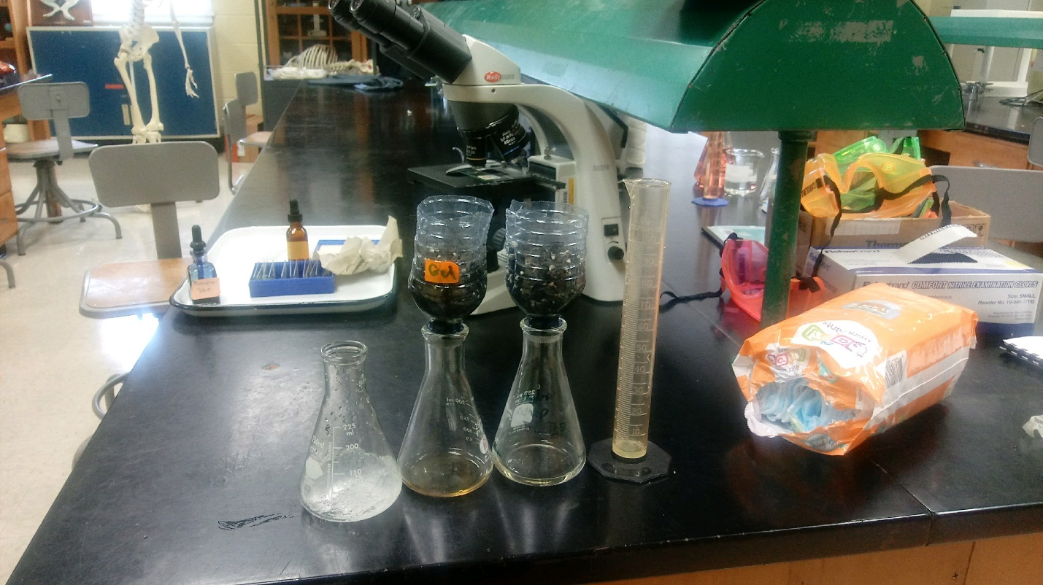
Discussion: What I observed from watching this lab was that the soil without hydrogel, the water flowed through the soil faster and the soil with the hydrogel, the water did not pass through as easily as the soil with hydrogel. Also, the color of the water changed with the soil that contained hydrogel.
Conclusion: I learned that hydrogel made the soil thicker to where the water ran through slowly and change its color.
Lab 2
8/31/2020
Nieeshia Mitchell
Acid Base Lab

Introduction: PH is a measurement of the amount hydronium (H3o+) and hydroxide (OH-) ions are in a solution. When there is more H3o+ or ions, you have an acid. When there is more OH- or ions, you have a base. Acids and bases are measured on a scale on 0-14, with 7 being neutral, acids being 0-7 and bases 7-14. Predicting the pH of 5 different common household items. Then predicting the PH balance of blackberries paper.
Materials/Method:
- Coke pH indicator (Blackberries) Vinegar
- Test tubes Litmus paper Tums
- Construction paper Tap Water Ziploc bag
- Bowl Graduated Cylinder
- Scissors Aspirin
Result: 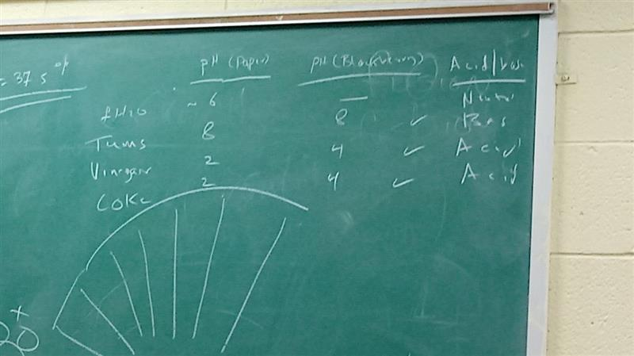
Discussion: What I observed while watching this lab was that the vinegar and coke were the most acidic households and the tap water and tums were bases. After testing the berry ph papers in the household items some of the ph balances changed.
Conclusion: I learned that many household items are acidic. When bases are mixed with acids it may change the ph balance.

