BIO 137 WORKSHEET 3 CELL STRUCTURE & FUNCTION Date September 14, 2020
Name Jacobi Williams
- Match the terms listed in the box below with the cell parts labeled. Use the Answer box below the diagram to label the cell parts (12x4=48)

Nucleolus, Ribosome, Nucleus, Centrioles, Rough ER, Smooth ER, Mitochondrion, Nucleoplasm, Lysosome, Cell membrane, nuclear membrane, Ribosome

Nucleolus, Cilia, Ribosome, Golgi apparatus, Centrioles, Rough ER, Smooth ER, Mitochondrion, Lysosome, Cell membrane
Give the diagram a title: Eukaryotic Cell Diagram (4 pts)
Answer Box
- Nucleus
- Nuclear Membrane
- Nucleoplasm
- Nucleolus
- Rough ER
- Ribosomes
- Cell Membrane
- Cytoplasm
- Mitochondrion
- Smooth ER
- Lysosome
- Centriole
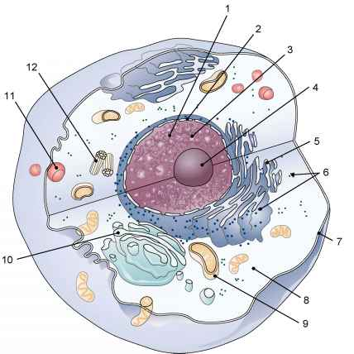
PARTS OF THE CELL

Match the descriptions in Column I with the name in Column II
Write the matching letter in the blank spaces (12x4= 48 pts)

COLUMN 1 COLUMN II

K 1. separates the genetic material from the rest of the cell a. Golgi apparatus

J 2. contain enzymes for digestion b. nucleus

G 3. where proteins are made (Protein synthesis) c. vacuole
A 4. Modifies, packs and ships substances for secretions d. centrioles

I 5. ribosomes are made here e. cytoplasm

L 6. controls entry into and out of the cell f. chloroplast

B 7. contain chromosomes g. ribosome

E 8. fluid (jelly like) part of protoplasm h. mitochondria
F 9. container of green pigment in a plant cell i. nucleolus

C 10. storage container in a cell j. lysosome

H 11. Contains enzymes for making ATP;
site for aerobic cellular respiration k. nuclear membrane
D 12. structures involved in animal cell division l. cell membrane

