(Group B) Tashea Symonette, Candice Colebrooke, Ibenese Jean-Gilles, Samson Dorsey
CE 211L : Digital Logic Lab
Pre-Lab 3: Digital Logic Gates
Objective:
• To study the basic logic gates: AND, OR, INVERT, NAND, and NOR.
• To study the representation of these functions by truth tables, logic diagrams and Boolean algebra.
• To observe the pulse response of logic gates.
• To measure the propagation delay of logic gates.

EXERCISES PART: Develop the truth table for all Logic gates in the Figure 1.
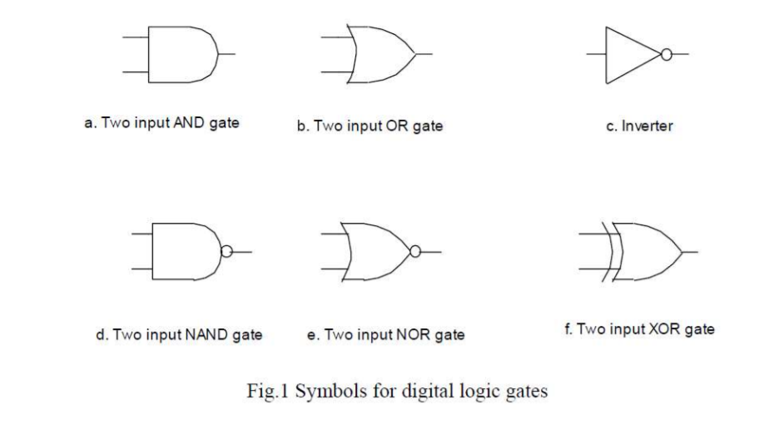

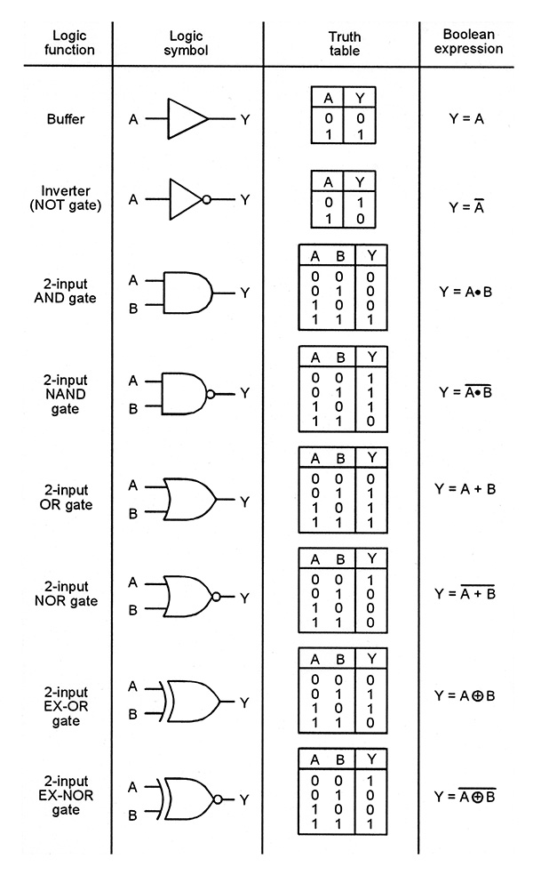

THEORY:
AND gate: A multi-input circuit in which the output is 1 only if all inputs are 1. The symbolic representation of the AND gate is shown in Fig. 1a.
OR gate: A multi-input circuit in which the output is 1 when any input is 1. The symbolic representation of the OR gate is shown in Fig. 1b.
INVERT gate: The output is 0 when the input is 1, and the output is 1 when the input is 0. The symbolic representation of an inverter is shown in Fig.1c.
NAND gate: AND followed by INVERT. The symbolic representation of the NAND gate is shown in Fig 1d. NOR gate: OR followed by INVERT as shown in Fig 1e.
EX-OR gate: The output of the Exclusive –OR gate, is 0 when it’s two inputs are the same and its output is 1 when its two inputs are different.
Truth Table: Representation of the output logic levels of a logic circuit for every possible combination of levels of the inputs.

