CE 211L : Digital Logic Lab
Final Lab 2: Binary and Decimal Numbers
Objective: To demonstrate the count sequence of binary number and the binary-coded decimal (BCD) representation.

MEASUREMENT PART:

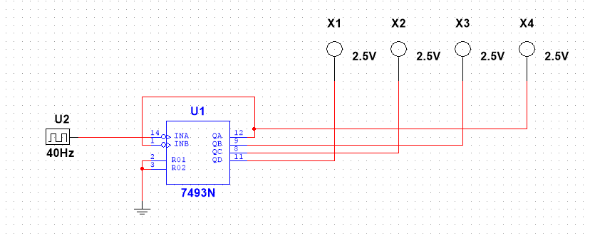
I.BINARY COUNT

Image of Binary Counter

7. Write the sequence of the binary numbers that are observed in your report.
ANS: The sequence observed was numbers 0-15 in Binary Code

9. Take picture of 3 sequence of the output and put it in your report

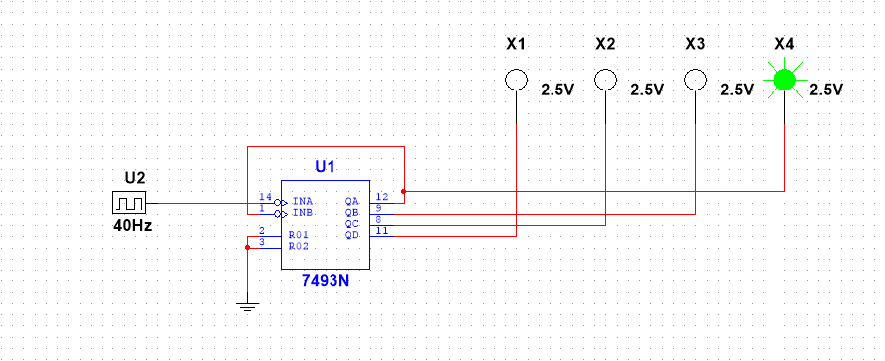
Binary Code 0001

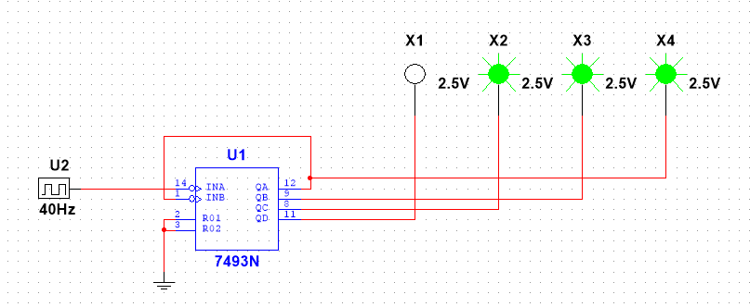
Binary Code 0111

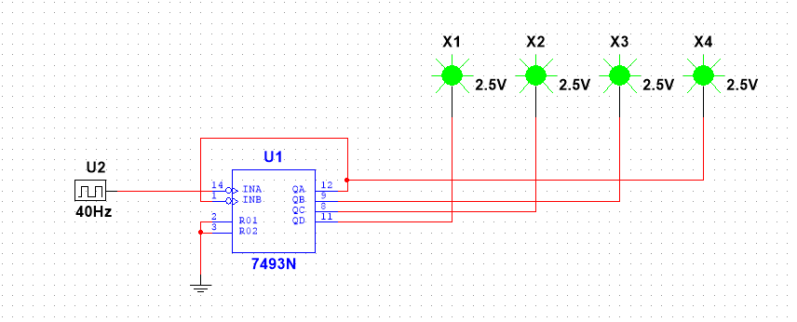
Binary Code 1111

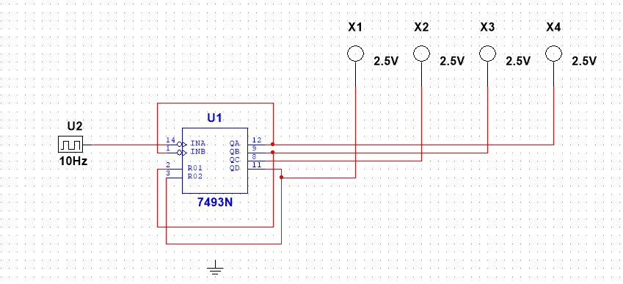
II. THE BCD COUNT
Image of BCD Counter

7. Write the sequence of the BCD that are observed.
ANS: The sequence observed was 0-9 in BCD

9. Take picture of 3 sequence of the output and put it in your report
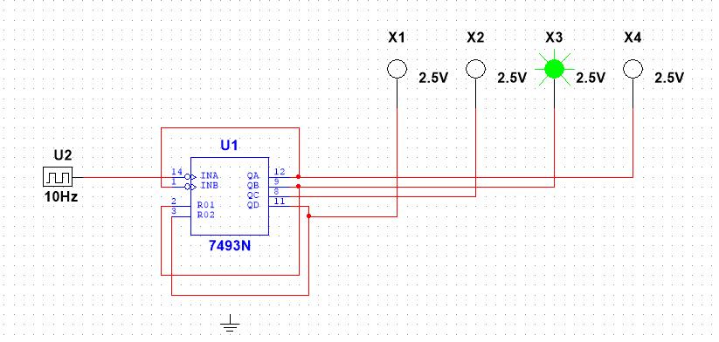

BCD 0010
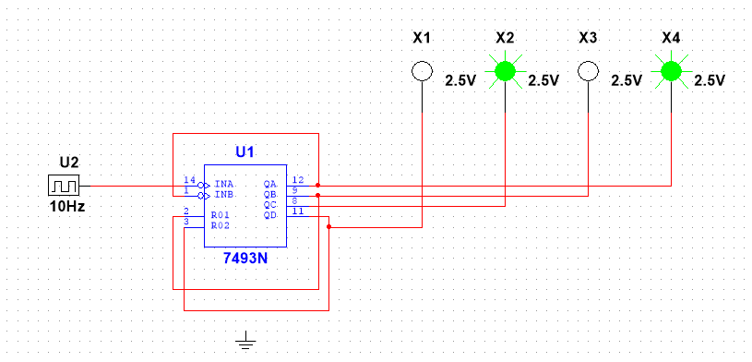
BCD 0101

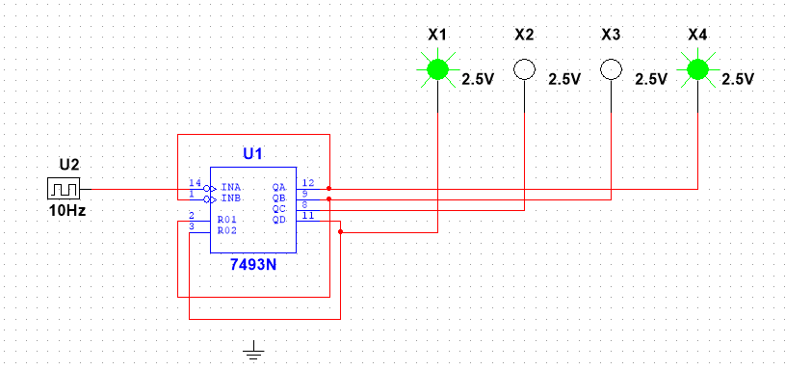
BCD 1001

Discussion
The comparison between both results of the Binary and BCD Counter was that the numbers were all inclusive of 0-9. Also, both counters were wired similarly, and received same results for the most part. The results were count in Binary and BCD.

