BIO 117 LAB 3 Chemistry of Life: pH of Matter

Pre-Lab
Acids, Bases, and pH Name: _Nadirah Karim_

The degree to which a solution is acidic or basic is represented by a quantity known as pH.
The pH of a solution can be measured by using pH meter, pH paper or color indicators.
The color indicators commonly used in biology labs are Bromothymol blue and Phenolphthalein.

Bromothymol blue is a chemical indicator that is blue in basic solutions, turns green in neutral, and turns yellow in acidic solutions. Phenolphthalein is a chemical indicator that is pink in basic solutions, and does not react with neutral and acidic solutions to exhibit a color change.

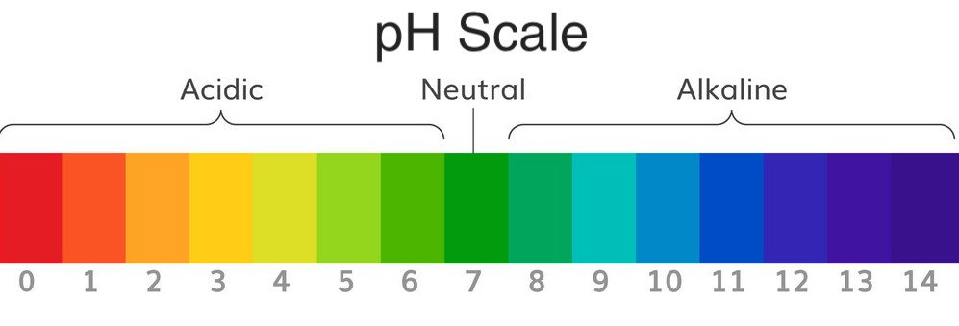

Use the above information answer the following questions:
1. Which of the following values indicates the greater concentration of acid?
pH 5 or pH 2? _2_
2. Which of the following values indicates the greater concentration of base?
pH 14 or pH 9? _14_
3. What does a pH of 7 indicate? _Neutral_
4. A student mixes strawberry koolaid and water. A pH meter is used to measure pH of 5.4. What kind of solution is strawberry koolaid?
- Acidic B. Basic C. Neutral

5. Bromothymol blue is a chemical indicator that is blue in basic solutions, turns green in neutral, and turns yellow in acidic solutions.

- What color you think bromothymol blue would be in water directly out of tap (pH 7.2)? _green-blue_
- What color you think bromothymol blue would be in water in which exhaled air is blown through a straw for 5 min and the pH is 5.1? _yellow-green_

- What color you think bromothymol blue would be in water after a snail has lived in it for three days (pH 5.8)? _yellow-green_
- What color you think bromothymol blue would be in water after 2mL of bleach has been added to it and the pH is 9.4 ? _blue_
- What color you think bromothymol blue would be in water with instant coffee added to it (pH 5.0)? _yellow-green_
Procedure I

Use the simulation lab to: pH Lab 1. Test and record the pH of coffee, blood, water, soap, milk, and soda pop.

2. Determine whether each is acidic, basic, or neutral.

3. Investigate whether changing the volume by adding 500ml of the substance being tested to the original volume affects the pH. Note the pH of the final volume of substances.

4. Investigate whether diluting each sample with 500ml of water affects the pH.
Please Note: All recordings must be done in the table 1 below.
TABLE 1
Sample | pH of Sample alone | Nature  Acidic/basic/neutral | pH after  Added sample | pH of  Diluted sample after  adding water
Coffee | 5.00 | Acidic | 5.00 | 5.30
Blood | 7.40 | Basic | 7.40 | 7.25
Water | 7 | Neutral | 7.00 | 7.00
Soap | 10.00 | Basic | 10.00 | 9.70
Milk | 6.50 | Acidic | 6.50 | 6.68
Soda Pop | 2.50 | Acidic | 2.50 | 2.80

Analysis of Data
Use the information from the Table 1 to answer the following questions:
1. Which is the most acidic substance? _Soda Pop_
2. Which is the most basic substance? _Soap_
3. Name the neutral substance. _Water_
4. What changes in pH occur when blood is diluted with water?
When blood is diluted with water its pH decreases, becoming either neutral or more acidic.
5. Is there any change in pH when the volume of blood is increased?
When the volume is increased the pH of blood stays the same.
Conclusion
Please note: You may try out the simulation with different samples to answer the next two questions.
6. What is the effect of volume on pH of substances? (Explain pH changes that might occur by increasing or decreasing the volume of the samples)
The effect of volume on the pH of substances is that it stays the same. As you add more of the substance, it doesn’t change the pH, unless you’re diluting it.

7. What is the effect of concentration on pH of substances? (Explain pH changes that might occur by increasing or decreasing the concentration of the samples)
The effect of concentration on pH of substances is that it decreases, the more the concentration increases.

Procedure 2: Copy down the pH of all samples in the appropriate column in Table 2. Predict the color change after adding the color indicators
TABLE 2
Sample | pH of Sample alone | Color After Adding  Bromothymol blue | Color After Adding  Phenolphthalein
Coffee | 5.00 | Yellow | Clear
Blood | 7.40 | Yellow-green | Clear
Water | 7.00 | Green | Clear
Soap | 10.00 | Blue | Pink
Milk | 6.50 | Yellow | Clear
Soda Pop | 2.50 | Yellow | Clear

ANALYSIS & CONCLUSION
Use the information from the above Table 2 to answer the following questions.
- Bromthymol blue changes color when mixed with an acid. What color should it become? _yellow_
- What color should Bromthymol blue be when in a base? _blue_

- What color would you expect Bromthymol blue to be if it were in a neutral solution? _green_
- Phenolphthalein changes to _pink_ in the presence of _basic solutions_.
- What is the advantage of using pH meter rather than Bromthymol blue or Phenolphthalein? _A pH meter instantly reads you the pH of an item. Whereas the Bromthymol blue and Phenolphthalein takes a while to show you the ph because you have to test it._
- Which reagent (Bromthymol blue or Phenolphthalein) could be considered as an acid indicator? _Bromthymol Blue_

