General Biology Lab (BIO 110L)
Lab Report LAB 7: ANATOMY OF FROG Total Points: 100
Name: ____miyah mccoy________________
- Match the terms listed in the box below with the body parts labeled in Diagram 1.
Lung, Gall Bladder, Liver, Small Intestine, Large Intestine, Esophagus, Stomach, Anus, Cloaca, Pancreas, Heart, & Spleen

Diagram 1 (12X3= 36 pts) Answer in the box below
1.esophagus
2.heart
3.lungs
4.liver
5.gall bladder
6.pancreas
7.stomach
8.spleen
9.small intestine
10.large intestine
11.cloaca
12.anus

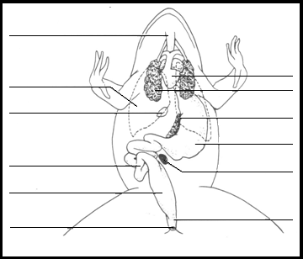
8
7
2
12
11
10
9
6
5
3
4
1

- _______________________

- _______________________

- _______________________

- _______________________

- _______________________

- _______________________

- ______________________

- ______________________

- _______________________

- _______________________

- _______________________

- ________________________

- _

B. Read the descriptions in the overview, study the diagram and match the terms with the descriptions (16x 4= 64)
______I___ 1. The membrane holds the coils of the small intestine together A. Peritoneum
_____D____ 2. This organ is found under the liver, it stores bile B. Cloaca
______E____ 3. The organ that is the first major site of chemical digestion C. Lungs
____B______ 4. Eggs, sperm, urine and wastes all empty into this structure D. Gall bladder
_____H_____ 5. The small intestine leads to this organ E. Stomach
_____O_____ 6. Absorption of digested food takes place here. F. Heart
____L______ 7. Yellowish structures that serve as an energy reserve G. Spleen
______M___ 8. The first part of the small intestine (straight part) H. Large intestine
_____K____ 9. The tube that leads from the frog’s mouth to the stomach I. Mesentery
____A_____10. A spider web like membrane that covers the organs J. Bladder
_____N__ 11. Regulates the exit of partially digested food from the stomach K. Esophagus
_____g____ 12. Organ found within the mesentery that stores blood L. Fat bodies
____P____ 13. The largest organ in the body cavity having 3 lobes M. Duodenum
_____F___ 14. A triangular structure that pumps blood N. Pyloric sphincter valve
____J____ 15. An empty sac that holds urine O. Small intestine
______C_ 16. Two spongy organs located behind the heart and liver. Supply oxygen P. Liver

