Bio 117Lab
The Microscope and Tour of Cells Total points:100
Lab Report
Name: Yu’Nique Dawkins

Date: 9/11/2020
Microscope
- (A) Study the diagram of the microscope.
(B) Match the terms listed below with the microscope parts labeled in the given figure (7 x 2 =14pts)
Lamp Stage Ocular Lenses Objective Lenses
Coarse Adjustment Knob Fine Adjustment Knob Revolving Nosepiece

ANSWER BOX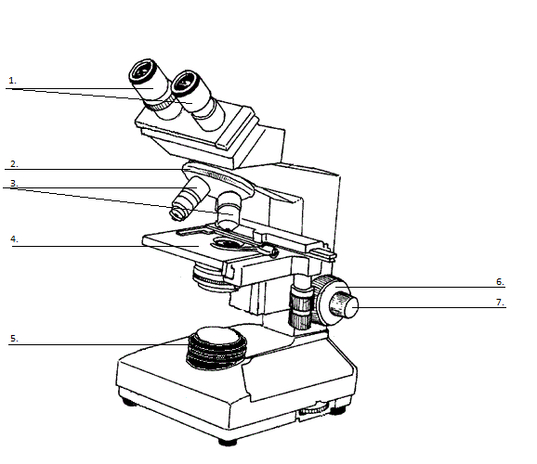

- Ocular Lense 2.Rvolving nosepiece

- Objective Lenses 4.Stage

5. Lamp 6. Course adjustment knob

7. Fine adjustment knob

Microscopic Images
If you cut out the letter “e” and place it on a slide this is what it looks like to the UNAIDED eye:
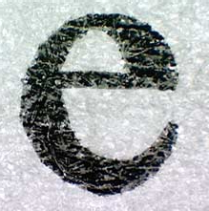

When you view it under a microscope on LOW power magnification, it looks like this:
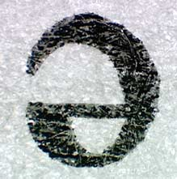

2. What do you notice about the images? (4 pts)
- the microscope must be broken.
- the slide was made incorrectly.
- the microscope inverted the image.

When switched to HIGH power magnification on the microscope the “e” looks like this:
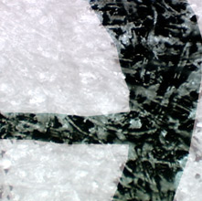
3. Compare the LOW power and HIGH power images. As magnification increased, what can you say about the
image? (4 pts)
a. you see more of it b. you see less of it c. it looks the same

4. When using a microscope, your movements are backwards due to mirrors and lenses inside the microscope.
Keeping this in mind, if you were looking through a microscope at an image and you moved the slide to
the RIGHT, which way will your image appear to move? (4 pts)

a. to the right b. to the left c. upward d. downward

5. The ocular lens (eye piece) of a microscope in our class magnify an image 10X. The HIGH power
objective lens magnifies by 40X. If the equation to calculate TOTAL MAGNIFICATION is:
OCULAR X OBJECTIVE = TOTAL MAGNIFICATION

What would be the total magnification of this microscope on HIGH power? ______1000x_______ (4 pts)

6. The following diagram illustrates the field of view as if you using low power magnification. Circle the part of
the slide (numbers) you would see if you switched from low power to high power magnification. (5 pts)
1
9 4
10
3 2
6

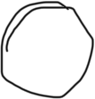

7. If you were using low power and wanted to look at the number 3 on high power, what should you do before you switch to high power? (4 pts)

A. Bring 3 to the center B. Focus on the number 10 without moving the slide C. Prepare a new slide with the numbers switched around.

8. How is a simple microscope different from a compound microscope? (5 pts)
There’s many differences in a simple microscope. The first difference is the number of lenses. The simple microscope has 1 sense and the compound microscope has 3-5 lenses. Simple microscope uses natural light source and the compound microscope uses illuminator light source.
9.What is the function of the ocular lens? (5pts)
The ocular lens magnifies the image.

10. You are asked to view a sample of pond water to find microorganisms under the microscope. Fill in the blank spaces with terms that you would follow to view the specimen. (12 pts)
Take a dropper full of pond water and place a few drops of the water on a ____slide________, cover it with a ______cover_____and place it on the ____stage_____. With the _____coarse______ adjustment knob and then the ____fine____ adjustment knob focus on the object you want to view. Start viewing with ___10x_______ objective lens to locate the specimen. Then move on to _____high______ power ______objective______ lens to view details..

Kingdom Plantae and Kingdom Animalia (Eukaryotes)
Plant cells (unlike animal cells) are surrounded by a thick, rigid cell wall.
Cheek cells are flat, irregularly shaped cells with a large nucleus visible near the center using a microscope.
11. Below are drawings of two cells Cell A and Cell B. Label the following structures: cell wall, cytoplasm, vacuole, nucleus, cell membrane and chloroplast
Give a TITLE to each drawing.

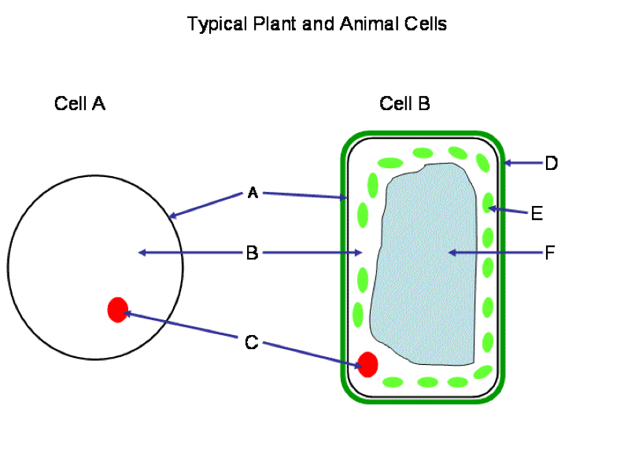

Title : Cell A: Animal Cell (2 pts) Title : Cell B: Plant Cell(2 pts)

Answer Box
A. Cell membrane B. Cytoplasms

C. Nucleus D. Cell wall

E. Chloroplast F. Vacuole
Cell parts
6x 2= 12 prs

12. State TWO structural differences between plant and animal cells. (3 pts)
Plant cells have a cell wall and animal cells do not. Plant cells have chloroplasts and animal cells do not.

13. What is the purpose of using the Lugol’s Iodine as a stain? (3 pts)
Lugol’s Iodine is used to indicate starches in organic compounds.
14. What is one function of the cell wall? (3 pts)
The Function of the Cell wall is to provides structural support and protection.

Prokaryotic Cells

15. Below is a drawing of a prokaryotic cell. Label the following structures: flagella, capsule, DNA, pilus, and ribosome
Give a TITLE to the drawing.

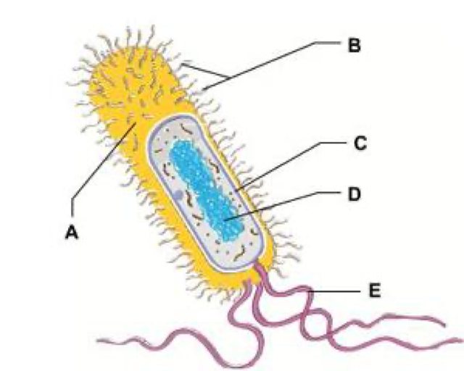

Title ___________Prokaryotic Cell ________________ (2pts)
(5 x 2= 10 pts)

A. Pili

B. Capsule

C. Ribosomes

D. DNA
E. Flagella

E. ____________________________

16. Why is the above cell a prokaryotic cell? (2 pts)

The cell above do not have a nucleus .

