`BIO 130 (General Biology)
Worksheet 2: The Origin of Life (CH. 19) (Total Points: 100)
Name: Deborah Kifle Date: August 17, 2020
- A. State the concept of spontaneous generation. (5 pts)
Life that originated form nonlife
B. Who proposed this concept? (5 pts)
Aristotle (284-322 B.C)
- A. State the concept of Panspermia. (5pts)
Life arose outside the earth and were transported to Earth to populate the earth.
B. Who proposed this concept? (5pts)
Swedish scientist named Svante Arrhenius
- Describe the concept of biogenesis. (10pts)
Life originates from pre-existing life.
- Describe briefly the chemical evolution of life on earth. (10pts)
The first living things arose from inorganic matter (C, H, O, N). Random combinations of of inorganic compounds, under the influence of strong ultraviolet light from the sun, resulted in the formation of extremely complex organic (carbon containing) compounds, which are the basis of life.

Evaluate & draw Conclution:
Study Redi's Experiment and answer the following questions that follow.
Redi's Experiment
In 1668, Francesco Redi, an Italian physician, performed an experiment that challenged the concept of spontaneous generation. He set up a controlled experiment to test the hypothesis that maggots arose spontaneously from rotting meat (figure 19.1). He used two sets of jars that were identical except for one aspect. Both sets of jars contained decaying meat, and both were exposed to the atmosphere. However, one set of jars was covered by gauze while the other was uncovered. Redi observed that flies settled on the meat in the open jars, but the gauze blocked their access to the meat in the covered jars. He found that maggots appeared on the meat in the uncovered jars but not on the meat in the covered ones.
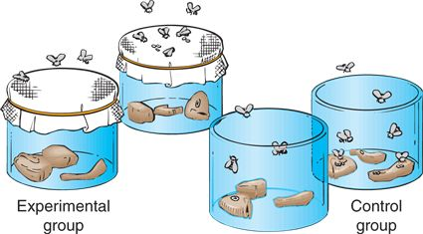
Questions from Redi’s experiment

- What hypothesis was Redi testing? (State the hypothesis in question form) (10pts)
  - To test the hypothesis that maggots arose spontaneously from rotting meat.
- Were both groups (experimental & control) exposed to air? (10pts)
  - No. the first pair were covered with gauze cloth while the other pair was exposed to the air.
- What was the variable? (10pts)
  - The gauze covers
- Where did the maggots come from in the control group? (10pts)
  - From the air
- Did Redi’s experiment support spontaneous generation? (10pts)
  - No, it did not.
- Which concept did this experiment support? (10pts)
  - biogenesis

