(obesity)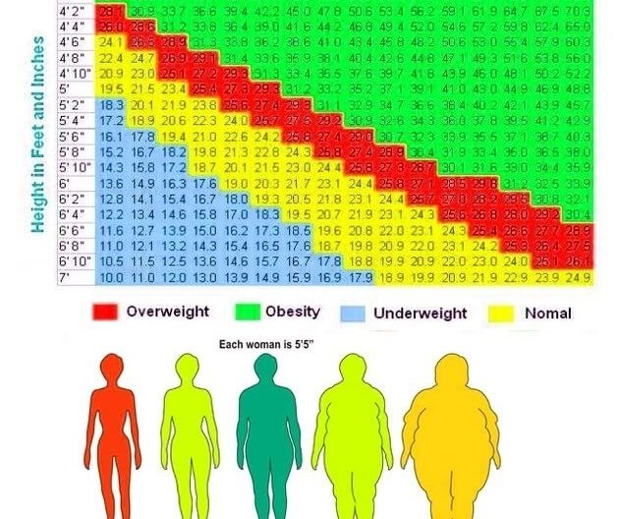

In 3 years…
Marcia Bacchus| HE 230 | 09/06/2020

What my life could be like in 3 years

Obesity, it’s a term people use when your body mass index is thirty or higher. You can find out what your body mass index is when you go to the doctor. This is something I fear whenever I go for my annual doctor’s visit, and not too long ago my doctor told me that I was overweight. When I heard that I immediately googled ways to lose weight when I got home and what were the effects if I gained or did not lose weight. There was a possibility I could have high blood pressure and or osteoarthritis. These diseases don’t run in my family that I know of.
Furthermore, I noticed my habits and the lack of exercise I did, and I was not happy with that. I decided to take some action and start tracking my weight and how much I need to lose. I kept a small book and inside the book had a date, what I ate for breakfast, lunch and dinner and what type of exercise or activity I did for that day. My current weight is 290 and I want to lose 100 pounds, but the only issue is how much am I willing to put into this? Being overweight did not help with self-confidence whatsoever, and I guess I never helped myself either. I guess it started when I was younger, and I had my first piece of candy in church. Then the trips to dollar tree to get a snack either after school or after church on Sunday.
However, I was semi active in school, the personal education class commonly known as P.E. I always played outside after school, and as I got older the less activities I did. Once I got into high school it was snacks 24/7 because the school lunch was horrible. I did attempt to play two sports, but I was not really used to all the exercising. By this time, I knew I was overweight I just chose not to acknowledge it. Being overweight causes, high blood pressure and Osteoarthritis these diseases can hurt you in the future. Since I am younger it hurts me more, I will not be able to do what I want with my life like travel or go sky diving or bungee jumping.
Osteoarthritis is also called degenerative joint disease, and is the most common type of arthritis that you can get in your 60’s but also your 20’s. Women also get it more than men, and it can also be inherited from your family members. Obesity is a major factor that can increase the risks for developing osteoarthritis. Osteoarthritis can occur in any joint of your body, and it commonly occurs in the weight-bearing joints. My lack of getting the right amount of sleep, and unhealthy eating habits will lead to osteoarthritis unless I change my ways.
However, I can change my ways and it starts today. I plan to eat out less and eat more greens, I plan to go walking and work my way up to cardio exercises. I also plan to eat less and less junk food every day I must switch from junk food to something healthier. I will be writing down what I eat everyday to keep track of what I eat. I also plan to step on the scale once a week to see if I have made any progress.
Additionally, towards the end of each week I should lose at least 2 to 5 pounds with the special diet I will be on. I will officially start my process on Monday, September the 13th of this year 2020. I will repeat my motivation affirmation before and after my day. My motivational speech is, “I am Beautiful, I am smart, I will look good either way, and I will not let anyone get in my way”. My final goal is 185 pounds, I want to boost my metabolism and my confidence level.
To conclude, I will have the result in 6 months, and each week I will take photos of the progress when I start to notice. I will also document my journey with pictures and journals. I will work hard to prevent myself from getting this disease, I only know one person with this disease, and they are barely able to get around. Its difficult for her to move because she is pain. That’s not how I want to live my life, I want to travel all around the world to teach and I can not do that if I keep doing the what I am doing now.

References

https://www.webmd.com/osteoarthritis/osteoarthritis-causes - “Understanding Osteoarthritis”
https://doi.org/10.1016/S0140-6736(14)60802-3 – “The Lancet- Osteoarthritis”:
Hiligsmann M Cooper C Arden N et al.
Health economics in the field of osteoarthritis: an expert's consensus paper from the European Society for Clinical and Economic Aspects of Osteoporosis and Osteoarthritis (ESCEO).

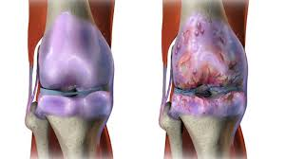Pictures
t