Social Media Usage: The influence on Depression and Personality Displacement
Claytonasia Hare
Literature Review
PSY 439A 01 Senior Research Project I
Dr. Shaneen Corujo
Benedict College

Fall 2020

Literature Review

Social media has emerged as a potentially powerful medium for communication with adolescents and young adults around their health choices. Judgement is an important aspect that is very crucial to life. Social media is an outlet to problems which cause people to communicate with strangers, they can be influenced by drugs,trends, and opinions. During this research you will find out the type of surveys and research that was conducted. You will learn why social media causes people to have an increase in mental health Disorders. In this study, leverage these behavioral cues, to build a statistical classifier that provides estimates of the risk of depression, before the reported onset. We find that social media contains useful signals for characterizing the onset of depression in individuals, as measured through decrease in social activity, raised negative affect, highly clustered ego networks, heightened relational and medicinal concerns, and greater expression of religious involvement. We believe our findings and methods may be useful in developing tools for identifying the onset of major depression, for use by healthcare agencies; or on behalf of individuals, enabling those suffering from depression to be more proactive about their mental health.
Social Media
“Society has a way of making people feel inferior to those being represented in the media. Constant questions of “am I good enough?” or thoughts of not being beautiful enough seem as though they are becoming more prominent as the media grows. With this new age of social media, people feel as if they have to constantly look their best, and put up a front that makes it seem like they live a perfect life”.
In the United States today, you're measurably bound to utilize web-based life more than not — by a ton. Roughly 77 percent of all Americans have an online networking profile or something to that effect. Facebook was established in 2004 by Mark Zuckerberg, Eduardo Saverin, Dustin Moskovitz, and Chris Hughes, every one of whom were understudies at Harvard University. Facebook turned into the biggest informal communities on the planet, with more than one billion users starting in 2012, and about a large portion of that number were using Facebook consistently. Instagram is the biggest developing internet-based platform. It was a triumph directly from the starting point with over a million users just two months after it was established. Despite the prominence of internet-based platforms and the rate with which they've embedded themselves into almost all features of our lives, there's an amazing absence of clear information about how they influence us actually: our practices, our social connections, and our psychological wellness. Studies have connected the utilization of online life to wretchedness, tension, less fortunate rest quality, lower confidence, carelessness, and hyperactivity — frequently in teenagers and young people. Another investigation states that there is in certainty a causal connection between the utilization of social media and negative impacts on prosperity, principally sadness and dejection. The investigation was distributed in the Journal of Social and Clinical Psychology.“What we found overall is that if you use less social media, you are less depressed and less lonely, meaning that the decreased social media use is what causes that qualitative shift in your well-being, “Before this, all we could say was that there is an association between using social media and having poor outcomes with well-being,” she said. The analysts state this is the first run through a causal connection that has ever been built up in logical research. The examination included 143 understudies from the University of Pennsylvania. They were arbitrarily relegated to one of two gatherings: one that would proceed with their Social Media use as normal or one that would essentially constrain access to Social Media.

To keep these trial conditions, the specialists took a look at telephone records, which reported how much time was spent utilizing each application every day. The entirety of the investigation members needed to utilize iPhones. “We didn’t think [complete abstinence] was an accurate representation of the landscape of the world that we live in today. Social media is around us in so many capacities,” Young said. The outcomes were clear: The group that utilized less online life, although it wasn't dispensed with, would be wise to emotional wellness results. Pattern readings for members were taken toward the start of the preliminary in a few territories of prosperity: social support, fear of missing out, loneliness, anxiety, depression, self-esteem, autonomy, and self-acceptance.

Toward the end of the preliminary, those in the test group saw both forlornness and burdensome side effects decrease with the biggest changes occurring in the individuals who detailed more impacts of misery. Prior research in responses to crisis and emergency messages has indicated that while the acquisition of information is critical in reducing anxiety and stress, informational needs and associated emotional reactions on the part of men and women may be quite different according to (McIntyre, Spence, & Lachlan 2010).

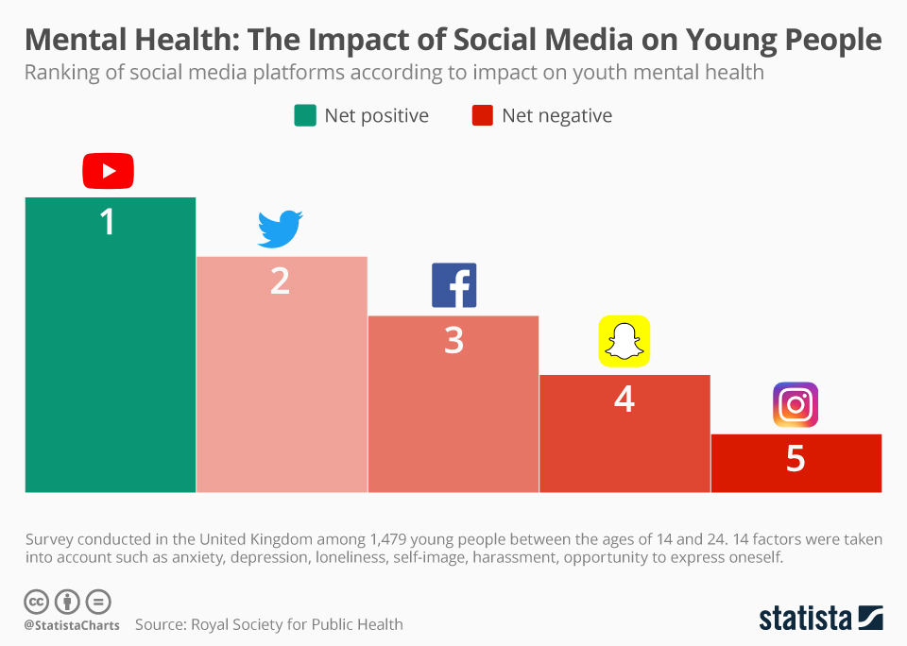

According to (statista charts, 2019) a chart was displayed to show the impact of social media on young people. The survey conducted 1,479 people ages between 14-24 factors taken in account depression, anxiety, loneliness, self image, harassment. In this paper I discovered previous research about social media usage and the impact on feelings of depression or loneliness it's been stated that by other experts

Histrionic Disorder
Histrionic personality disorder (HPD) is characterized by a long-standing pattern of attention seeking behavior and extreme emotionality. Someone with histrionic personality disorder wants to be the center of attention in any group of people, and they feel uncomfortable when they are not. While often lively, interesting, and sometimes dramatic, they have difficulty when people aren’t focused exclusively on them. People with this disorder may be perceived as being shallow, and may engage in sexually seductive or provocative behavior to draw attention to themselves. Grohol, J. (2020). Histrionic personality Disorder has become a common phase of depression especially in today's world with the growth and demand of social media increasing as more minorities are diving into the virtual world seeking positive but sometimes negative attention.
Individuals who spend a lot of time on social media to make impressions of themselves in the minds of others have been shown to display indications of histrionic personality (Sorokowski et al. 2016; Renner et al. 2008). Individuals who believe emotional support is digitally attainable are predictive of histrionic indications (Rosen et al. 2013a). Furthermore, histrionic personality beliefs can affect individuals’ social relationships. Social approval is important for individuals in terms of social relationships and is important in terms of individuals’ psychological needs and makes them feel socially accepted (Gabbert et al. 2003). Social approval basically comprises social reward and can have a major effect on daily social decision-making. Individuals who want to gain social approval and/or refrain from non-acceptance may behave less authentically in the course of their close or distant relationships (Venaglia and Lemay 2017). One of the features of histrionic personality is emotional shallowness (APA 2013), and individuals with histrionic tendencies may need more social approval than individuals who do not have histrionic tendencies. Therefore, based on the psychological literature, the study is that histrionic personality belief will have a positive and direct effect on the need for social approval. All individuals have a desire to be liked. The requirement to belong and be liked appears to be a universal phenomenon (Baumeister and Leary 1995; Leary and Baumeister 2000), and consequently, individuals also want to be liked by others on social media. Histrionic personality is defined by seductive behaviors (American Psychiatric Association, 2013), so individuals with histrionic tendencies may desire being liked more than the other individuals who do not have histrionic tendencies.

In the DSM-V criteria for the diagnosis of histrionic personality disorder, someone with the disorder shows at least five of the following symptoms in a variety of contexts:

- Considering relationships to be more intimate than they actually are.
- Being easily influenced by other people or circumstances.
- Being theatrical and dramatic in expressing emotions.
- Speaking in a way that is excessively impressionistic but lacking in detail.
- Consistently drawing attention to oneself through physical appearance.
- Expressing emotions that are shallow in that shifting rapidly from one extreme to another, or from one emotion to another.
- Engaging in seductive or provocative behaviour during ordinary social interactions where that kind of behaviour is inappropriate.
- Feeling uncomfortable in situations where one is not the centre of attention.

Social media gives individuals a misguided feeling of reality where connections can show up more emotionally intimate than they really, which can uplift the manifestation HPD concerning the deception of intimacy. Companionships dependent via social media are not equivalent to kinships, in person. This doesn't imply that they are less significant companionships, yet kinships created through social media are in danger of existing it could be said of faked intimacy. For individuals with HPD, fellowships that exist inside social media can be confounding and unhelpful in introducing a figment of intimacy that affirms instead of challenging one of the disorder's key side effects.

Attention seeking is normal via social media and it tends to be innocuous for the majority users yet mentally unhelpful for users with HPD or individuals with an inclination towards it. Social media can focus on themselves through their physical appearance by allowing them to post pictures that give them mental awards from users. That can be innocuous for the vast majority, however such settings may be concealing a predominance of histrionic personality disorder. Social media may be hiding side effects which, however normal in that circumstance, can be psychopathological on the off chance that they continue in different contexts.

Treatments for Histrionic Personality Disorder is a combination of medication and therapy. Treatment will work with the patient to get a clearer understanding of symptoms, screen for them, and create adapting skills, learn new practices, and make sound limits. Medicine commonly is endorsed to help control impulsive actions or serious feelings just as issues that happen with this disorder are, similar to depression.

Conclusion
This research is being conducted to prove that social media has impacted humanity on a different level leading individuals feeling depressed, and feeling that they don’t belong or in other words feeling displaced. Social media is an outlet to problems which cause people to communicate with strangers but also be influenced by other factors like drugs, alcohol and violence. During this research you will find that high usage of social media could influence behavior changes mostly mental illness. “It’s proven that being on these media platforms could cause you to feel as though your life isn’t going the way you think it should, sometimes social media could make you feel like you are behind and not where you need to be in life the more we scroll the more the more displaced we become with reality”.
In this study you were able to learn about why social media can cause people to have an increase in mental health, depression is a serious and widespread public health challenge. We become more vulnerable when we spend too much time on social media. Those who spend less time may have a better chance of not becoming depressed due to self independence and not having any distractions versus a person who tends to post excessively. This research was conducted to expand previous knowledge about depression and social media and the importance of what can cause behavior displacement.

Reference

American Psychiatric Association (2013). Diagnostic and Statistical Manual of Mental Disorders 5 (DSM-5). Arlington, VA: American Psychiatric Association.

Abbasi, I., Y. Amichai-Hamburger, G., CS. Andreassen, M., CS. Andreassen, S., CS. Andreassen, T., RF. Baumeister, M., . . . S. Zhao, S. (1970, January 01). Histrionic Personality, Narcissistic Personality, and Problematic Social Media Use: Testing of a New Hypothetical Model. Retrieved September 11, 2020, from https://link.springer.com/article/10.1007/s11469-019-00139-5

Armstrong, M., &amp; Richter, F. (2019, September 06). Infographic: Mental Health: The Impact of Social Media on Young People. Retrieved September 11, 2020, from https://www.statista.com/chart/19262/impact-of-social-media-on-mental-health/

Baumeister, F. R., &amp; Leary, R. M. (n.d.). The Need to Belong: Desire for Interpersonal Attachments ... Retrieved September 11, 2020, from https://pdfs.semanticscholar.org/3dcc/3d262c08f8f4eb8f766ad72f06d580869309.pdf

Guivarch, C., &amp; Hallegatte, S. (2012). 2C or Not 2C? SSRN Electronic Journal. doi:10.2139/ssrn.1988201
Kamau, C. (2020, July 01). Social Media and Histrionic Personality Disorder. Retrieved September 11, 2020, from https://www.psychologytoday.com/us/blog/the-science-mental-health/202007/social-media-and-histrionic-personality-disorder

Lin, X., Spence, P., Sellnow, T., &amp; Lachlan, K. (2016, June 08). Crisis communication, learning and responding: Best practices in social media. Retrieved September 11, 2020, from https://www.sciencedirect.com/science/article/pii/S0747563216304137

R. B.. Cialdini, N., M.. Deutsch, H., D.. Edwards, D., K. E.. Forbes, A., F.. Gabbert, A., F.. Gabbert, A., . . . D. B.. Wright, G. (1970, January 01). Memory conformity: Disentangling the steps toward influence during a discussion. Retrieved September 11, 2020, from https://link.springer.com/article/10.3758/BF03193873

Renner, H. K., Friedel, S., Merzbacher, G., &amp; Laux, L. (2008). (PDF) A Review on the Present Condition of Histrionic ... Retrieved September 11, 2020, from https://www.researchgate.net/publication/335796609_A_Review_on_the_Present_Condition_of_Histrionic_Personality_Disorder

Rosen, L., Whaling, K., Rab, S., Carrier, L., &amp; Cheever, N. (2013, January 03). Is Facebook creating "iDisorders"? The link between clinical symptoms of psychiatric disorders and technology use, attitudes and anxiety. Retrieved September 11, 2020, from https://www.sciencedirect.com/science/article/pii/S0747563212003172

Leary, M. R. (1983). A brief version of the Fear of Negative Evaluation Scale. Personality and Social Psychology Bulletin, 9(3), 371–375.

Venaglia, R. B., & Lemay, E. P. (2017). Hedonic benefits of close and distant interaction partners: the mediating roles of social approval and authenticity. Personality and Social Psychology Bulletin, 43(9), 1255–1267.

